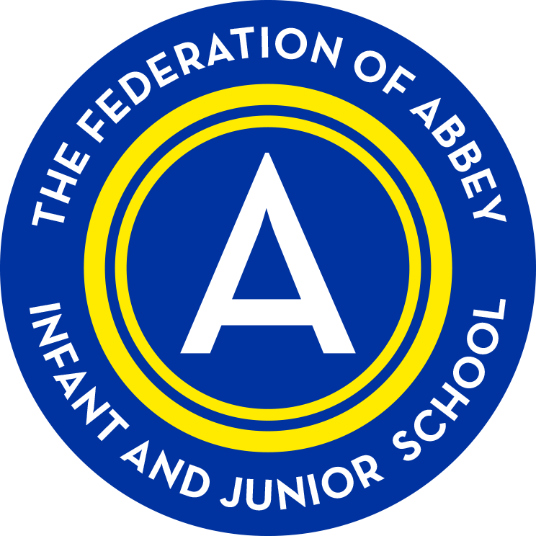
The Federation of Abbey Infant and Abbey Junior School
Promoting British Values 2019

British Values are defined as; democracy, the rule of law, individual liberty, mutual respect and tolerance of different faiths and beliefs. We regularly promote these values through our own school values, life skills, curriculum and the wider range of enrichment activities across the school.

Value | How We Promote It
Democracy  An understanding of how citizens can influence decision-making through the democratic process.  Links to:  Respect  Tolerance  Understanding  Responsibility  Trust  Rights  Hope  UN CRC Article 12: Children have the right to say what they think should happen, when adults are making decisions that affect them, and to have their opinions taken into account.  (see UN 12 assemblies) | - We have an elected School Council, Health and Safety Council, and class representatives (friendship buddies). This is used as an opportunity to promote and teach about democracy and the electoral process.  - We encourage volunteerism in and out of school. This includes Abbey Junior PCSOs/Safeguarding Champions/Litter Watch Champions, class monitors, 'Meeters and Greeters', sports advocates, lunchtime helpers, librarians, reading buddies, ICT monitors and also raising money for local and national charities.  - Children are part of shaping the curriculum and policy development in the school. School Council contribute to policies that will directly impact them, such as the Behaviour policy. The council vote on how the school consider taking part in charity events each year.  - School Health and Safety Council have decided on changes for 'first aid provision', and processes which have reduced accidents across the school (playtime provision, lining up, first aid, behaviour, walking around the school etc - see H& S log).  - Children are part of the selection process for class teachers and senior staff members. The school council interviewed our head teacher during his interview.  - Democracy is taught through historical research of the Romans (Y4), Ancient Greece (Y3) civilisation and Slavery (Y6) topics. Y2 complete a unit of work during Black History Month on Martin Luther King and Apartheid. There are units of work and assemblies with link to the 'Prevent For Schools' Website and resources. The focus is on good quality multi-cultural education.  - Democracy is also promoted through additional Well-being assemblies/PSHE lessons, whole school assemblies and collective worship.  - The school has an active 'elected' governing body who hold the school to account and support the school.  - There is a Friends of Abbey (PTA) group and work in the best interests of the school and vote on school events and how to spend money raised by the community.  - Children are taught about the United Nations Convention on the Rights of the Child and learn to respect their rights and the rights of others.  - The school are developing the ‘Rights Respecting School’ project.
The rule of law  An appreciation that living under the rule of law protects individual citizens and is essential for their wellbeing and safety.  Links to:  Respect  Co-operation  Courage  Responsibility  UN CRC Article 19: Governments should ensure that children are properly cared for, and protect them from violence, abuse and neglect by their parents, or anyone else who looks after them. | - We have an effective and robust 'behaviour policy and anti-bullying policy' in place.  - In managing behaviour, we focus on a positive “Assertive Discipline” model that aims to reward and encourage good behaviour. All staff should manage behaviour in this way at all times.  - High expectations of behaviour and conduct are encouraged in all areas of school (outside of school, classroom, playtime, lunchtime, clubs, educational visits and extra-curricular activities).  - Staff are trained in emotion coaching, ACE, de-escalation techniques (MAPA) and provided with a ‘Behaviour Toolkit’.  - We have a child friendly 'home school agreement'  - Classes work with children to create routines, rules and a class promise linked to Rights Respecting Schools.  - We have high expectations about pupil conduct and this is reflected in our Behaviour Policy. There are rewards for exhibiting good and caring behaviour and consistent demonstration of our values is recognised through; ‘Star of the Week’ , ‘class Pupil of the Week’ awards and the Kindness Cup.  - Using positive praise strategies children's achievements are celebrated in 'going for gold' and 'rainbow behaviour charts' across the school.  - Lunchtime supervisors reward children for their conduct with house points. These are celebrated in assembly each week with the lunchtime trophy.  - Attendance awards, certificates and prizes celebrate and promote good attendance.  - Through our contact with the public at school educational visits and from visitors within school, we have regular comments on the high standards of behaviour exhibited from our children.  - Our school assemblies, circle time, well-being assemblies/PSHE teach children how to earn trust and respect and develop a strong sense of morality; knowing right from wrong and doing the right thing even when it’s difficult.  - West Midlands Police and the local PCSOs visit the school regularly to talk to the children and explain about their role in society. Their work with the Abbey Junior PCSO team increases their visibility and helps children have an understanding of their role and the rule of law.  - Assemblies about seat belt safety, road safety and safer parking ensure that children have an understanding of the law and how to follow rules that keep us safe.  - SENTINEL are links to the local police force providing support for staff to help safeguarding.  - Opportunities for vulnerable children to work with WMPolice on projects such as Young Farmers and Teamworx provide positive relationships with the police and reinforce the law.  - Visits from MPs (MP Spellar Warley Constituency) and other local politicians provide links with parliament and government.  - The school council took an educational visit to the Houses of parliament.  - We teach the children about CEOP and the role they play in keeping our internet safe. We promote 'safer internet day' and the values associated with this.  - There are links with NSPCC/O2 Gurus – who have delivered assemblies to parents and children on safeguarding issues and internet safety.  - Parent surveys help us develop our life skills curriculum.  - Children are taught about the United Nations Convention on the Rights of the Child and learn to respect their rights and the rights of others (UN 12 assemblies)
Individual liberty  Individual liberty is seen as the right to believe, act and express oneself freely. It is the protection of your rights and the rights of others. It is seen in day to day life through the following:  - Equality and Human Rights  - Respect and Dignity  - Rights, choice, consent and individuality  - Values and principles  Links to:  Respect  Courage  Responsibility  Trust  Hope  Rights  UN CRC Article 31: All children have a right to relax and play, and to join in a wide range of activities.  UN CRC Article 15: Children have the right to meet together and to join groups and organisations, as long as this does not stop other people from enjoying their rights. | - Through the 'UN 12 Assemblies', children are taught about the United Nations Convention on the Rights of the Child and learn to respect their rights and the rights of others. (see collective worship).  - The Rights Respecting Schools project teaches a child about their rights and individual liberty and their responsibilities.  - Through collective worship, HRSE, curriculum, PSHE curriculum/well-being assemblies and Religious Education children are taught about personal responsibility and making the choices which promote healthy relationships.  - Children are encouraged to show ambition and aspiration. They are encouraged to take opportunities to follow their interests in art, music, sport etc. Talents are celebrated and encouraged.  - We cover difficult topics such as 'National Holocaust Day', War and ‘Slavery’. During Black History Month we look at those who campaigned for equality. We tackle gender divides through assemblies, celebrating international women’s’ day and approaches to teaching children. We promote our difference as being something to celebrate and embrace and cover topics on disability, special needs. Through our HRSE education we discuss the variety of family units and relationship preferences.  - Each term we promote our school anti-bullying campaign 'Abbey Let's Start Stop'. This is done through fun activities, wrist bands, badges, posters, theatre groups, NSPCC visits and workshops.  - The Abbey behaviour and anti bullying policy has been written with our children.  - Our 'quality assurance' policy ensures that at six points throughout the year the children have an opportunity to voice their opinions on the curriculum and areas of school life. These are used to change and improve our provision.  - PREVENT for schools - resources to promote multi cultural education are built into our curriculum.  - Safeguarding assemblies using resources from Sandwell Safeguarding Champions, NSPCC and CEOP are delivered for all children across the school to help keep them safe.  - Support for staff for responding to concerns about extremism and radicalisation - see safeguarding lead.  - HRSE lessons on consent and healthy relationships.  - Children are taught how to keep themselves safe, including on-line. This is done through; theatre group visits (anti bullying), road safety assemblies and workshops, seat belt safety, stranger danger lessons, e-safety lessons, assemblies and visits from organisations such as the NSPCC, school crossing patrol warden, Abbey Junior PCSOs, CSE team and WM Police and PCSOs.
Mutual respect  Mutual respect is understanding that we all don’t share the same beliefs and values. Respecting the values, ideas and beliefs of others whilst not imposing our own on others.  Links to:  Respect  Friendship  Co-operation  Belonging  Trust  Honesty  Humility  UN CRC Article 2: The Convention applies to everyone whatever their race, religion, abilities, whatever they think or say and whatever type of family they come from.  UN CRC Article 30: Children have a right to learn and use the language and customs of their families, whether these are shared by the majority of people in the country or not. | - The school follows a comprehensive SACRE Religious Education Programme, developed in Sandwell. The RE teaching focuses on the groups of children and the predominant faiths in our community. Teaching is therefore relevant and purposeful. To develop respect within our community the programme includes a wide range of visitors and visits to places of worship.  - We have high expectations about pupil conduct and this is reflected in our Behaviour Policy and Equality Policy.  - Through our school’s values, well-being programme/PSHE/HRSE, Rights Respecting School project, and circle time children are taught to respect each other, to be cooperative and collaborative, be supportive and to look for similarities while being understanding of differences.  - Kindness cups are awarded each week for pupils who demonstrate an act of kindness.  - PREVENT for schools assist in developing good multi-cultural education - Year 6 project on Slavery.  - Assemblies were delivered focusing on helping other pupils to understand specific special needs – autism, dyslexia, downs syndrome etc  - Children are taught about the United Nations Convention on the Rights of the Child and learn to respect their rights and the rights of others.  - Stonewall resources are used to support anti-homophobic bullying assemblies.  - SEND - Achievement for All. SEND anti-bullying resources are attached to the school anti-bullying policy, with interactive links to support parents, carers, staff and children.  - Friendship Buddy representatives support and represent each class.  - Staff can access areas in school to support children who are struggling - the 'Bank' (AJS) and 'Rainbow Room' (AIS) provide a quiet and ‘safe’ space for children.
Tolerance of different faiths and beliefs  An acceptance that other people having different faiths or beliefs to oneself (or having none) should be accepted and tolerated, and should not be the cause of prejudicial or discriminatory behaviour; and an understanding of the importance of identifying and combating discrimination.  Links to:  Respect  Tolerance/Understanding  Belonging  Trust  Patience  Hope  UN CRC Article 14: Children have the right to think and believe what they want, and to practise their religion, as long as they are not stopping other people from enjoying their rights. Parents should guide their children on these matters. | - We have high expectations about pupil conduct and this is reflected in our school Behaviour and Anti- Bullying Policy and Equality Policy and Religious Education Policy.  - Tolerance of different faiths and beliefs is promoted through the Syllabus for Religious Education (Sandwell SACRE). Children learn about different religions, their beliefs, places of worship and festivals. Children reflect on the culture and belief of others and make connections with their own life. This is supplemented by assemblies (Key Stage and whole school), which also mark and celebrate significant religious festivals such as Ramadan, Diwali, Rosh Hashanah, etc.  - Visits are made by local religious leaders and children have the opportunity to visit places of worship in the local community.  - We have links with Warley Methodist Church who provide ‘Open The Book’ assemblies. They dramatise stories from the Bible and ask children to make connections with this Christian story to our own lives.  - PREVENT for schools - developing good multi cultural education through the curriculum.  - Children are taught about the United Nations Convention on the Rights of the Child and learn to respect their rights and the rights of others.

