Friday 23rd October 2015

Dear Year 3 Parents,

We are trialing an exciting ‘Year 3 on-line message page’ to encourage an on-going conversation with children, parents and school focusing on learning. There are links below and QR codes to help you find this page.
We would like to see if our children enjoy the idea of posting messages and developing communication skills about the topics and areas of study we are looking at within Year 3.

It is part of our web-site and is publicly viewable. Posts that children make will not appear on the public world wide web until they have been approved. Children can post and edit their own comments only. Comments and posts will be moderated and checked by staff.

This is a brand new idea for us, Y3 are the only year group trying this out. We are excited to see how this develops….could be great! Have a super half-term!

http://www.abbeyfederation.co.uk/y3-board/
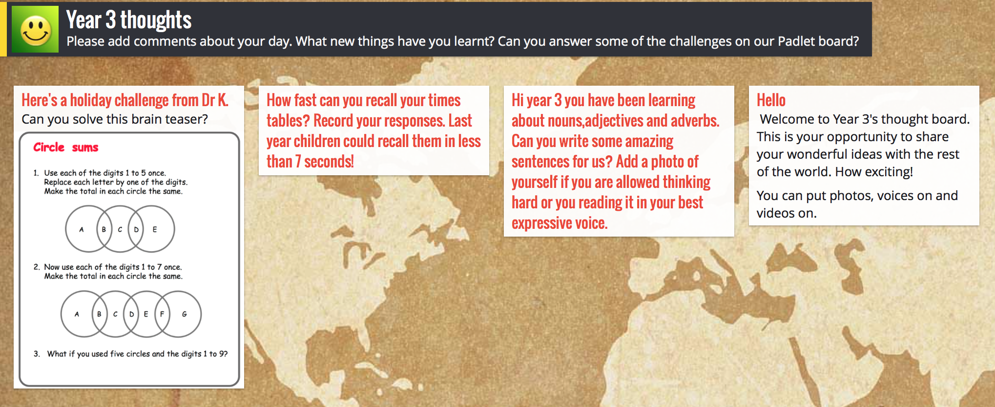
Yours sincerely

The Year 3 team.

