Assessment, marking and feedback @ Abbey.

Reading | 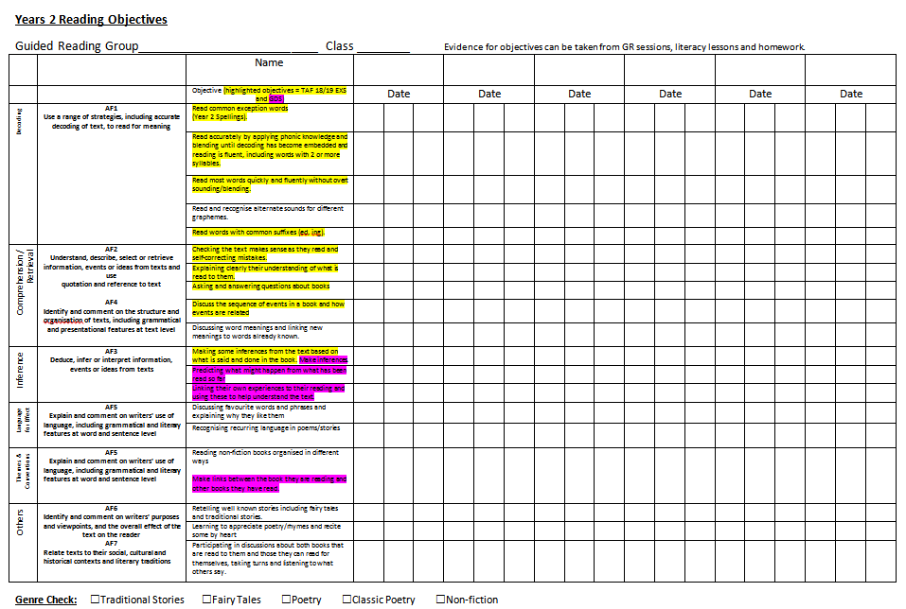 | In Y1-Y6 - Non-Negotiable. One of these, per group in the class, in the reading folder and highlighted to show evidence against the NC. Highlighted areas show the TAF  Guided reading records will form part of this; running reading records; Salford tests; NFER tests; practice SATS or Testbase questions; Phonics e-tests termly
Writing | 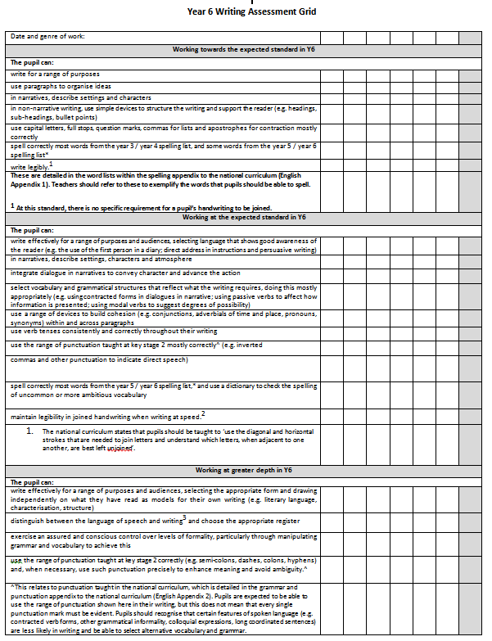  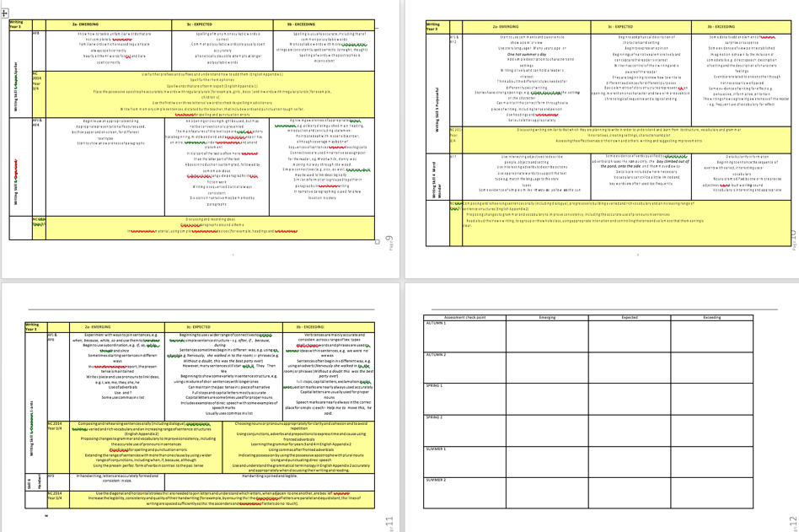 | Non-Negotiable. One of these, stuck in each ‘Wow writing’ book and highlighted to show evidence against the new NC. In Y2 & Y6 alternating assessment direct against the TAF (see Y6 picture example)
Maths | 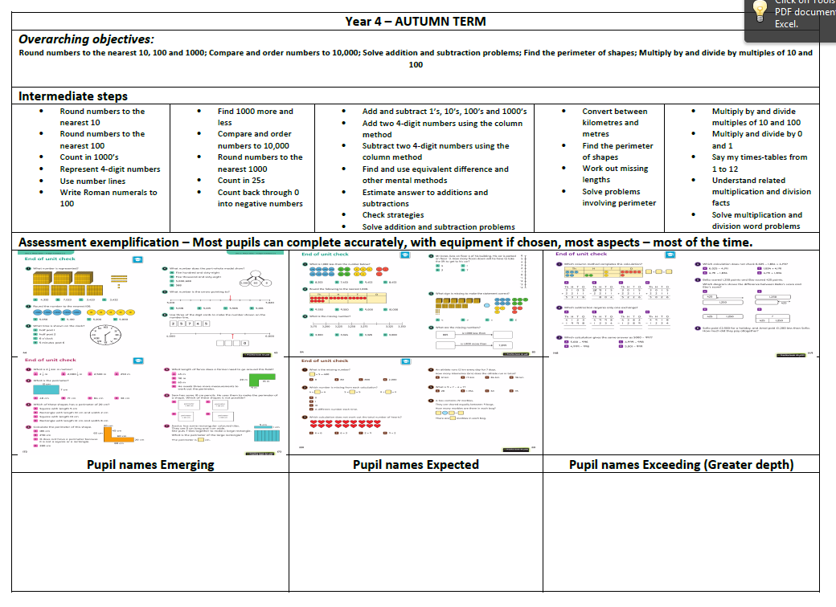 | Non-Negotiable. One of these, per group in the class, in the maths folder and highlighted to show evidence against the new NC mini-steps.  Maths folders may contain Power maths assessments; Testbase; Practice SATS, NFER tests; SENI assessments; mental maths tests/records of results
Non-core | 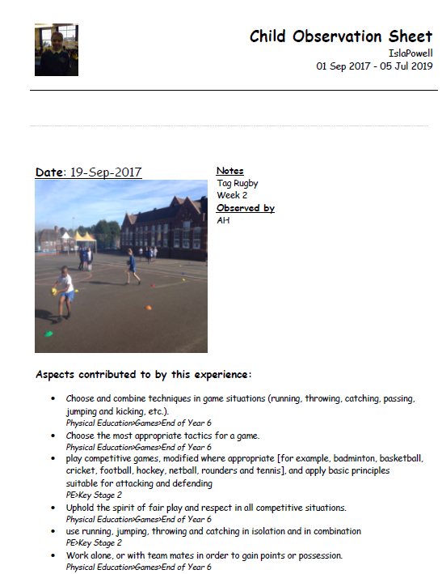 | Termly samples of work across the broad range of subjects to demonstrate progress against our curriculum.  Abbey’s skill progression statements.
EYFS | 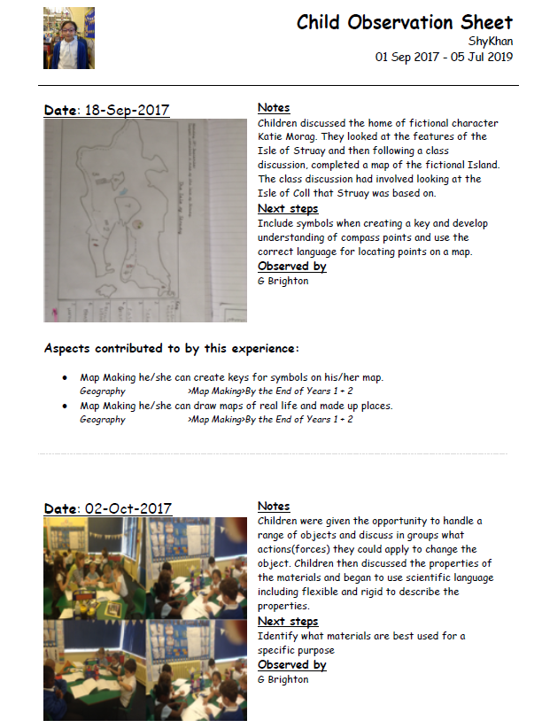 | One observation per week, per child. Focussed using key-worker approach.  Next-steps discussion at the end of the day to inform provision.  Development matters statements.  Target Tigers – two per child, per term. Home/school cameras to capture parent voice of learning at home.  Welcomme language in YN  Phonics – see reading above.
Other useful assessment information may include: see below

 | Autumn 1 | Autumn 2 | Spring 1 | Spring 2 | Summer 1 | Summer 2
STATUTORY TESTS/TASKS | YN Baseline  YR Baseline (possibly new baseline 2020) |  |  |  | Phonics screen  Y2 Tasks  Y6 Tests  YR summative
READING AGES & COMP AGES | Reading sweep - New Salford test (RA + Comp) |  |  | Reading sweep - New Salford test (RA + Comp)
SPELLING AGES | Young’s test |  |  |  | Young’s test
Standardised tests |  | Power Maths |  | Power Maths |  | Power Maths  NFER Y3-5
EYFS | One observation per week, per child. Focussed using key-worker approach.  Next-steps discussion at the end of the day to inform provision.  Development matters statements.  Target Tigers – two per child, per term. Home/school cameras to capture parent voice of learning at home.
Phonics | Phonics baseline YR, Y1, Y2 re-tests; Y3 WTS or lower; Y4-6 target children – Ipad for workload | END OF TERM  Phonics YR, Y1, Y2 re-tests; Y3 WTS or lower; Y4-6 target children – Ipad for workload | Y1 Phonic screen check – IPAD for workload | END OF TERM  Phonics YR, Y1, Y2 re-tests; Y3 WTS or lower; Y4-6 target children – Ipad for workload |  | END OF TERM  Phonics YR, Y1, Y2 re-tests; Y3 WTS or lower; Y4-6 target children – Ipad for workload
Speech & Language | Welcomme language N,R (those still below), |  |  |  |  | Welcomme language N,R (those tested September),
Attitudes to school | Abbey Survey |  |  |  |  | Abbey Survey
Pupil progress | In house target of pupils – provision maps check. Directed time – names not numbers | In house target of pupils – provision maps check. Directed time – names not numbers | In house target of pupils – provision maps check. Directed time – names not numbers | In house target of pupils – provision maps check. Directed time – names not numbers | In house target of pupils – provision maps check. Directed time – names not numbers | In house target of pupils – provision maps check. Directed time – names not numbers
SEND | Some pupils will have CEW/HFW/Phonic check/Maths skill lists to support Profile targets – these will be updated through the year. |  | IEP, ILP, IBP  Profile  After autumn 2 pupil progress – often 1st week Sp 1. |  | IEP, ILP, IBP  Profile  After autumn 2 pupil progress – often 1st week Sp 1. | I IEP, ILP, IBP  Profile  End of year review and plan to facilitate transition
Governors | Governors Report  IDSR  In-house Target setting  Premiums review |  | Governors Report |  | Governors Report  End of year summative data on attainment and achievement
Data drops | EYFS Baseline – all areas | SIMS –  Progress –/0/+  Meet the year group POS Attainment N/Y/EXC  R,WR,MA  EYFS PSED, CLL, LIT, NUM predictions |  | SIMS –  Progress –/0/+  Meet the year group POS Attainment N/Y/EXC  EYFS PSED, CLL, LIT, NUM predictions |  | Finalise -/0/+ Progress  Finalise Attainment N/Y/EXC  Complete  Summer 2 EMG-, EMG. EXP-. EXP. EXC-. EXC  EYFS end of year 1,2,3 – all areas  Non-Core EMG, EXP, EXC all subjects & summative progress judgement.

