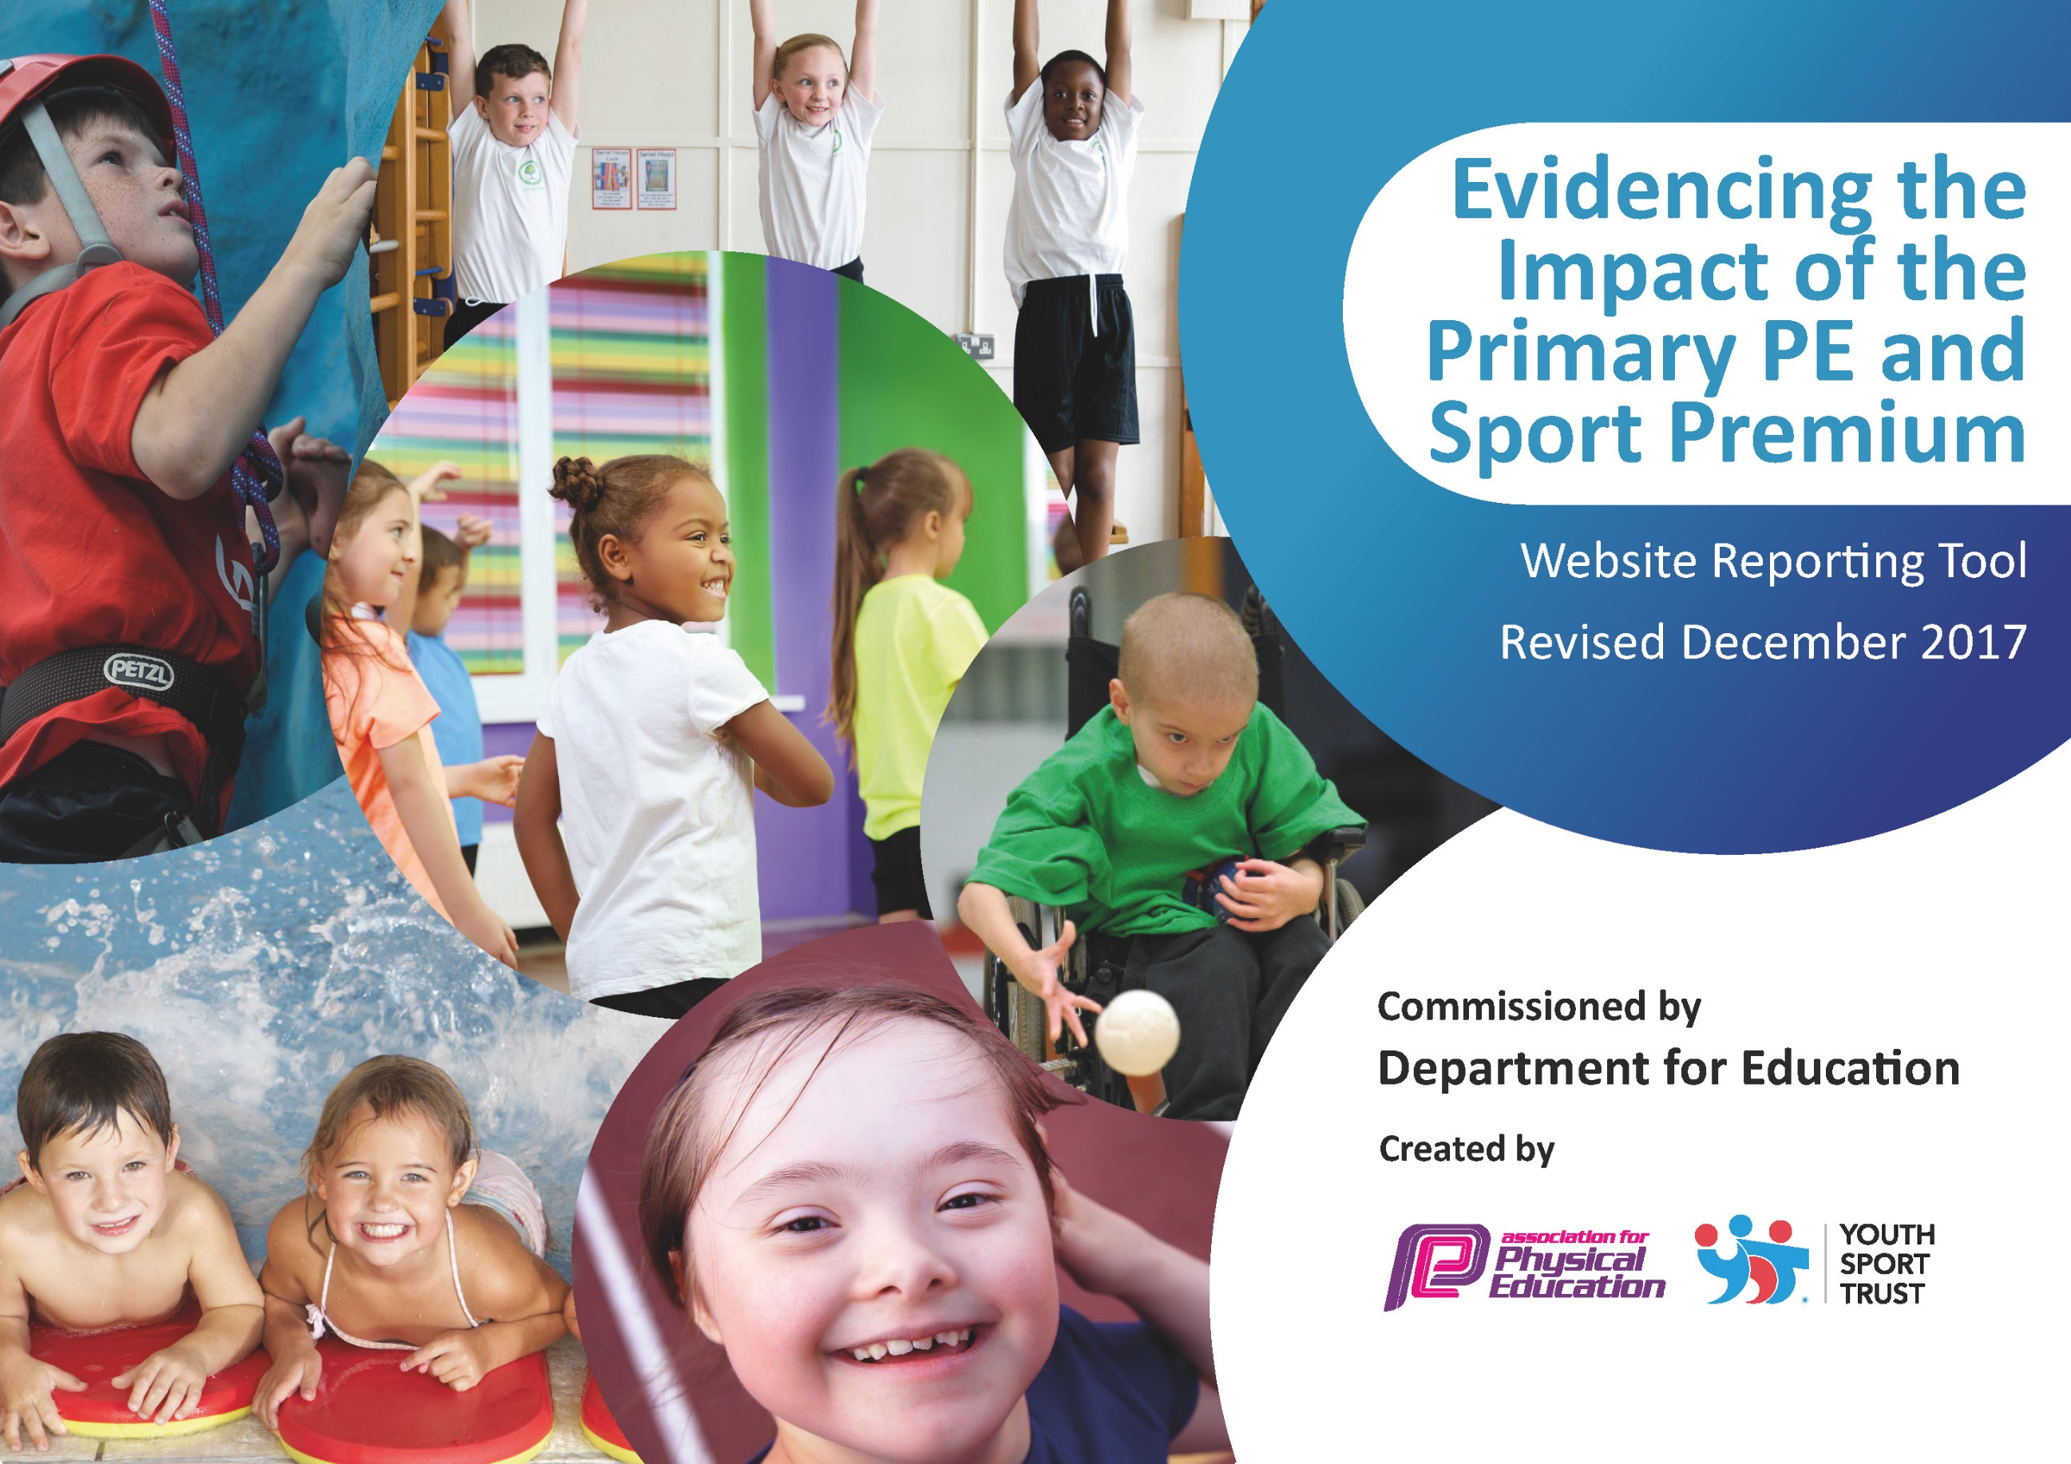



Schools must use the funding to make additional and sustainable improvements to the quality of PE and sport they offer. This means that you should use the Primary PE and Sport Premium to:

- develop or add to the PE and sport activities that your school already offers
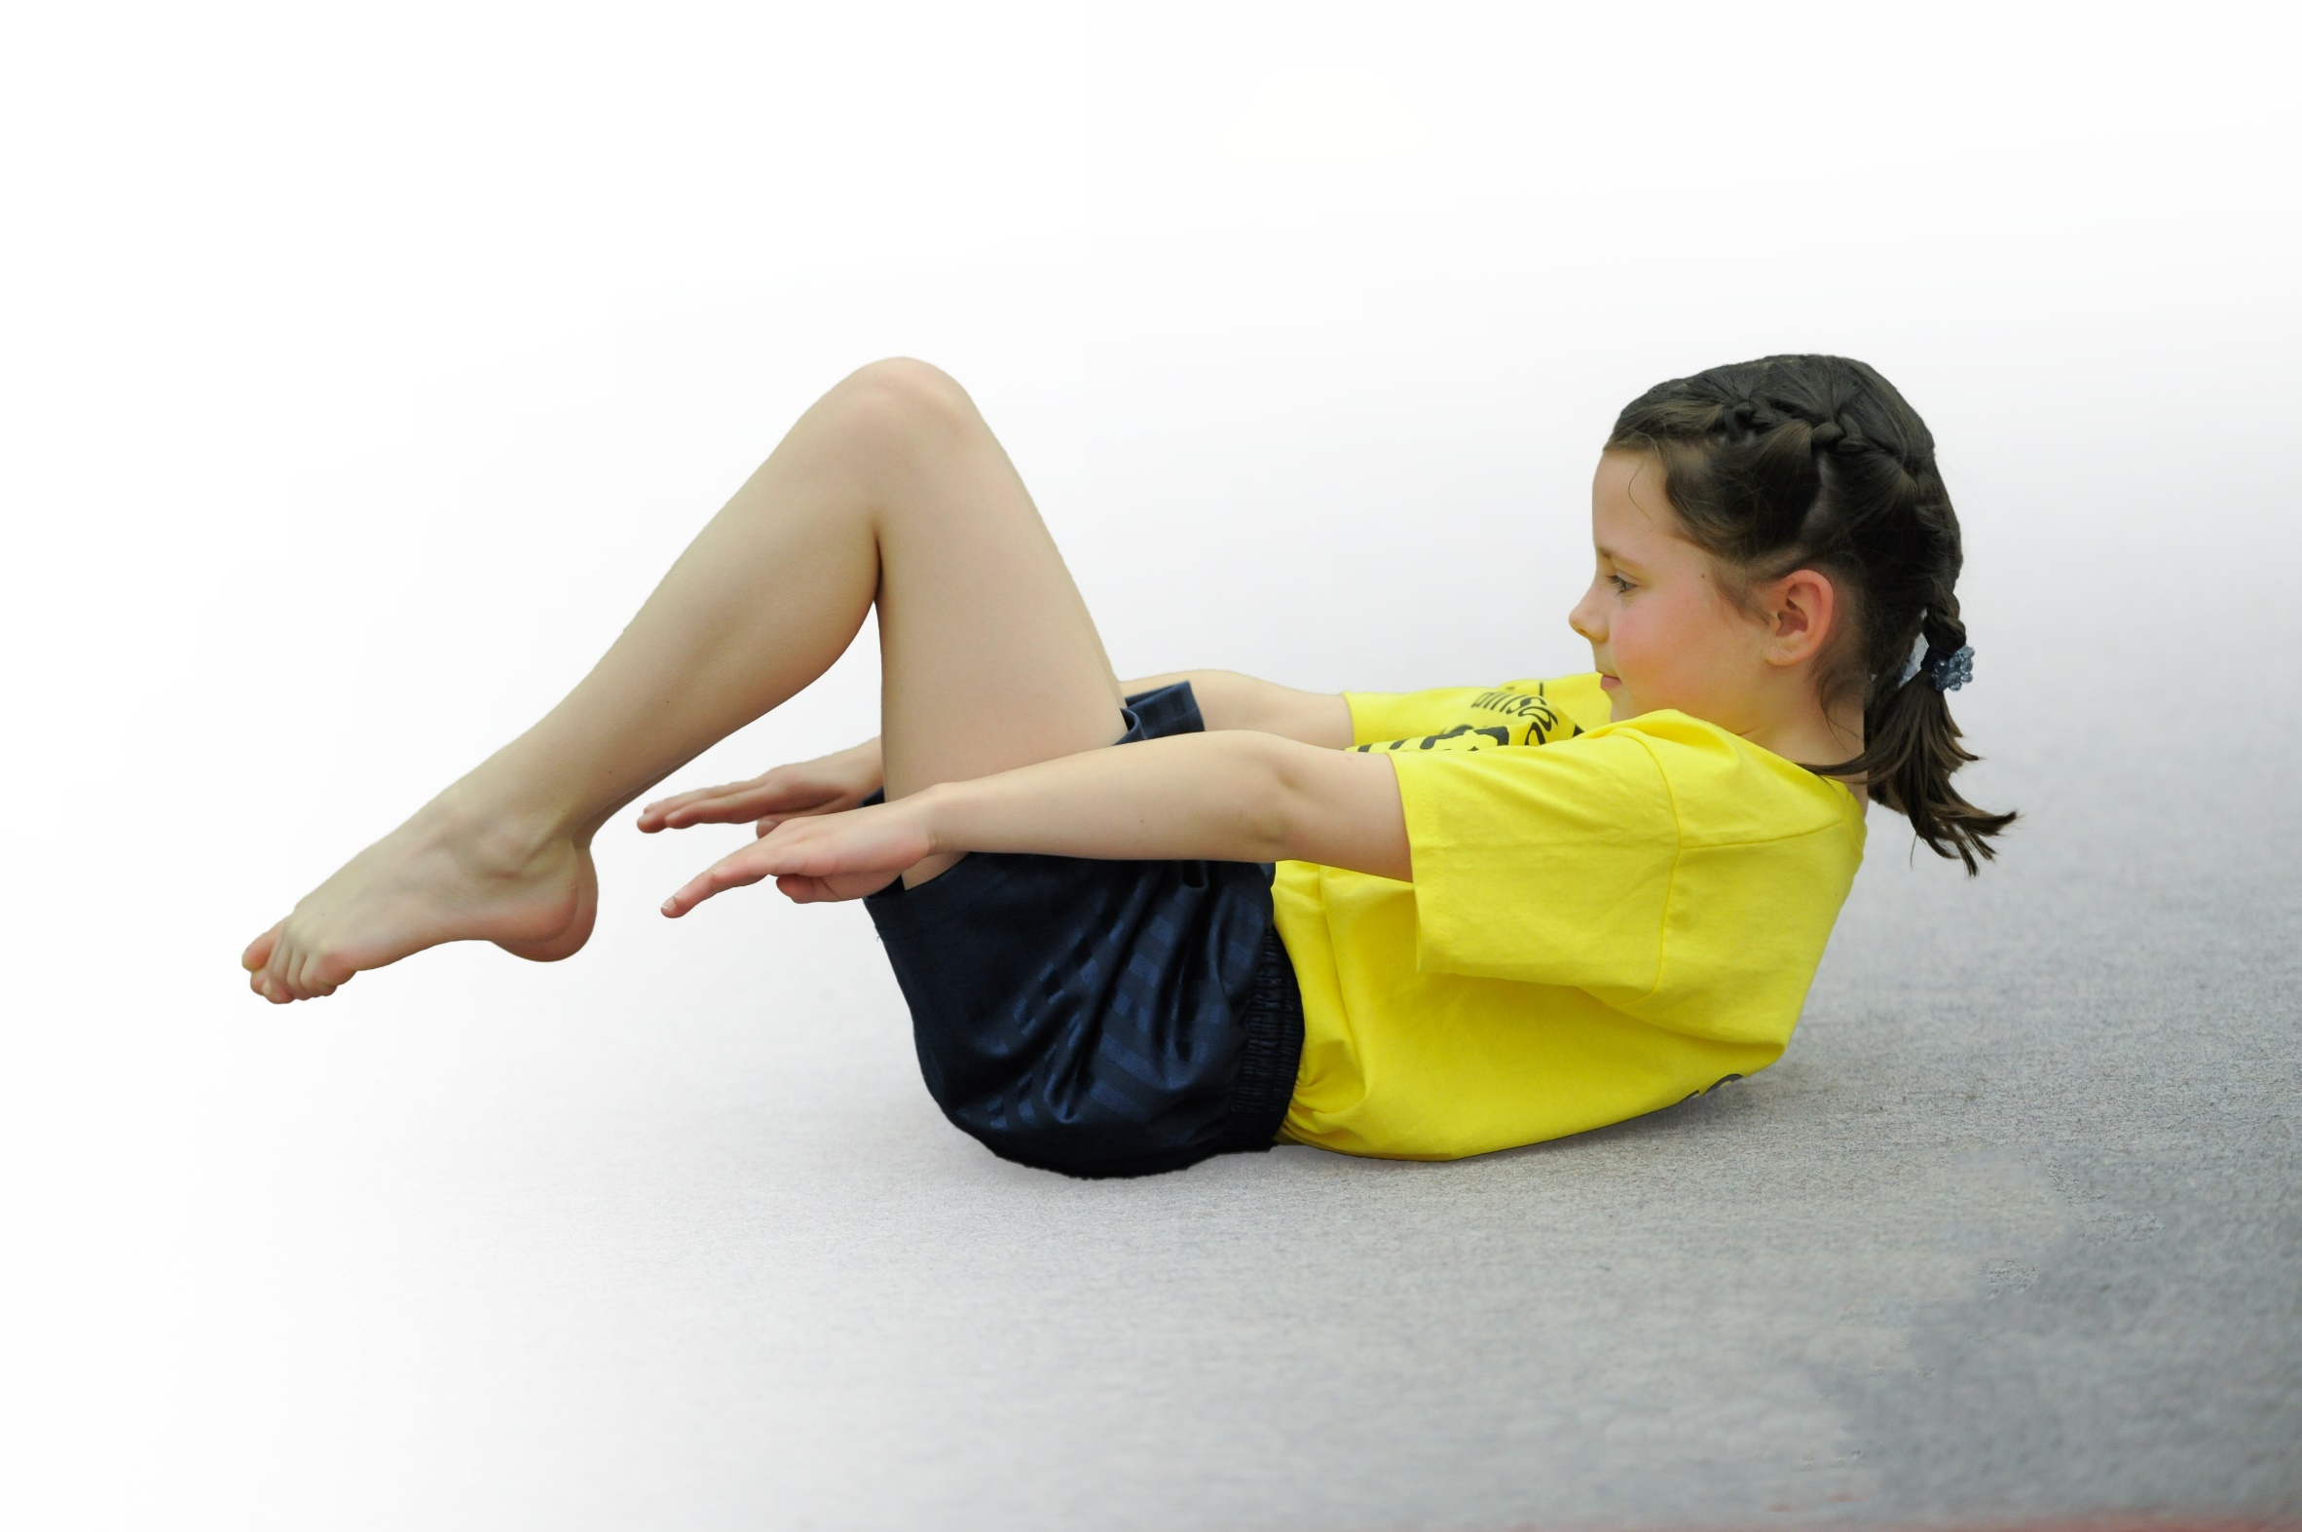
- build capacity and capability within the school to ensure that improvements made now will benefit pupils joining the school in future years

Please visit gov.uk for the revised DfE guidance including the 5 key indicators across which schools should demonstrate an improvement. This document will help you to review your provision and to report your spend. DfE encourages schools to use this template as an effective way of meeting the reporting requirements of the Primary PE and Sport Premium.

We recommend you start by reflecting on the impact of current provision and reviewing the previous spend.
Under the Ofsted Schools Inspection Framework, inspectors will assess how effectively leaders use
the Primary PE and Sport Premium and measure its impact on outcomes for pupils, and how effectively governors hold them to account
for this.

Schools are required to publish details of how they spend this funding as well as on the impact it has on pupils’ PE
and sport participation and attainment.
We recommend regularly updating the table and
publishing it on your website as evidence
of your ongoing review into how you are using the money
to secure maximum, sustainable impact. To see an example of how to complete the table please click HERE.

Support for review and reflection - considering the 5 key indicators from DfE, what development needs are a priority for your setting and your students now and why? Use the space below to reflect on previous spend, identify current need and priorities for the future.

Key achievements to date: | Areas for further improvement and baseline evidence of need:
OFSTED- The extra sports funding provided for primary schools has been spent well. All staff have been trained in teaching physical education, so the quality of teaching has improved. More pupils are taking up sport each year and many more now take part in competitive sport.  Subject leaders and teachers responsible for aspects of the school’s work play a good part in helping to move the school forward.  SIA - Pupils’ attitudes to learning are good and engagement is high. A strong pastoral team exists to support pupils’ specific needs. Outdoor learning in the Early Years is being encouraged partly through a Forest School curriculum which is exciting and engaging for all children. The outdoor area has been cleared and reorganised to allow children in the early years to fully explore the environment.  OTHER – The school has successfully been awarded the aFPE Mark – with distinction; The Sainsbury’s Gold Award; Black Country award for effective use of PE Premium x 2 | From the 2018-19 SIP:  1. Children will have the opportunity to participate in daily exercise session to promote a healthy active lifestyle and improve mental & emotional wellbeing  2. Monitor the use of ICT in PE including using 2simple Assessment tool consistently across The Federation  3. More outstanding teaching in PE more of the time. Delivered by teachers with increased confidence through CPD and support from subject lead
Targets from SIP 2018-19  Targets – What we will achieve:  1a. 10 Mins of daily physical activity timetabled into the curriculum.  1b. Children will gain the physical confidence and competence to opt in to extra-curricular activity  1c. Children will access a weekly (class/phase) assembly which will be a wellbeing assembly, including physical activity.  2a. Staff will build a profile of children in their class in Physical Education using 2simple.  2b. Staff will be able to assess PE with increased confidence  3a. Develop and improve the teaching of Games and Gymnastics across the Federation  3b. Lessons will be planned and taught with clear differentiation (STEP) so that all pupils make progress | Success Criteria from SIP 2018-19 – How will we know we have achieved it?  1. Children and staff will participate in a range of physical activities throughout each week. Outcomes measured link to 1c.  1b. Attendance of Extra Curricular activity will continue to improve and allow PE Lead to identify the most inactive pupils.  1c. All children and staff will report improved attitudes to learning. Focused and settled classrooms.  2a. Further support staff’s knowledge and evidence of children's progress in PE  2b. Staff will identify children requiring additional support and the gifted and talented  3a. Staff will express improved confidence by accessing internal and external CPD in games and gymnastics. Pupils will enjoy performing, learning and make at least good progress.  3b. Medium term plans show clear differentiation and is reflected in short term plans, lesson preparation and delivery.

Meeting national curriculum requirements for swimming and water safety | Please complete all of the below*:
What percentage of your current Year 6 cohort (2017-18) swim competently, confidently and proficiently over a distance of at least 25 metres?  What percentage of your current Year 6 cohort swim (2018-19) competently, confidently and proficiently over a distance of at least 25 metres? | 59%  69%
What percentage of your current Year 6 cohort use a range of strokes effectively [for example, front crawl, backstroke and breaststroke]? | 52%
What percentage of your current Year 6 cohort perform safe self-rescue in different water-based situations? | 52%
Schools can choose to use the Primary PE and Sport Premium to provide additional provision forswimming but this must be for activity over and above the national curriculum requirements. Have you used it in this way? | See plan below.

*Schools may wish to provide this information in April, just before the publication deadline.

Action Plan and Budget Tracking
Capture your intended annual spend against the 5 key indicators. Clarify the success criteria and evidence of impact that you intend to measure to evaluate for students today and for the future.

Academic Year: 2018/19 | Total fund allocated: KS1 £16,900; KS2 £19,640 | Date Updated: April 2018
Key indicator 1: The engagement of all pupils in regular physical activity – Chief Medical Officer guidelines recommend that primary school children undertake at least 30 minutes of physical activity a day in school |  |  |  | Percentage of total allocation:
 |  |  |  | 4%
School focus with clarity on intended impact on pupils: | Actions to achieve: | Funding allocated: | Evidence and impact: | Sustainability and suggested next steps:
- support and involve the least active children by providing targeted activities, and running or extending school sports and holiday clubs  - introduce new sports, dance or other activities to encourage more pupils to take up sport and physical activities  The number of pupils who attend less than 1 club will be targeted to ensure that there is the opportunity for 100% of pupils to attend and therefore receive an additional 1 hour of physical activity through extra-curricular provision. | Targeted AH PE Afterschool session KS1  (10 weeks x 3 terms x 1 hour (21ph) £630 | Targeted AH PE Afterschool session KS2  (10 weeks x 3 terms x 1 hour (21ph) £630 | 20 pupils per club, per term to be targeted.  (At the end of reporting cycle, update the numbers who attended here)  (Report the range of clubs and attendance here) | This is an additional resource that is funded through the PE premium. At 4% of the total, should this funding be reduced then this aspect would be removed from school provision.
- support and involve the least active children by providing targeted activities, and running or extending school sports and holiday clubs  Ten targeted places for those who would benefit from the activity during the school break. These ten pupils would receive an additional 3 days of 5 hours physical activity through extra-curricular provision. | Free places at Sports Camp to target those at risk of becoming, or remaining, obese in Y1/2  10 places x £10 per day x 10 days £1000 | £1000 | 10 places per holiday scheme to be targeted.  (At the end of reporting cycle, update the numbers who attended here)  (Report the range of activities undertaken and attendance at the holiday club) | This is an additional resource that is funded through the PE premium. At 4% of the total, should this funding be reduced then this aspect would be removed from school provision.
Key indicator 2: The profile of PE and sport being raised across the school as a tool for whole school improvement |  |  |  | Percentage of total allocation:
 |  |  |  | 0 %
School focus with clarity on intended impact on pupils: | Actions to achieve: | Funding allocated: | Evidence and impact: | Sustainability and suggested next steps:
The profile of PE is well established and as a result, resources do not need to be allocated in this year’s plan for this indicator. | N/A |  | Impact evidenced through the school’s self-review, subject reports and SIP.

Key indicator 3: Increased confidence, knowledge and skills of all staff in teaching PE and sport |  |  |  | Percentage of total allocation:
 |  |  |  | 51 %
School focus with clarity on intended  impact on pupils: | Actions to achieve: | Funding  allocated: | Evidence and impact: | Sustainability and suggested  next steps:
- Provide staff with professional development, mentoring, training and resources to help them teach PE and sport more effectively  90% of pupils reach ARE against the school’s curriculum; 20% reach AARE against the school’s curriculum.  90% of pupils make good or better progress against the school’s assessment system; 20% of pupils make better than expected progress against the school’s assessment system. | Timetabled dedicated PE CPD day including vacant hall use to facilitate team teach, modelling, demonstrating, CPD.  Impact report on the range of CPD received each term | CPD (50% of AH 1 day per week) £5320 KS1; 50% of AH 1 day per week £5320 KS2.  External CPD £1815 | - Subject leader more confident when undertaking lesson observations/team teaching - able to provide effective feedback and lead discussions.  WIDER IMPACT AS A RESULT OF ABOVE  Skills, knowledge and understanding of pupils are increased significantly - see note about end of key stage attainment targets  Pupils really enjoy PE and Sport, are very keen to take part and demonstrate a real desire to learn and improve  (Update this at the end of the cycle with the in-house attainment and achievement information) | - This will lead to sustainability as all staff will be supported to feel confident to deliver PE and Sport both within and outside the curriculum.
- provide staff with professional development, mentoring, training and resources to help them teach PE and sport more effectively | Fun-fit EYFS PE programme and bespoke 1:1 and small group catch-up to develop core strength and cross lateral movement.  EYFS outcomes for PD remain at national | Fun Fit (50% of KS 1 day per week) £4030; 50% of KS1 1 day per week KS2 £4030) | Those with SEND make good progress from starting points  Core strength impacts upon gross and fine motor control; this impacts upon handwriting and proportion of pupils reaching ARE at EYFS, KS1 and KS2. | This will lead to sustainability as all staff will be supported to feel confident to deliver this programme through the coaching and mentoring process.

Key indicator 4: Broader experience of a range of sports and activities offered to all pupils |  |  |  | Percentage of total allocation:
 |  |  |  | 5 %
School focus with clarity on intended  impact on pupils: | Actions to achieve: | Funding  allocated: | Evidence and impact: | Sustainability and suggested  next steps:
- Continue to offer a wider range of activities both within and outside the curriculum in order to get more pupils involved.  - Focus particularly on those pupils who do not take up additional PE and Sport opportunities. | - Arrange a pupil survey to ascertain what pupils would like.  - Involve external coaches to work with staff in clubs. | Friday PM additional sport  (50% of £65 per day x 30 weeks) £975  Friday PM additional sport  (50% of £65 per day x 30 weeks) £975 | 90% of pupils say they enjoy PE and Sport and want to get involved in more activities.  Range of clubs supports all ages and stages to ensure an effective mix to engage all  (At the end of the reporting cycle add detail of the number of clubs and attendances by key-stage and gender) | This is an additional resource that is funded through the PE premium. At 4% of the total, should this funding be reduced then this aspect would be removed from school provision.  School will continue to offer (paid) sports coaches to deliver a wide range of activities as our school community desire this facility.

Key indicator 5: Increased participation in competitive sport |  |  |  | Percentage of total allocation:
 |  |  |  | 41 %
School focus with clarity on intended  impact on pupils: | Actions to achieve: | Funding  allocated: | Evidence and impact: | Sustainability and suggested  next steps:
- To introduce additional competitive sports identified by pupils in recent survey in order to engage more pupils.  - Engage more KS1 pupils in inter/intra school teams.  All pupils enter an annual sports day | - Arrange friendly competition - inter/intra school - use the local sport partnership network.  Abbey co-ordinate 6 x KS1 competition days per academic year. | £2000  1 per half term (six days cover for AH)  Mini-bus costs inc. driver  Venue Costs  = £4980  £1000 | All KS1 pupils have the opportunity to compete in at least one competition per academic year.  (At the end of the reporting cycle add detail of the number of competitions and attendances by key-stage and gender)  All pupils compete in an inter-school sports day. | - Member of staff to take charge of the competitive sport co-ordination across SCOS (Smethwick collaboration of schools).
Additional factor identified by school.
- To ensure all existing swimmers increase their attainment by 10 metres thus increasing their confidence in water.  - All remaining non-swimmers achieve 25 metres thus meeting the statutory requirements of the national curriculum for PE.  - All pupils can perform safe self-rescue over a varied distance so they are confident and safe in water. | - Renegotiate additional pool time at another primary school to increase the swimming time in water by 50%.  - To utilise the coach based at the swimming pool to work alongside teachers. | £7000 | - 100% of pupils increased their distance swimming by 10 metres.  - 85% of pupils can swim 25 metres at year 6.  - 85% of pupils can perform safe self-rescue.  (At the end of the reporting cycle add detail of the number of pupils who have met the end of key-stage swimming expectation) | - The Governors have agreed to ensure that they will ring fence funding to ensure the maximum amount of pupils leave the school being able to swim 25 metres.  - Where appropriate, SEND funding will be allocated to non- swimmers.  - The teachers will work together to ensure all staff involved are confident and competent to support the acquisition of skills.

Funding breakdown PE Premium
What can the money be spent on? | KS1 £16,900 | KS2 £19,640
- provide staff with professional development, mentoring, training and resources to help them teach PE and sport more effectively | CPD (50% of AH 1 day per week) £5320 | CPD (50% of AH 1 day per week) £5320
- provide staff with professional development, mentoring, training and resources to help them teach PE and sport more effectively | Fun Fit/EYFS PE Programme (50% of KS 1 day per week) £4030 | Fun Fit (50% of KS 1 day per week) £4030
- enter or run more sport competitions | Competitive sport external competition £1000 | Competitive sport external competition £1000
provide staff with professional development | AFPE Membership (50%) £275 | AFPE Membership (50%) £275
 |  | KS2 Whole school sports Day at external venue £1000
provide staff with professional development | Dance Desk (50%) professional membership £375 | Dance Desk (50%) professional membership £375
- provide additional swimming provision targeted to pupils not able to meet the swimming requirements of the national curriculum | N/A | 35% additional swimming time utilising a local school’s pool  £7000
- hire qualified sports coaches to work with teachers to enhance or extend current opportunities | Friday PM additional sport  (50% of £65 per day x 30 weeks) £975 | Friday PM additional sport  (50% of £65 per day x 30 weeks) £975
- support and involve the least active children by providing targeted activities, and running or extending school sports and holiday clubs  - introduce new sports, dance or other activities to encourage more pupils to take up sport and physical activities | Targeted AH PE Afterschool session KS1  (10 weeks x 3 terms x 1 hour (21ph) £630 | Targeted AH PE Afterschool session KS2  (10 weeks x 3 terms x 1 hour (21ph) £630
- support and involve the least active children by providing targeted activities, and running or extending school sports and holiday clubs | Free places at Sports Camp to target those at risk of becoming, or remaining, obese in Y1/2  10 places x £10 per day x 10 days £1000 | N/A
- Raise KS1 competitive sport by organising and running dedicated SCOS cross-cluster competitions | 1 per half term (six days cover for AH) £990  Mini-bus costs inc. driver £1000  Venue Costs 6 x 165 = £
- Cover costs for staff to attend CPD | AH x 3 days per year  2 x teachers x 2 days per year  £1155  £16897 | 2 x teachers x 2 days per year  £660  £19,917

