
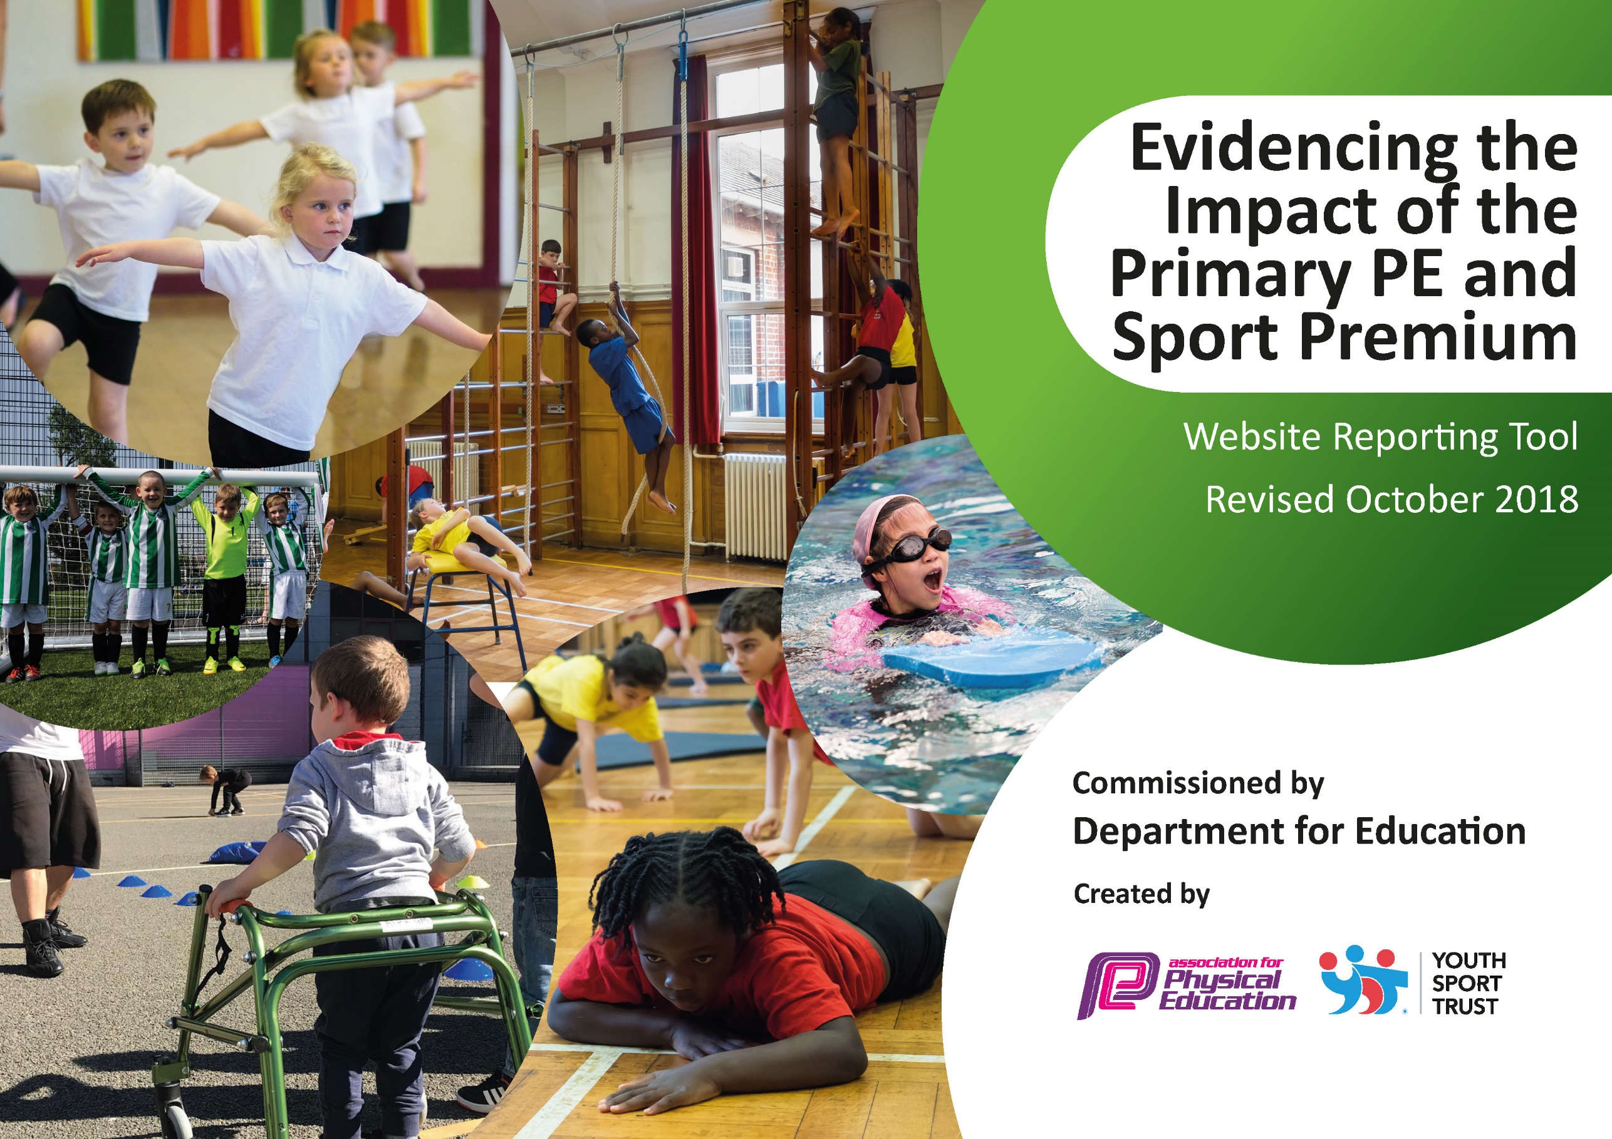
The Federation of Abbey Infant & Junior.

Review of PE Premium spend from 2018-19.

Planned spend of PE Premium 2019-20
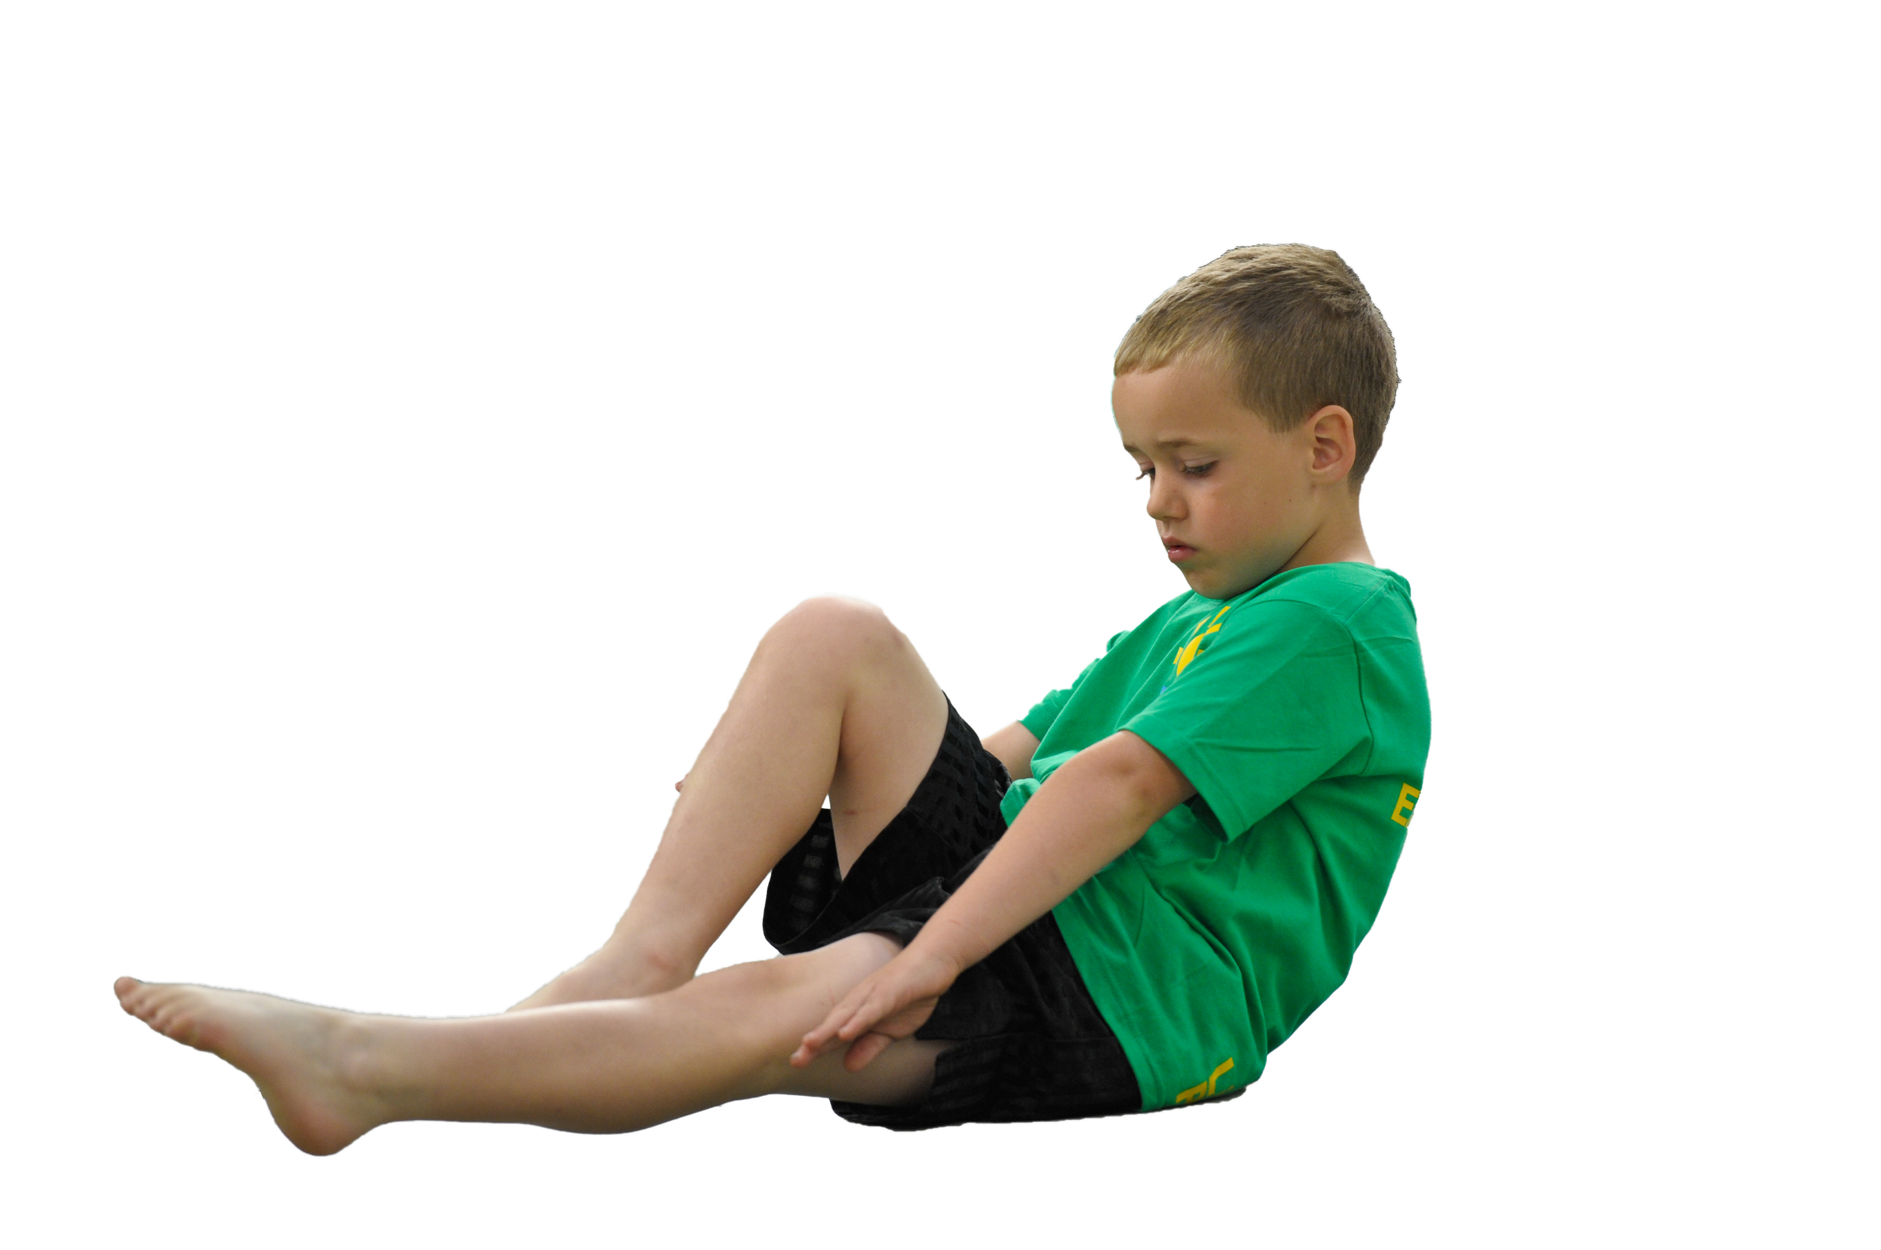
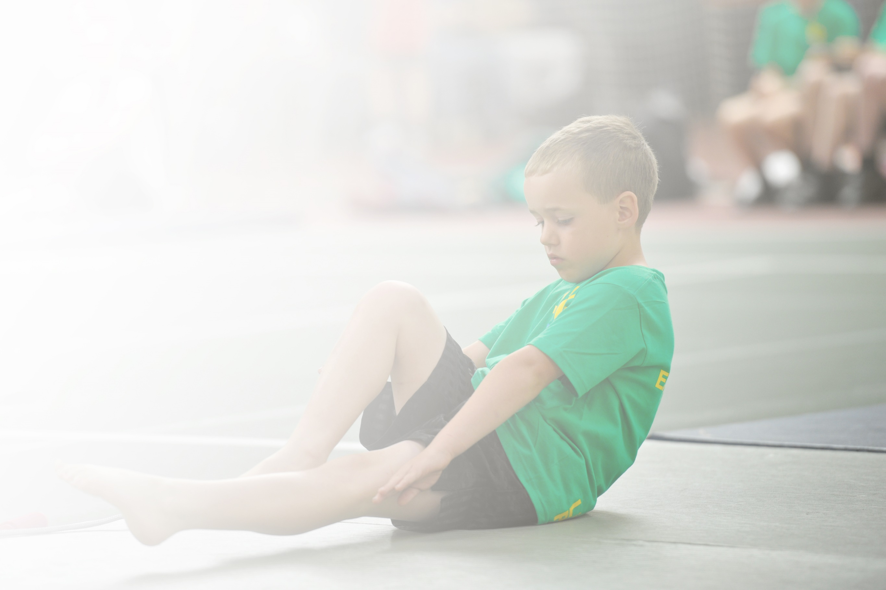
Schools must use the funding to make additional and sustainable improvements to the quality of Physical Education, Sport and Physical Activity (PESPA) they offer. This means that you should use the Primary PE and Sport Premium to:

- Develop or add to the PESPA activities that your school already offer
- Build capacity and capability within the school to ensure that improvements made now will benefit pupils joining the school in future years

Please visit gov.uk for the revised DfE guidance including the 5 key indicators across which schools should demonstrate an improvement. This document will help you to review your provision and to report
your spend. DfE encourages schools to use this template as an effective way of meeting the reporting requirements of the Primary PE and Sport Premium.

We recommend you start by reflecting on the impact of current provision and reviewing the previous
spend. Under the Ofsted Schools Inspection Framework, inspectors will assess how effectively leaders use the Primary PE and Sport Premium and measure its impact on outcomes for pupils, and how effectively governors hold them to account for this.

Schools are required to publish details of how they spend this funding as well as on the impact it has on pupils’ PE and sport participation and attainment by the end of the summer term or by 31 July 2019 at the
latest.
We recommend regularly updating the table and publishing it
on your website throughout the year, as evidence of your
ongoing review into how you are using the money to
secure maximum, sustainable impact. To see an
example of how to complete the table please
click HERE.

Support for review and reflection - considering the 5 key indicators from DfE, what development needs are a priority for your setting and your students now and why? Use the space below to reflect on previous spend, identify current need and priorities for the future.

Key achievements to date: | Areas for further improvement taken from the SIP 2019-20
OFSTED- The extra sports funding provided for primary schools has been spent well. All staff have been trained in teaching physical education, so the quality of teaching has improved. More pupils are taking up sport each year and many more now take part in competitive sport.  Subject leaders and teachers responsible for aspects of the school’s work play a good part in helping to move the school forward.  SIA - Pupils’ attitudes to learning are good and engagement is high. A strong pastoral team exists to support pupils’ specific needs. Outdoor learning in the Early Years is being encouraged partly through a Forest School curriculum which is exciting and engaging for all children. The outdoor area has been cleared and reorganised to allow children in the early years to fully explore the environment.  OTHER – The school has successfully been awarded the aFPE Mark – with distinction; The Sainsbury’s Gold Award; Black Country award for effective use of PE Premium x 2 | Develop a bank of non-core assessment material in the form of tasks and some ‘tests’ that inform staff use of assessment information to inform provision across subjects. | Tasks link directly to taught units. Tasks are not standalone ‘tests’ but are used as part of the learning journey to inform next-steps and summative assessment of learning.  In PE this will take the form of staff recognising acutely ‘what a good one looks like’ (WAGOLL), sometimes linked to the progression maps; others linked to the STEP principle.
 | Revise the agreed Abbey ‘steps to success’ to reflect the pedagogical changes made to 2018-19.  Ensure staff understanding about the menu of agreed practice and how/when it is appropriate to use these techniques across all subjects. | As part of directed time CPD, review with stakeholders. Draw upon self-review, current educational thinking and leaders’ vision and ambition for the school to ensure clarity and consistency of our agreed TLA systems and structures.  Ensure that all leaders drive the consistent message about how and when to choose from our agreed ‘steps to success’ to ensure good or better learning.  In PE this will look at ensuring active lessons focussed on developmental steps to overarching lesson/sequence of lesson objectives.
 | To ensure all non-core subjects have a clear progression of skills that embed the overarching aims of the National Curriculum | Subject leads to work collaboratively to revise the current curriculum provision for non-core subjects.  Subject leads to ensure the coverage of skills clearly matches the overarching aims of the National Curriculum.  Subject leads to deliver CPD for staff to ensure the progression of skills are clear and understood by all staff.  External providers to work with subject leads/phases with ideas for implementing progress of skills tailored to Abbey.
 | To improve the quality of teaching and learning across all subjects by ensuring all staff are clear about the learning journey. | Subject leaders to revise the current skills progression maps to ensure they meet the needs of our school and community and the overarching aims of the National Curriculum.  Subject leads to provide staff with CPD to enable a clear understanding of skills progression.  Staff to ensure the lesson sequence clearly builds upon prior learning by using the skills progression framework.  Staff to ensure planned activities match the skills progression, taking account of all learners but particularly the bottom 20%  Staff to ensure hook lesson/experience/ day take place at the start of a unit  Staff to plan for 2Simple assessment points.

Meeting national curriculum requirements for swimming and water safety | Please complete all of the below:
What percentage of your current Year 6 cohort swim competently, confidently and proficiently over a distance of at least 25 metres?  N.B. Even though your children may swim in another year please report on their attainment on leaving  primary school. | 69% (leavers 18-19)  73% (leavers 19-20)
What percentage of your current Year 6 cohort use a range of strokes effectively [for example, front crawl, backstroke and breaststroke]? | 52% (leavers 18-19)  66% (Leavers 19-20)
What percentage of your current Year 6 cohort perform safe self-rescue in different water-based situations? | 52% (leavers 18-19)  100% (leavers 19-20)
Schools can choose to use the Primary PE and Sport Premium to provide additional provision for swimming but this must be for activity over and above the national curriculum requirements. Have you used it in this way? | Yes – see plan below.

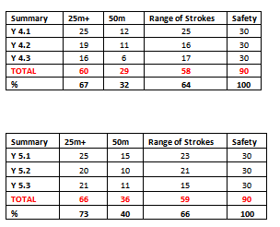
IMPACT

There is strong evidence of impact because of the proportion of pupils attaining the 25m NC aim. Additionally, the % of pupils who can swim 50m+ is good and improving.
Compared to the national figures for swimming (see below) – the school is stronger in all aspects.

This is good evidence that the spend on additional swimming time is working and effective.

Leaders will continue with this aspect into 2019-20.

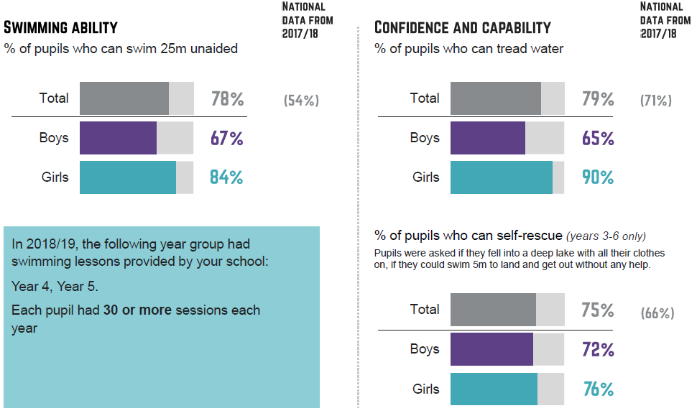
Note: Extract from ‘Active lives school report’ totals do not match the figures above because only one class from Y3-6 was sampled.

IMPACT STATEMENT OF 2018-19 SPEND
Academic Year: 2018/19 | Total fund allocated: KS1 £16,900; KS2 £19,640 | Date Updated: July 2019
Key indicator 1: The engagement of all pupils in regular physical activity – Chief Medical Officer guidelines recommend that primary school children undertake at least 30 minutes of physical activity a day in school |  |  |  | IMPACT
School focus with clarity on intended impact on pupils: | Actions to achieve: | Funding allocated: | Evidence and impact: | There is strong evidence of pupils having access to a range of sporting and active clubs right throughout the day. The tables on the LHS side show good take up within the school day and additionally 40% are taking up the option of an additional hour after school in KS2; 89% in KS1.  This is in addition to the in-school national curriculum PE and swimming where most year groups are having 2hours of PE a week too.  Leaders will continue this plan through 19-20 based on the success of 18-19.  One aspect for improvement will be the targeting of pupils. Whilst this has worked, the targeted ten have not consistently turned up. To extend the plan into 19-20, places will be sent automatically to parents, handles sensitively, for their children.
- support and involve the least active children by providing targeted activities, and running or extending school sports and holiday clubs  - introduce new sports, dance or other activities to encourage more pupils to take up sport and physical activities  The number of pupils who attend less than 1 club will be targeted to ensure that there is the opportunity for 100% of pupils to attend and therefore receive an additional 1 hour of physical activity through extra-curricular provision. | 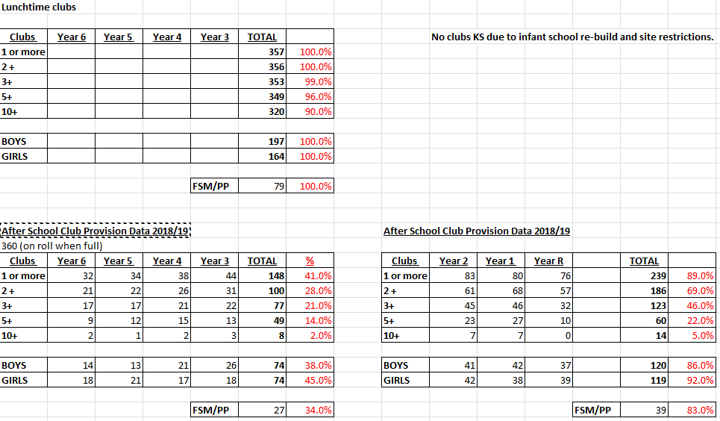
- support and involve the least active children by providing targeted activities, and running or extending school sports and holiday clubs

Ten targeted places for those who would benefit from the activity during the school break. These ten pupils would receive an additional 3 days of 5 hours physical activity through extra-curricular provision.
Key indicator 2: The profile of PE and sport being raised across the school as a tool for whole school improvement |  |  |  | Percentage of total allocation:
 |  |  |  | 0 %
School focus with clarity on intended impact on pupils: | Actions to achieve: | Funding allocated: | Evidence and impact: | Sustainability and suggested next steps:
The profile of PE is well established and as a result, resources do not need to be allocated in this year’s plan for this indicator. | 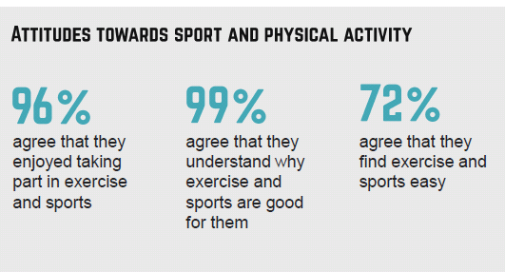 |  | Impact evidenced through the school’s self-review, subject reports and SIP. | IMPACT  There is strong evidence of impact because of the attitudes to sport that Abbey pupils hold, notably enjoyment in taking part and the understanding of the importance of this for a healthy life.  This is embedding future life skills and may well contribute to pupils’ mental health and attitudes to exercise as adults.  Additionally, the pupil perception of the their activity levels compared to the national data is strong across nearly all comparators.  This is another strong indicator of the school’s effectiveness in engaging pupils in positive sport.

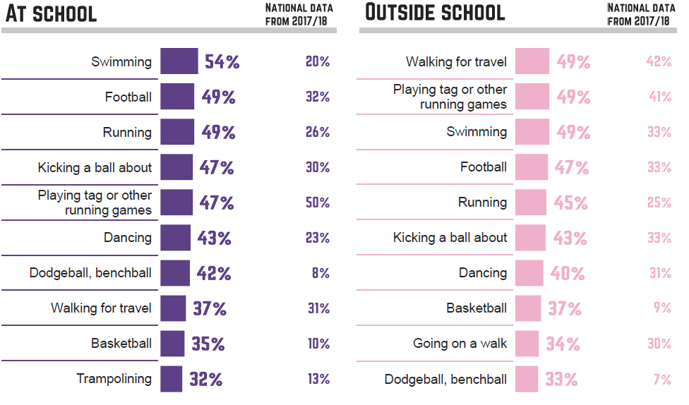

Key indicator 3: Increased confidence, knowledge and skills of all staff in teaching PE and sport |  |  |  | IMPACT
School focus with clarity on intended  impact on pupils: | Actions to achieve: | Funding  allocated: | Evidence and impact: | In addition to the staff impact statements, there is a good evidence of impact in terms of the proportion of pupils attaining ARE or above in PE. Sample YR PD, Y2 & Y6 assessment information in the middle column.  Due to the success of this aspect on outcomes, this will continue into 19-20.  Due to the impact of ‘fun-fit’ on EYFS outcomes, additional support though PE development officer and LSP will be deployed through 19-20 to catch pupils who fall behind with their gross-motor and core strength.
- Provide staff with professional development, mentoring, training and resources to help them teach PE and sport more effectively  90% of pupils reach ARE against the school’s curriculum; 20% reach AARE against the school’s curriculum.  90% of pupils make good or better progress against the school’s assessment system; 20% of pupils make better than expected progress against the school’s assessment system. | 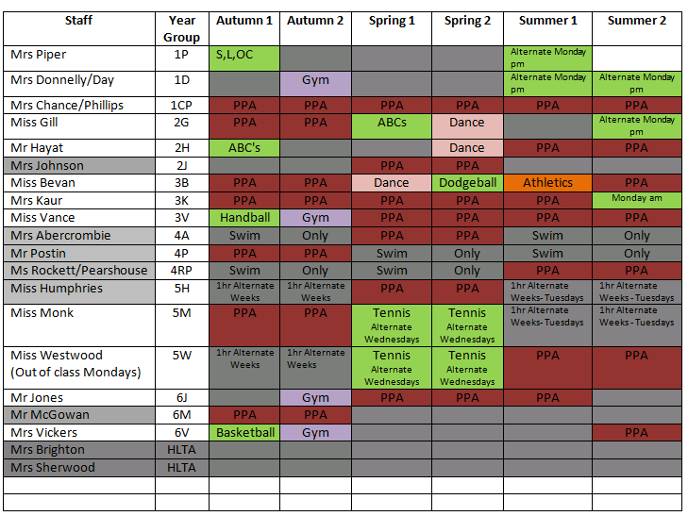  IMPACT  The table shows how the CPD has been shared across the school and for different aspects of PE.  Staff report (see CPD 2018-19 report)  - Increased confidence  - Improved knowledge of the STEP principle  - Link between INTENT & IMPLEMENTATION (seeing the plan in action)  - Increased subject knowledge – knowing WAGOLL  - Improved questioning by using key vocabulary  - Inclusion of soft skills – linked to head, heart hands.  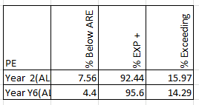  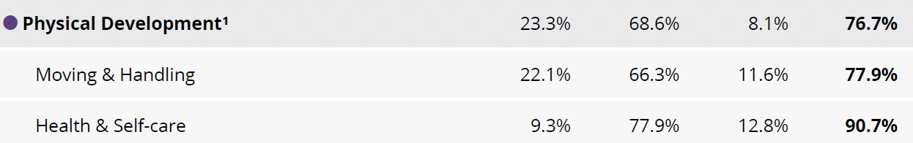
- provide staff with professional development, mentoring, training and resources to help them teach PE and sport more effectively

Key indicator 4: Broader experience of a range of sports and activities offered to all pupils |  | IMPACT
School focus with clarity on intended  impact on pupils: | See the impact as part of Indicator 1 above. | See the impact as part of Indicator 1 above.
- Continue to offer a wider range of activities both within and outside the curriculum in order to get more pupils involved.  - Focus particularly on those pupils who do not take up additional PE and Sport opportunities. | See the impact as part of Indicator 1 above.

Key indicator 5: Increased participation in competitive sport |  |  |  | IMPACT
School focus with clarity on intended  impact on pupils: | Actions to achieve: | Funding  allocated: | Evidence and impact: | External competitions are strong at KS2. There are few (1) opportunity for KS1 competition, Abbey attended.  Asa a result, a cluster wide competition of six local schools agreed to plan and host. Abbey completed theirs, others did not.  As a result, the new plan will place an increased emphasis on intra-school competition whilst still maintaining inter-school competition so that KS1 benefit more widely and wider numbers in KS2
- To introduce additional competitive sports identified by pupils in recent survey in order to engage more pupils.  - Engage more KS1 pupils in inter/intra school teams.  All pupils enter an annual sports day | 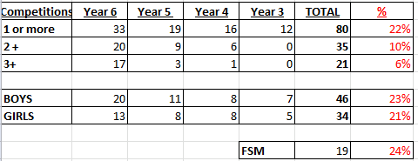
Additional factor identified by school. |  |  |  | IMPACT
- To ensure all existing swimmers increase their attainment by 10 metres thus increasing their confidence in water.  - All remaining non-swimmers achieve 25 metres thus meeting the statutory requirements of the national curriculum for PE.  - All pupils can perform safe self-rescue over a varied distance so they are confident and safe in water. | See Impact as above |  |  | See evidence above – strong impact – run again as a strategy to provide additional swimming time.

Action Plan and Budget Tracking
Capture your intended annual spend against the 5 key indicators. Clarify the success criteria and evidence of impact that you intend to measure to evaluate for students today and for the future.

 | Academic Year: 2019/20 |  | Total fund allocated: KS1 £16,900; KS2 £19,640 |  | Date Updated: July 2019
 | Key indicator 1: The engagement of all pupils in regular physical activity – Chief Medical Officer guidelines recommend that primary school children undertake at least 30 minutes of physical activity a day in school |  |  |  |  |  |  |  | Percentage of total allocation:
 |  |  |  |  |  |  |  |  | 4%
 | School focus with clarity on intended impact on pupils: |  | Actions to achieve: |  | Funding allocated: |  | Evidence and impact: |  | Sustainability and suggested next steps:
School focus with clarity on intended impact on pupils: |  | Actions to achieve: |  | Funding allocated: |  | Evidence and impact: |  | Sustainability and suggested next steps:
- support and involve the least active children by providing targeted activities, and running or extending school sports and holiday clubs  - introduce new sports, dance or other activities to encourage more pupils to take up sport and physical activities  The number of pupils who attend less than 1 club will be targeted to ensure that there is the opportunity for 100% of pupils to attend and therefore receive an additional 1 hour of physical activity through extra-curricular provision. |  | Targeted AH PE Afterschool session KS1  (10 weeks x 3 terms x 1 hour (21ph) £630 |  | Targeted AH PE Afterschool session KS2  (10 weeks x 3 terms x 1 hour (21ph) £630 |  | 20 pupils per club, per term to be targeted.  (At the end of reporting cycle, update the numbers who attended here)  (Report the range of clubs and attendance here) |  | This is an additional resource that is funded through the PE premium. At 4% of the total, should this funding be reduced then this aspect would be removed from school provision.
- support and involve the least active children by providing targeted activities, and running or extending school sports and holiday clubs  Ten targeted places for those who would benefit from the activity during the school break. These ten pupils would receive an additional 3 days of 5 hours physical activity through extra-curricular provision. |  | Free places at Sports Camp to target those at risk of becoming, or remaining, obese in Y1/2  10 places x £10 per day x 10 days £1000  Additional from 18-19 review – target formal invitation to families using the school’s FSW as liaison. |  | £1000 |  | 10 places per holiday scheme to be targeted.  (At the end of reporting cycle, update the numbers who attended here)  (Report the range of activities undertaken and attendance at the holiday club) |  | This is an additional resource that is funded through the PE premium. At 4% of the total, should this funding be reduced then this aspect would be removed from school provision.
 | Key indicator 2: The profile of PESSPA being raised across the school as a tool for whole school improvement |  |  |  |  |  |  |  | Percentage of total allocation:
 |  |  |  |  |  |  |  |  | 0%
 | School focus with clarity on intended impact on pupils: |  | Actions to achieve: |  | Funding allocated: |  | Evidence and impact: |  | Sustainability and suggested next steps:
 | The profile of PE is well established and as a result, resources do not need to be allocated in this year’s plan for this indicator. |  | N/A |  |  |  | Impact evidenced through the school’s self-review, subject reports and SIP.

 |  |  | Key indicator 3: Increased confidence, knowledge and skills of all staff in teaching PE and sport |  |  |  |  |  |  |  |  |  |  |  | Percentage of total allocation:
 |  |  |  |  |  |  |  |  |  |  |  |  |  |  | 63%
 |  |  | School focus with clarity on intended  impact on pupils: |  |  | Actions to achieve: |  |  | Funding  allocated: |  |  | Evidence and impact: |  |  | Sustainability and suggested  next steps:
 | - Provide staff with professional development, mentoring, training and resources to help them teach PE and sport more effectively  90% of pupils reach ARE against the school’s curriculum; 20% reach AARE against the school’s curriculum.  90% of pupils make good or better progress against the school’s assessment system; 20% of pupils make better than expected progress against the school’s assessment system. |  |  |  | Timetabled dedicated PE CPD day including vacant hall use to facilitate team teach, modelling, demonstrating, CPD.  Impact report on the range of CPD received each term |  |  | CPD (50% of AH 1 day per week) £5320 KS1; 50% of AH 1 day per week £5320 KS2.  External CPD £1815 |  |  | - Subject leader more confident when undertaking lesson observations/team teaching - able to provide effective feedback and lead discussions.  WIDER IMPACT AS A RESULT OF ABOVE  Skills, knowledge and understanding of pupils are increased significantly - see note about end of key stage attainment targets  Pupils really enjoy PE and Sport, are very keen to take part and demonstrate a real desire to learn and improve  (Update this at the end of the cycle with the in-house attainment and achievement information) |  |  | - This will lead to sustainability as all staff will be supported to feel confident to deliver PE and Sport both within and outside the curriculum.
 | - provide staff with professional development, mentoring, training and resources to help them teach PE and sport more effectively  - Additional staffing (outcome from 2018-19 review) to catch those who do not meet the fun-fit/core strength objectives |  |  |  | Fun-fit EYFS PE programme and bespoke 1:1 and small group catch-up to develop core strength and cross lateral movement.  EYFS outcomes for PD remain at national |  |  | Fun Fit (50% of KS 1 day per week) £4030; 50% of KS1 1 day per week KS2 £4030)  Fun-fit AH ½ day £2660 |  |  | Those with SEND make good progress from starting points  Core strength impacts upon gross and fine motor control; this impacts upon handwriting and proportion of pupils reaching ARE at EYFS, KS1 and KS2. |  |  | This will lead to sustainability as all staff will be supported to feel confident to deliver this programme through the coaching and mentoring process.
 |  |  | Key indicator 4: Broader experience of a range of sports and activities offered to all pupils |  |  |  |  |  |  |  |  |  |  |  | Percentage of total allocation:
 |  |  |  |  |  |  |  |  |  |  |  |  |  |  | 5%
 |  |  | School focus with clarity on intended  impact on pupils: |  |  | Actions to achieve: |  |  | Funding  allocated: |  |  | Evidence and impact: |  |  | Sustainability and suggested  next steps:
- Continue to offer a wider range of activities both within and outside the curriculum in order to get more pupils involved.  - Focus particularly on those pupils who do not take up additional PE and Sport opportunities. |  |  |  | - Arrange a pupil survey to ascertain what pupils would like.  - Involve external coaches to work with staff in clubs. |  |  | Friday PM additional sport  (50% of £65 per day x 30 weeks) £975  Friday PM additional sport  (50% of £65 per day x 30 weeks) £975 |  |  | 90% of pupils say they enjoy PE and Sport and want to get involved in more activities.  Range of clubs supports all ages and stages to ensure an effective mix to engage all  (At the end of the reporting cycle add detail of the number of clubs and attendances by key-stage and gender) |  |  | This is an additional resource that is funded through the PE premium. At 4% of the total, should this funding be reduced then this aspect would be removed from school provision.  School will continue to offer (paid) sports coaches to deliver a wide range of activities as our school community desire this facility.
 |  | Key indicator 5: Increased participation in competitive sport |  |  |  |  |  |  |  |  |  |  |  |  | Percentage of total allocation:
 |  |  |  |  |  |  |  |  |  |  |  |  |  |  | 15%
 |  | School focus with clarity on intended  impact on pupils: |  |  |  | Actions to achieve: |  |  | Funding  allocated: |  |  | Evidence and impact: |  |  | Sustainability and suggested  next steps:
- To introduce additional competitive sports identified by pupils in recent survey in order to engage more pupils.  - Engage more KS1 pupils in inter/intra school teams.  - Engage more KS2 pupils in inter/intra school teams.  All pupils enter an annual sports day; intra-school medals & certificates |  |  |  | - Arrange friendly competition - inter/intra school - use the local sport partnership Sainsbuty’s Games & intra-comp.  Abbey co-ordinate 6 x KS1 intra- sport competition days per academic year.  Abbey co-ordinate 6 x KS2 intra- sport competition days per academic year.  Competition medals, certificates and swimming certificates and badges (see additional factor) |  |  | £2000  1 per half term (twelve days cover for AH)  Mini-bus costs inc. driver  Competition and cover costs  = £2148  £1250 |  |  | All KS1 & KS2 pupils have the opportunity to compete in at least one competition per academic year.  (At the end of the reporting cycle add detail of the number of competitions and attendances by key-stage and gender)  All pupils compete in an intra-school sports day. |  |  | - Member of staff to take charge of the competitive sport co-ordination across Abbey.
Additional factor identified by school. |  |  |  |  |  |  |  |  |  |  |  |  | Percentage of total spend 19%
- To ensure all existing swimmers increase their attainment by 10 metres thus increasing their confidence in water.  - 85% achieve 25 metres thus meeting the statutory requirements of the national curriculum for PE (increase of 20% on 18-19)  - All pupils can perform safe self-rescue over a varied distance so they are confident and safe in water. |  |  |  | - Renegotiate additional pool time at another primary school to increase the swimming time in water by 50%.  - To utilise the coach based at the swimming pool to work alongside teachers. |  |  | £7000 |  |  | -  - 85% of pupils can swim 25 metres at year 6.  - 100% of pupils can perform safe self-rescue.  (At the end of the reporting cycle add detail of the number of pupils who have met the end of key-stage swimming expectation) |  |  | - The Governors have agreed to ensure that they will ring fence funding to ensure the maximum amount of pupils leave the school being able to swim 25 metres.  - Where appropriate, SEND funding will be allocated to non- swimmers.  - The teachers will work together to ensure all staff involved are confident and competent to support the acquisition of skills.

Funding breakdown PE Premium
What can the money be spent on? | KS1 £16,900 | KS2 £19,640
- provide staff with professional development, mentoring, training and resources to help them teach PE and sport more effectively | CPD (50% of AH 1 day per week) £5320 | CPD (50% of AH 1 day per week) £5320
- provide staff with professional development, mentoring, training and resources to help them teach PE and sport more effectively | Fun Fit/EYFS PE Programme (50% of KS 1 day per week) £4030  ½ day AH £2660 | Fun Fit (50% of KS 1 day per week) £4030
- enter or run more sport competitions | Competitive sport external competition (Sainsbury’s) and intra-school £1000 | Competitive sport external competition (Sainsbury’s) and intra-school £1000
provide staff with professional development | AFPE Membership (50%) £487.50 | AFPE Membership (50%) £487.50
provide staff with professional development | Dance Desk (50%) professional membership £0 – covered as part of AFPE | Dance Desk (50%) professional membership £0 – covered as part of AFPE
- provide additional swimming provision targeted to pupils not able to meet the swimming requirements of the national curriculum | N/A | 35% additional swimming time utilising a local school’s pool  £7000
- hire qualified sports coaches to work with teachers to enhance or extend current opportunities | Friday PM additional sport  (50% of £65 per day x 30 weeks) £975 | Friday PM additional sport  (50% of £65 per day x 30 weeks) £975
- support and involve the least active children by providing targeted activities, and running or extending school sports and holiday clubs  - introduce new sports, dance or other activities to encourage more pupils to take up sport and physical activities | Targeted AH PE Afterschool session KS1  (10 weeks x 3 terms x 1 hour (21ph) £630 | Targeted AH PE Afterschool session KS2  (10 weeks x 3 terms x 1 hour (21ph) £630
- support and involve the least active children by providing targeted activities, and running or extending school sports and holiday clubs | Free places at Sports Camp to target those at risk of becoming, or remaining, obese in Y1/2  10 places x £10 per day x 10 days £1000 | N/A
- Raise KS1 & 2 competitive sport by organising and running dedicated intra-school competition and using external networks (where appropriate) e.g. Sainsbury | 1 per half term (12 days cover for AH) £2148  Mini-bus costs inc. driver £1000  Medals, certificates, swimming certificates and badges £1250
- Cover costs for staff to attend CPD | AH x 3 days per year  2 x teachers x 2 days per year  £1155  £ 19655 costs against a grant of £16897.  Therefore spend of 116% | 2 x teachers x 2 days per year  £660  £20102.5 against a grant of £19,917  Therefore spend of 101%

