
The funding has been provided to ensure impact against the following OBJECTIVE:
To achieve self-sustaining improvement in the quality of PE and sport in primary schools. It is important to emphasise that the focus of spending must lead to long lasting impact against the vision (above) that will live on well beyond the Primary PE and Sport Premium funding.
It is expected that schools will see an improvement against the following 5 key indicators:
Department for Education Vision for the Primary PE and Sport Premium
ALL pupils leaving primary school physically literate and with the knowledge, skills and motivation necessary to equip them for a healthy, active lifestyle and lifelong participation in physical activity and sport.
Evidencing the Impact of Primary PE and Sport Premium
-Guidance & Template-
- the engagement of all pupils in regular physical activity – kick-starting healthy active lifestyles
- the profile of PE and sport being raised across the school as a tool for whole school improvement
- increased confidence, knowledge and skills of all staff in teaching PE and sport
- broader experience of a range of sports and activities offered to all pupils
- increased participation in competitive sport
It is a statutory requirement of Ofsted, under their Common Inspection Framework, to ensure that information on the use of the Primary PE and Sport Premium is available on your school website. One of the key purposes of putting information on the school website is to keep parents informed, so this information should be written in a format that is clear and easily accessible. We recommend that you upload the following template to your website to serve that purpose.
Developed by  

Primary Physical Education and Sport premium planning and actions should show how use of funding contributes to this vision through identified school priorities which can be measured through reference to key outcome indicators. It is important that the main drivers for improvement are those identified by the school through their self-review. Each school should aim to achieve the following objective:
OBJECTIVE: To achieve self-sustaining improvement in the quality of PE and sport in primary schools.
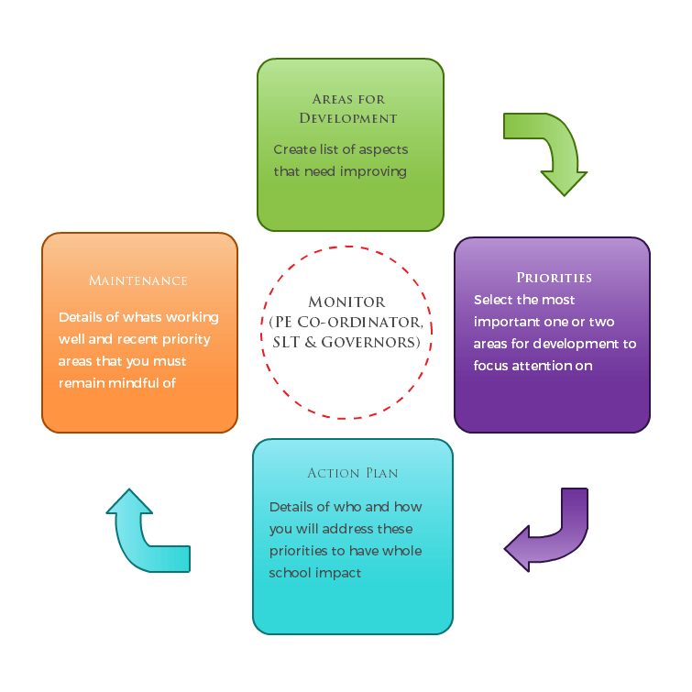
Please see Figure 1 (below): A process model to support your thinking:

DEPARTMENT FOR EDUCATION GUIDANCE ON HOW TO USE THE PRIMARY PE AND SPORT PREMIUM
Schools must use the funding to make additional and sustainable improvements to the quality of PE and sport they offer. This means that you should use the premium to:
- develop or add to the PE and sport activities that your school already offers
- make improvements now that will benefit pupils joining the school in future years
For example, you can use your funding to:
- hire qualified sports coaches to work with teachers
- provide existing staff with training or resources to help them teach PE and sport more effectively
- introduce new sports or activities and encourage more pupils to take up sport
- support and involve the least active children by running or extending school sports clubs, holiday clubs and Change4Life clubs
- run sport competitions
- increase pupils’ participation in the School Games
- run sports activities with other schools
You should not use your funding to:
- employ coaches or specialist teachers to cover planning preparation and assessment (PPA) arrangements - these should come out of your core staffing budgets
- teach the minimum requirements of the national curriculum – including those specified for swimming.

SECTION 1 – EVALUATION OF IMPACT/LEARNING TO DATE
In previous years, have you completed a self-review of PE, physical activity and school sport? Yes
Have you completed a PE, physical activity and sport action plan/ plan for the Primary PE and Sport Premium spend? Yes
Is PE, physical activity and sport, reflective of your school development plan? Yes
Are your PE and sport premium spend and priorities included on your school website? Yes

Clubs | Year 2 | Year 1 | TOTAL | %
1 or more | 58 | 48 | 106 | 59%
2 + | 42 | 36 | 78 | 43%
3+ | 34 | 31 | 65 | 36%
5+ | 17 | 19 | 36 | 20%
10+ | 1 | 4 | 5 | 3%

Extended Schools Provision DATA 2014/15
360 (on roll when full)
Clubs | Year 6 | Year 5 | Year 4 | Year 3 | TOTAL | %
1 or more | 80 | 84 | 84 | 83 | 331 | 92.0%
2 + | 74 | 83 | 80 | 82 | 319 | 89.0%
3+ | 72 | 82 | 76 | 80 | 310 | 86.0%
5+ | 61 | 77 | 66 | 77 | 281 | 78.0%
10+ | 38 | 44 | 24 | 69 | 175 | 49.0%
BOYS | 38 | 37 | 35 | 44 | 154 | 92.0% | /168
GIRLS | 42 | 47 | 49 | 39 | 177 | 94.0% | /188
 |  |  |  | FSM | 44 | 88.0% | /50
Competitive School Sport DATA 2014/15
360 (on roll when full)
Competitions | Year 6 | Year 5 | Year 4 | Year 3 | TOTAL | %
1 or more | 57 | 40 | 22 | 19 | 123 | 34%
2 + | 32 | 19 | 13 | 10 | 74 | 19%
3+ | 17 | 10 | 6 | 2 | 35 | 8%
BOYS | 32 | 17 | 10 | 11 | 70 | 42%
GIRLS | 25 | 23 | 12 | 8 | 68 | 36%
 |  |  |  | FSM | 18 | 36%
Sports Camp DATA 2014/15
540 (on roll when full KS1&2)
Clubs | Year 6 | Year 5 | Year 4 | Year 3 | Year 2 | Year 1 | TOTAL | %
1 or more | 6 | 18 | 4 | 18 | 19 | 10 | 75 | 14%
2 + | 5 | 14 | 1 | 9 | 10 | 5 | 44 | 8%
3+ | 3 | 11 | 1 | 6 | 7 | 2 | 30 | 6%
BOYS | 5 | 11 | 3 | 13 | 10 | 7 | 49 | 19% | /262
GIRLS | 1 | 7 | 1 | 5 | 9 | 3 | 26 | 10% | /275

Use the space below to identify what your use of the Primary PE and Sport Premium has been to date, and priorities for the coming year:
Key priorities to date: | Key achievements/What worked well: | Key Learning/What will change next year:
- Staff Professional Learning (PL) to be put in place to improve subject knowledge and confidence.  - Target groups of children to increase participation  - Increase Competition opportunity for KS1  - Develop Inclusive planning resources/Equipment  - Utilise PL opportunities provided from memberships  - Monitor and review how PESS impacts on attendance and academic achievement | Subject lead working alongside staff to up-skill and improve confidence. This is working well staff are increasingly confident in a range of activities which has a positive impact on the children's learning. The standard of teaching is becoming more consistent and children are enjoying all of their PE lessons irrespective of who is teaching be it the class teacher or subject lead.  Participation is steadily increasing year on year. We have an excellent monitoring system that allows us to highlight key groups of children. We have targeted the least active children in a Change4Life festival in September 15 and think that this will increase their participation in extra-curricular activity.  KS1 pupils entered Dance, Multi Skills and Football competitions in 2014/15. It is great to see them getting involved in competition and would like to continue to increase this.  Inclusive equipment has been purchased and we now have a wide range of equipment that is used to differentiate in PE lessons and is used specifically in interventions such as FUNFIT.  Subject Lead continually supported and up-skilled. This is working very well as it enables them to continuously pass on further knowledge to wider staff.  Interventions such as FUNFIT are well to improve pupils fine/gross motor skills, with the specific aim of improving academic achievement in handwriting. | Yes. The Impact of this ensures sustainability beyond the funding. Maintaining high quality teaching and learning for our pupils.  Gain the AFPE Mark.  Yes. Being able to successfully monitor participation allows us to target and engage the least active children. We aim to inspire all pupils to lead healthy active life styles and this is an important tool in achieving that.  Yes. Competitive sport is an excellent way of instilling British Values such as respect, tolerance, and fair play at an early age. Using sport to inspire, enthuse and educate children at Abbey to collaborate and compete as part of a team.  Yes. Inclusive equipment is a fantastic way of engaging All pupils in PE and provides a wide variety of ways to differentiate tasks.  Yes. CPD is crucial to ensuring sustainability. Utilising memberships with YST, NDTA, afPE and Dancedesk are invaluable for providing CPD opportunities.  Yes. Children have the opportunity to 'close the gap' in their development by improving their motor skills. This is having significant impact on their handwriting.

SECTION 2 – REFLECTION: WHAT HAVE WE ACHIEVED AND WHERE NEXT? 2015/ 2016

Vision: ALL pupils leaving primary school physically literate and with the knowledge, skills and motivation necessary to equip them for a healthy, active lifestyle and lifelong participation in physical activity and sport.
Objective: To achieve self-sustaining improvement in the quality of PE and sport in primary schools against 5 key indicators:
- the engagement of all pupils in regular physical activity – kick-starting healthy active lifestyles
- the profile of PE and sport being raised across the school as a tool for whole school improvement
- increased confidence, knowledge and skills of all staff in teaching PE and sport
- broader experience of a range of sports and activities offered to all pupils
- increased participation in competitive sport

SECTION 3 – PLANNING YOUR PROVISION AND BUDGET FOR THE COMING YEAR
Use the template below to plan how you intend on spending your Primary PE and Sport Premium funding this academic year, to include which of the 5 key indicators that priority relates to. The greyed out boxes allow you to re-visit this section later in the year to review and plan next steps.

Step by step guidance notes to support completion of the template to achieve self-sustaining improvement in the quality of PE and sport in primary schools:
Step 1: Confirm the total fund allocated
Step 2: Review activities and impact to date either using the template you used last year or the space provided at the top of the template
Step 3: Confirm your priorities in terms of impact on pupils and enter into column B to detail your school focus (e.g. improved the quality of children’s physical literacy at key stage 1)
Step 4: Cross reference these with the 5 key indicators for the Primary PE and Sport Premium by selecting the aspect(s) that this relates to (e.g. increased confidence, knowledge and skills of all staff in teaching PE and sport) and select these from the drop down menu in column A
Step 5: Complete column C to outline key actions to achieve these outcomes (e.g. whole staff training)
Step 6: Complete column D to detail funding allocated to this priority (e.g. £100)
Step 7: Complete column F to show how you plan to evidence the impact of this spend on young people
Step 8: Identify when you will revisit this template to update with actual spend, impact and sustainability next steps (greyed out columns E, G & H)
Step 9: The greyed out columns will be useful when reviewing your school’s spend later in the year to confirm actual spend and impact to support further plans for the future and sustainability.
Academic Year:  2015/2016 |  | Total fund allocated:  £18,000
PE and Sport Premium Key Outcome Indicator | School Focus/ planned Impact on pupils | Actions to Achieve | Planned Funding | Actual Funding | Evidence | Actual Impact (following Review) on pupils | Sustainability/  Next Steps
1. the engagement of all pupils in regular physical activity – kick-starting healthy active lifestyles | - Increase participation in extra-curricular activity.(Healthy Active Lifestyles)  - Pupils enjoy a broad range of sports activities | - Target specific groups to increase participation e.g. least active  - Pupil voice/School Council | 1500 |  | - Extra curricular data sheet.
2. the profile of PE and sport being raised across the school as a tool for whole school improvement | - Pupils are highly motivated to achieve their best  - Behaviour across school is excellent  - Pupil's handwriting is improved | - Achievement is celebrated weekly in whole school assembly.  - Sports Team selections are dependent upon class work and behaviour  - FUNFIT intervention for targeted children | 500 |  | - Extra-curricular data sheet  - Funfit assessment folder

continued…
3. increased confidence, knowledge and skills of all staff in teaching PE and sport | - Staff are confident in teaching a range of activities in PE  - Pupil look forward to and enjoy making progress in all PE lessons | - Internal CPD from subject lead  - External CPD opportunities  - Subject leader CPD | 2000 |  | - Lesson Observation  - CPD Record
4. broader experience of a range of sports and activities offered to all pupils | - Pupils enjoy a broad range of new and traditional sports | - Pupil voice/School council gauge interest in new sports  - Abbey Bucket list  - Use a variety of quality providers | 10,500 |  | - Extra curricular Data Sheet  - Curriculum Long term plan
5. increased participation in competitive sport | - Pupils are highly motivated to lead a healthy active lifestyle  - Behaviour is excellent  - Profile of PE&SS is raised | - Attend Sainsbury School Game competitions  - Access competitive sport through local partnerships | 2500 |  | - Competition calendar and data sheet

After every update, please remember to upload the latest version to your website.

Completed by: R Kentish & A Hinton
Date: 01/09/2015
Developed by
Supported by

Review Date: 01/09/2016

