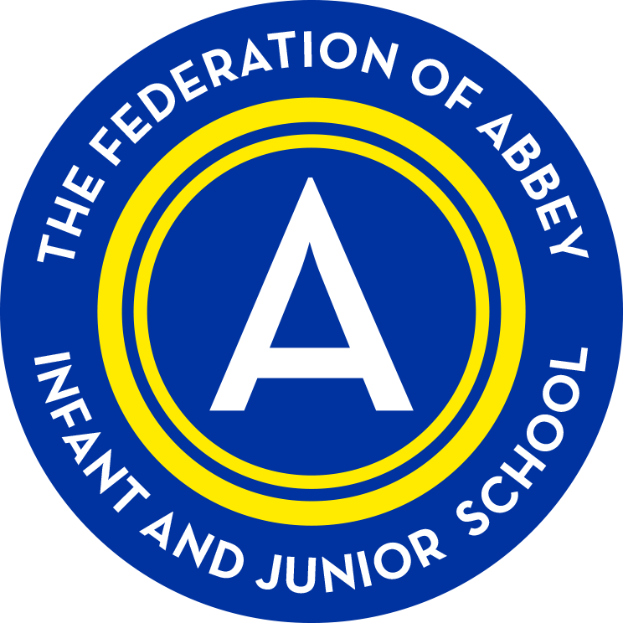
The Federation of Abbey Infant and Junior School.
Pupil Premium Grant Expenditure review.
Plan to Parents and Governors 2015-16.
Overview of the school
Number of pupils and Pupil Premium Grant (PPG) received
Total pupils on roll | 335 (inf) + 359 (Jun)
Total number eligible for PPG | 54 (inf) + 106 (Jun)
Total amount received | £65,840 + £125,240

Nature of support 2015/16
The funding for the Pupil Premium has been allocated in the following ways:

Increase teaching assistant support to develop and run interventions across the school in phonics, reading, mathematics and other wave 2 & 3 interventions.

Support the targeting of a group of KS1 & KS2 pupils.

Curriculum focus of PPG spending 2015-16
Following an analysis of the impact of interventions during the preceding year the school has focussed its additional support on increasing the range of withdrawal interventions used to support children e.g. through the introduction of Catch-up Maths, Better Reading Partners, 5 minute boxes, enable plus and more.

School has increased support for phonics and guided reading from learning support practitioners through providing a greater level of differentiation for these sessions.

School has increased support for targeting groups to accelerate progress from learning support practitioners through providing a greater level of differentiation for these sessions.
Pupil Premium Strategy | Rationale
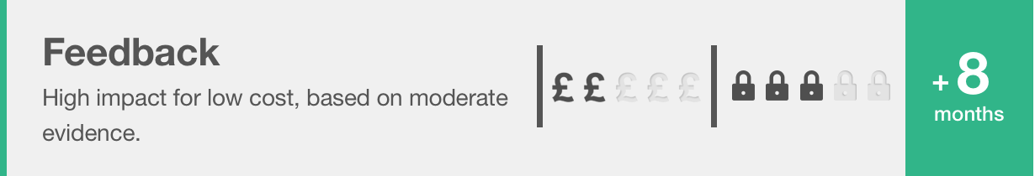 | In general, research-based approaches which explicitly aim to provide feedback to learners, such as Bloom’s ‘mastery learning’, also tend to have a positive impact. Feedback has effects on all types of learning across all age groups. Research in schools has focused particularly on English, mathematics and, to a lesser extent, science.  At Abbey this appears through the application of our developmental marking and feedback policy and predominately appears in English and Mathematics.
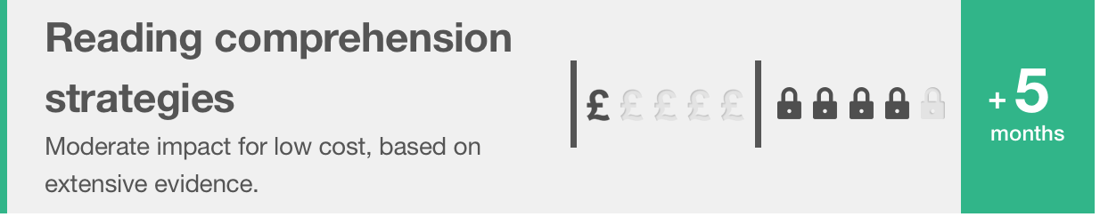 | Comparative findings indicate that, on average, reading comprehension approaches appear to be more effective than phonics or oral language approaches for upper primary and secondary pupils, both in terms of short-term and long-term impact.  At Abbey this appears through the use and application of the ‘Catch up Reading’ and ‘Better Reading Partners’ (BRP) programmes.
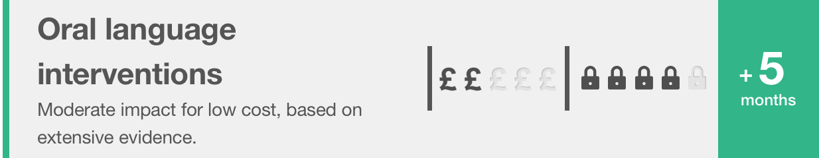 | There is consistent evidence supporting reading to young children and encouraging them to answer questions and to talk about the story with a trained adult. Conversely, ‘whole language’ approaches, which focus on meaning and personal understanding, do not appear to be as successful as those involving more interactive and dialogic activities. A number of studies show the benefits of trained teaching assistants effectively supporting both oral language skills and reading outcomes.  In addition, for all oral language interventions certain factors are associated with higher learning gains, suggesting that careful implementation is important. Approaches which explicitly aim to develop spoken vocabulary work best when they are related to current content being studied in school and when they involve active use of any new vocabulary.  At Abbey this appears through the use of Welcomme Language Screening, ELKLAN and Talk for Writing along with an embedded use of effective talking strategies through the curriculum and SALT programmes.
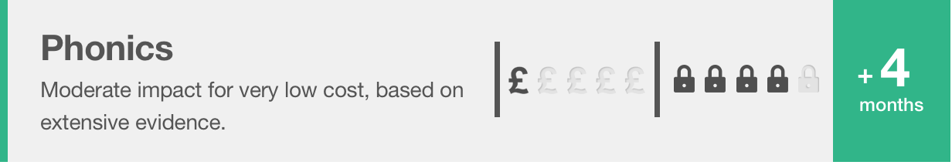 | Phonics approaches have been consistently found to be effective in supporting younger readers to master the basics of reading, with an average impact of an additional four months’ progress. Research suggests that phonics is beneficial for younger learners (4-7 year olds) as they begin to read. Teaching phonics is more effective on average than other approaches to early reading (such as whole language or alphabetic approaches), though it should be emphasised that effective phonics techniques are usually embedded in a rich literacy environment for early readers and are only one part of a successful literacy strategy.  At Abbey this can be seen through the systematic teaching of phonics until mastery.
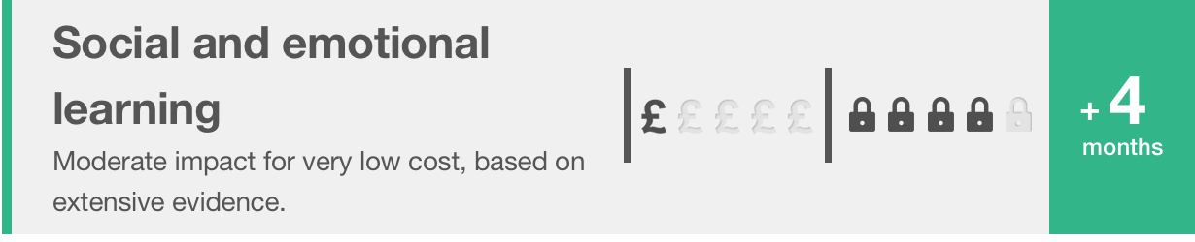 | Three broad categories of interventions can be identified: 1. Universal programmes which seek to improve behaviour and generally take place in the classroom; 2. More specialised programmes which are targeted at students with either behavioural issues or behaviour and academic problems; 3. School level approaches to developing a positive school ethos or improving discipline which also aim to support greater engagement in learning.  At Abbey this can be seen through the consistent application of the behaviour management strategy, individualised programmes supported by Inclusion Support and the pastoral team in ‘The Zone’ and ‘The Rainbow room’. Further examples to be seen include ‘Fun Fit’, ‘Write Dance’, ‘Chirpy and bounce’, ‘Music intervention’.

Review of impact:

Note: The 2015-16 Key stage tests are not directly comparable to the old national curriculum levels and at the time of publishing – not all national data is available and this will be amended once un-validated ROL is published.
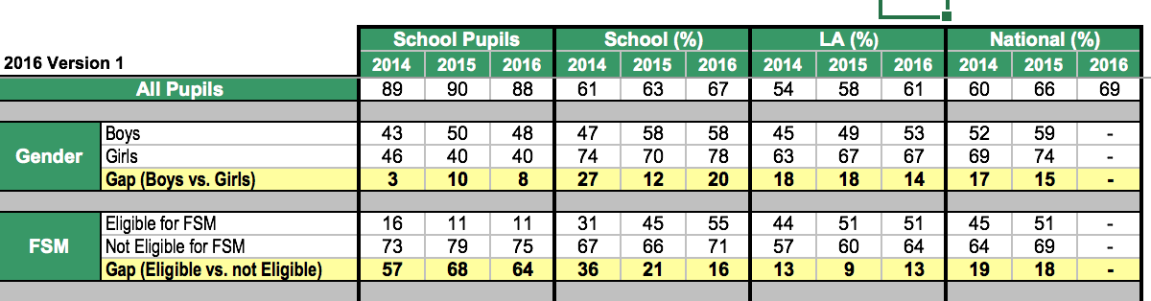
EYFS: Strongly rising attainment of FSM pupils, gap has narrowed by 20% over two years of new leadership team. Stronger rate of improvement than the national PP group.
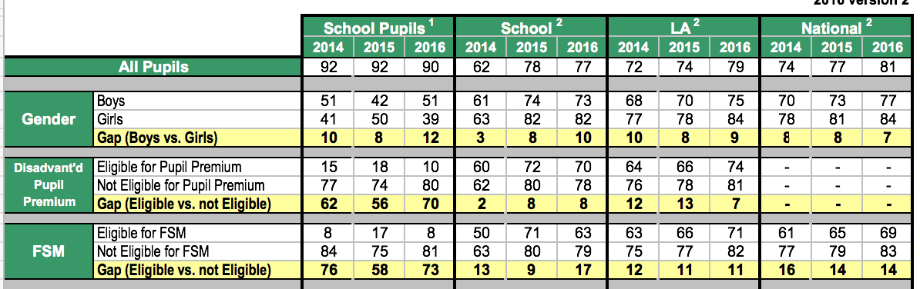
Y1 Phonics – 10% rise in proportion making the Y1 phonic screen over two years. Gap still remains and school is addressing in PP plan for 2016-17.
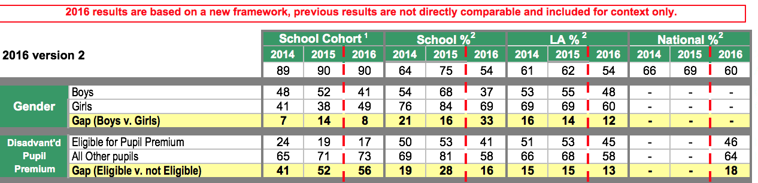
KS1 R&WR&MA – PP attaining broadly as well as the national PP. Gap still remains and school is addressing through targeted support in the PP plan 2016-17 and provision mapping.
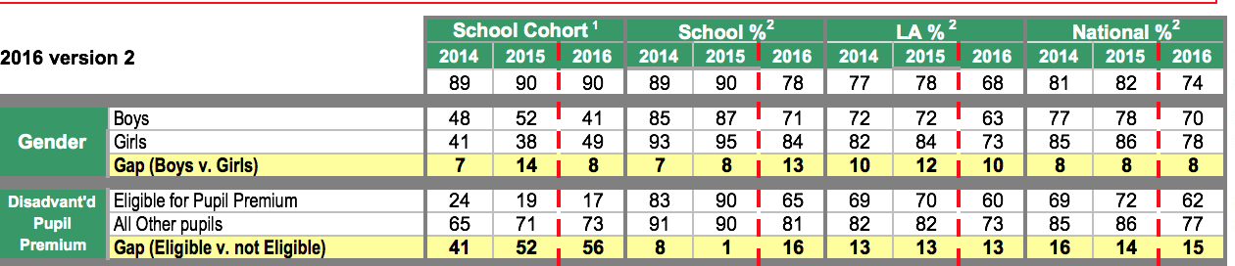
KS1 Reading – PP above LA & National groups. Historical trend very similar performance to in-school and above national non-PP. Suggests effective use of spend for Reading – one year’s data makes the 2016 performance difficult to assess. Importantly the more-able PP are doing as well as the national non-PP
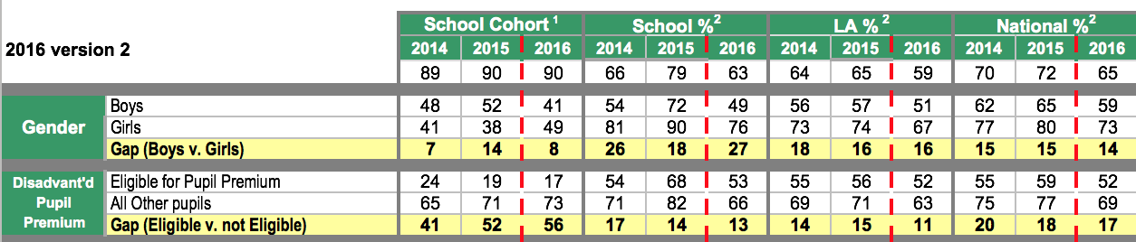
KS1 Writing – historical diminishing difference14-15 including a stronger rate of improvement than the national non-PP group. Suggests effective use of spend for wiring – one year’s data makes the 2016 performance difficult to assess. The more-able PP have attained as well as the national PP group and there is less of a difference between the Abbey more-able PP and national non-PP/national PP.
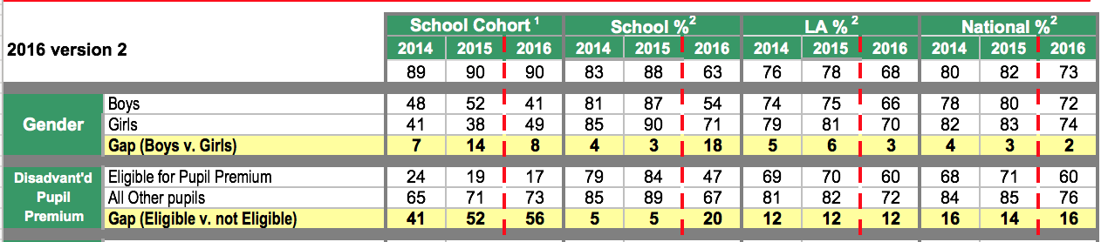
KS1 Maths – Historical diminishing difference in 14 and 15. A gap has appeared with the PP group against national PP and national non-PP. Gap still remains and school is addressing through targeted support in the PP plan 2016-17 and provision mapping. The more-able PP have out-performed the national PP and the gap is less between the national PP and non-PP national group.
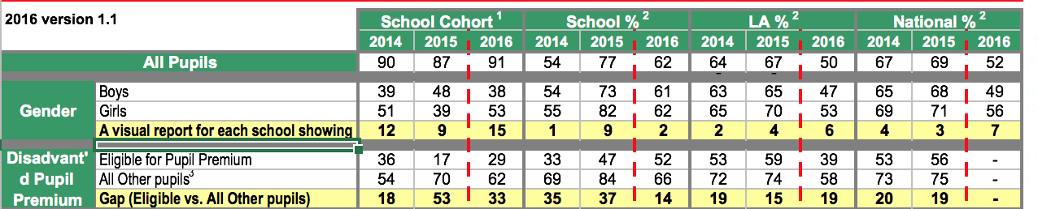
KS2 R&WR&Ma – strong upward trend of diminishing the differences, this needs to continue into 2016-17.
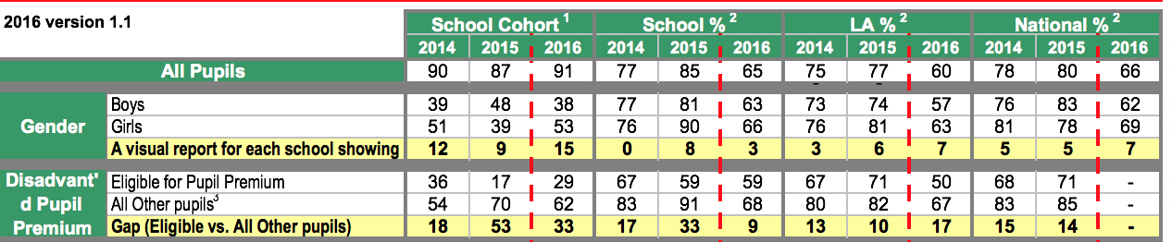
KS2 Reading – 2016 data shows a much reduced gap in-school. National data not yet available. Importantly the more-able PP have done well compared to the emerging national picture.
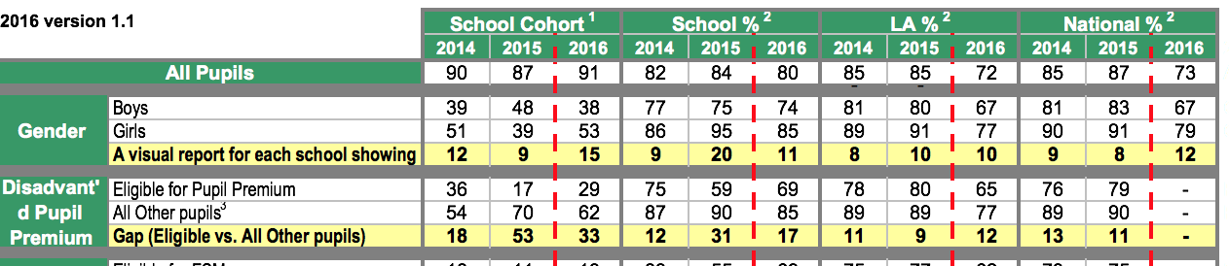
KS2 writing – A variable trend over time. Importantly the more-able PP have attained well compared to the whole cohort and La data. National data not yet available.
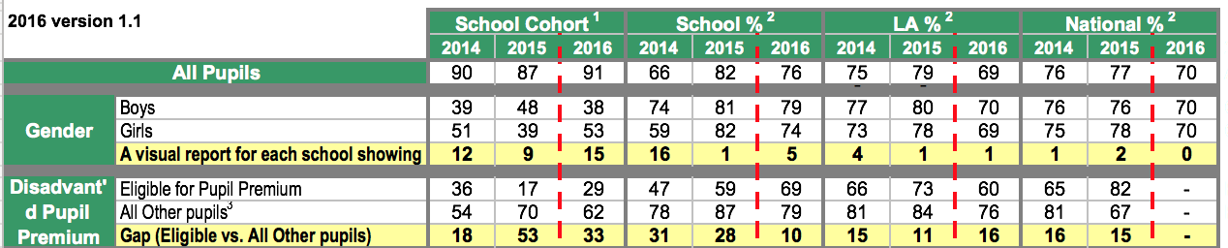
KS2 Maths – strong upward trajectory over time. Diminihsing the difference well. National data yet to emerge. More-able PP have done well against the LA data.
Importantly, the in-year tracking of attainment and achievement shows a strong picture across the school. See the PP plan 16-17 for the detail.

