Risk Assessment for: Business support/Admin/Reception staff |  |  |  | Location: Whole Site
Assessment Date: | September 2024 | Name of Assessor(s): | Richard Kentish |  | Assessment Ref No: JS01
Severity:
1 | No Lost time
2 | Under 7-day injury or illness
3 | Over 7-day injury or illness (RIDDOR)
4 | Specified injury or illness (RIDDOR)
5 | Fatality, disabling injury or illness
Likelihood
1 | Very unlikely
2 | Unlikely
3 | Likely
4 | Very likely
5 | Certain
Risk Matrix scoring guide:

High (15-25) | These risks are unacceptable; significant improvements in risk control are required. The activity should be halted with immediate effect until risk controls are identified/implemented that reduce the risk to an acceptable level
Medium (5-12) | Additional control measures should be identified and implemented to reduce the risks associated with the activity or workplace so far as reasonably practicable
Low (1-4) | Minimal control measures are required to be implemented to satisfy the level of risk. Maintain current arrangements for risk control

Hazard | Who might be harmed and how? | CONTROL MEASURES  (existing workplace precautions/risk control systems in place) | What further action is required? | By Who and When? | Residual Risk rating |  |  | Date completed
 |  |  |  |  | L | S | R | Date completed
Manual Handling | All staff – injury to back, arms or legs | - Site Manager trained in safe manual handling techniques – will support staff and undertake manual handling on request  - Cleaning staff trained in manual handling techniques | - Before moving anything – review the load.  - If the load can be split into manageable parts – do this before moving  - Use specialist moving equipment e.g. trolley  - All other staff to receive manual handling training  - Storage to be reviewed – light things kept high up, heavy things low down  - Self-manage and be sensible about what can be moved – follow the guide below | All staff manual handling | 2 | 2 | 4 | September 2024
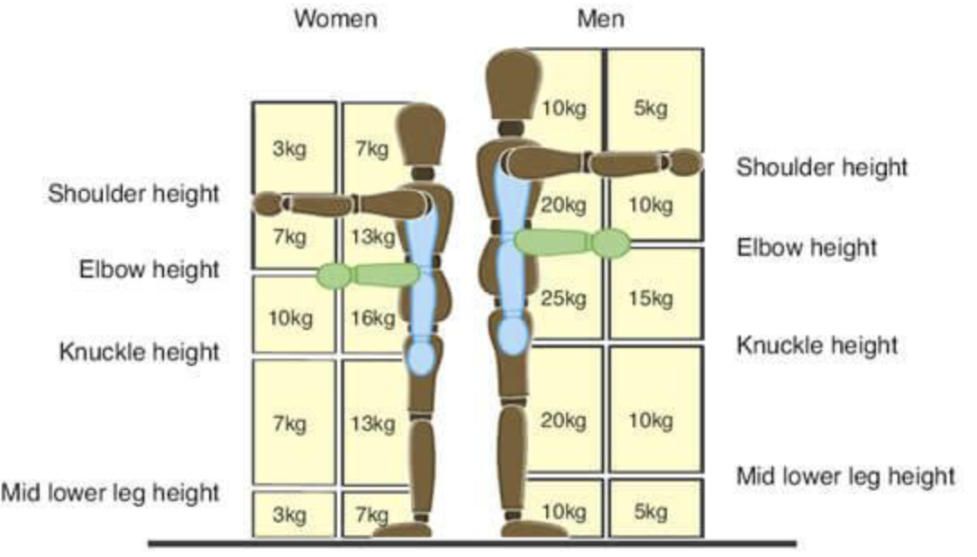

Assessment reviewed [Date]: | Reviewed by [Name]: | Comments:

