
The Federation of Abbey Infant and Junior School.
Pupil Premium Grant Expenditure
Report to Parents and Governors 2013-14
Overview of the school
Number of pupils and Pupil Premium Grant (PPG) received
Total pupils on roll | 335 (inf) + 359 (Jun)
Total number eligible for PPG | 63 (inf) + 104 (Jun)
Total amount received | £40,310 + £74,100

Nature of support 2013/14
The funding for the Pupil Premium has been allocated in the following ways:

Increase teaching assistant support to develop and run interventions across the school in phonics, reading, mathematics and other wave 2 & 3 interventions.

Support the targeting of a group of KS1 & KS2 pupils.

Curriculum focus of PPG spending 2013-14
Following an analysis of the impact of interventions during the preceding year the school has focussed its additional support on increasing the range of withdrawal interventions used to support children e.g. through the introduction of Catch-up Maths, Better Reading Partners, 5 minute boxes, enable plus and more.

School has increased support for phonics and guided reading from learning support practitioners through providing a greater level of differentiation for these sessions.

School has increased support for targeting groups to accelerate progress from learning support practitioners through providing a greater level of differentiation for these sessions.

Impact of Pupil Premium Spend
EYFS

Children enter YN low and leave YR broadly average (61% at a good level of development compared to national of 60%)
Year 1
The gap between the FSM (Pupil Premium) Group and non-FSM (Pupil Premium) group is broadly similar within school (60%-62%) and the in-school gap is much lower than the National FSM/non-FSM group gap. The in-school FSM group broadly perform in-line with the National FSM group (60-63%). The in-school increase in performance of this group has improved +19% over three years.
KS1
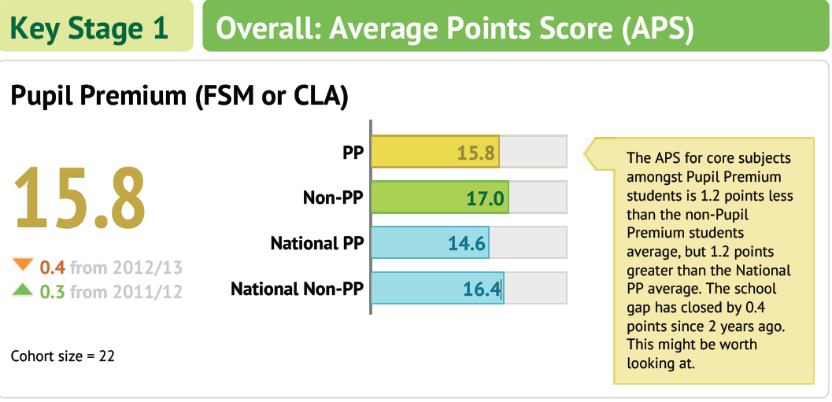

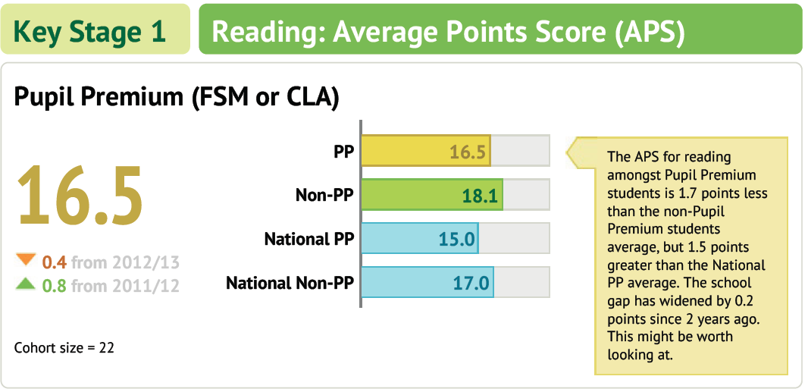
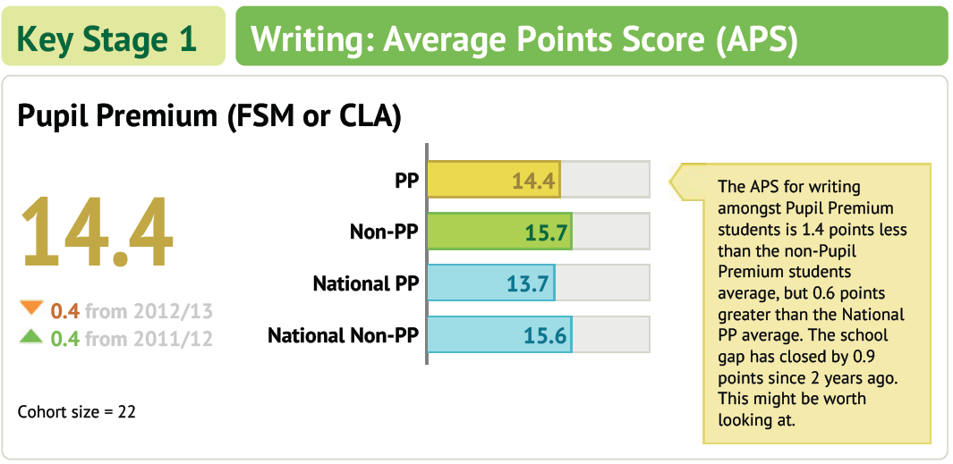
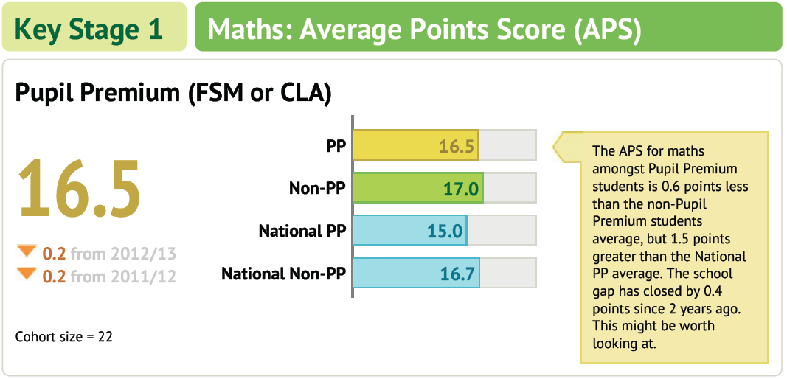
KS2
It is important to recognise the significance of the Background to the KS1 data that is now presenting through final KS2 outcomes – see the SEF for the full detail.
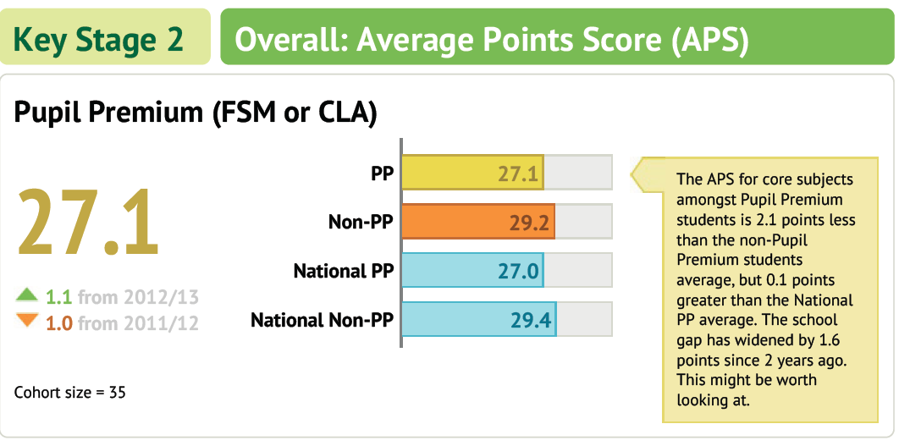
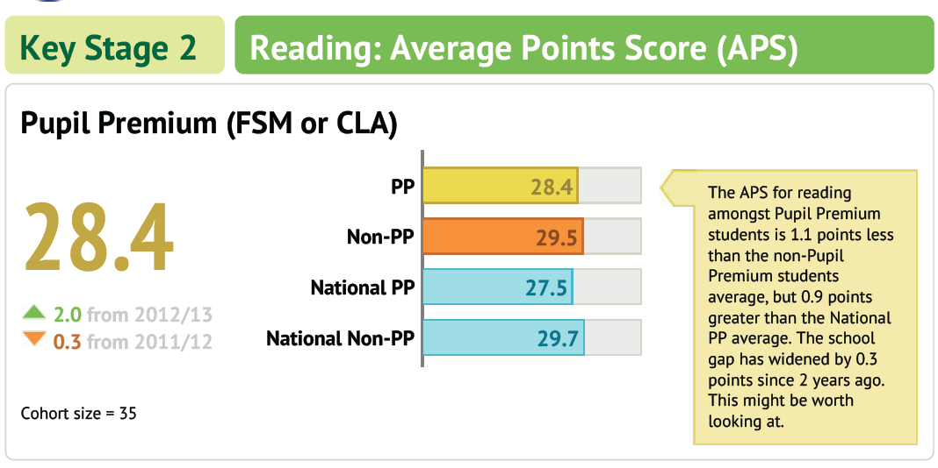
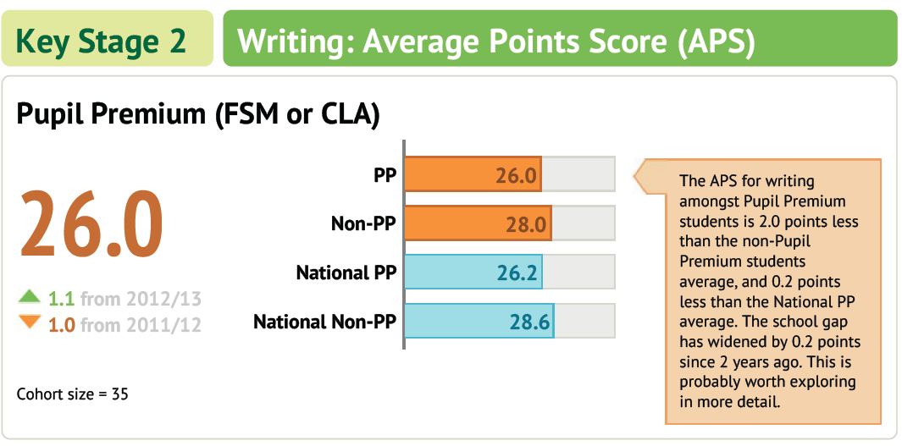
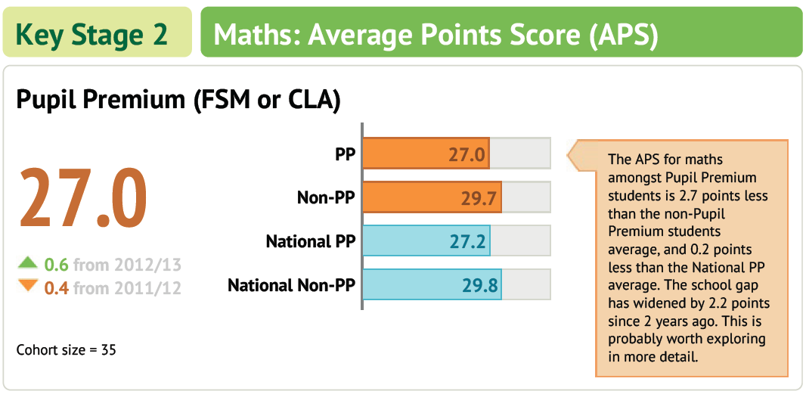

In year progress: -

In house tracking data suggests that the proportion of FSM on-track to make progress in line with national comparators, across all year groups, compares favourably with the national picture. The proportions on track for two and three levels progress is on track to match the national progress measures across all ability groups. [Note- these measures will change following the change to the new National Curriculum]

School Wide interventions – examples.

Intervention | Length of sessions | Number of sessions per week | 1:1 or group | *Cost of running the intervention per session | *Overall cost over a 10 week period
BRP | 20 minutes | 3 | 1:1 | £3.33 per child | £100 per child
HFW | 5 minutes | 5 | 1:1 | £0.85 per child | £42.50 per child
Precision Teaching | 15 minutes | 5 | 1:1 | £2.50 per child | £125 per child
Phonics/reading boosters, 5 minute box, name writing, numeracy | 5 minutes | 5 | 1:1 | £0.85 per child | £42.50 per child
Catch Up maths/literacy | 20 minutes | 3 | group | £3.33 per group | £100 per group
ELS | 20 minutes | 5 x 16 weeks | group | £3.33 per group | £266 per group

The impact of interventions for 2013/14:
Value for money examples.
Catch up Literacy – resulted in accelerated progress of 1 additional sub-level over a 10 week period in R, Wr & Ma (17/28; 21/28; 26/28)
Catch up Maths ‘Mad Maths” resulted in 7/9 increasing by an additional sub-level of accelerated progress.
Reading comprehension impacted on Y4 R, Wr & Ma by 9/11, 8/11 and 9/11 making an additional sub-level of accelerated progress.

