Pupil Premium Plan 2019-20 including 28-19 review.


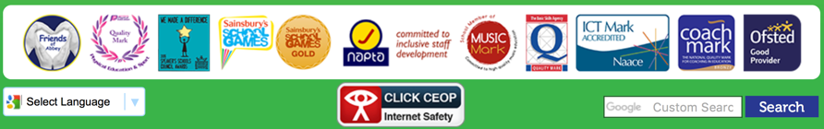

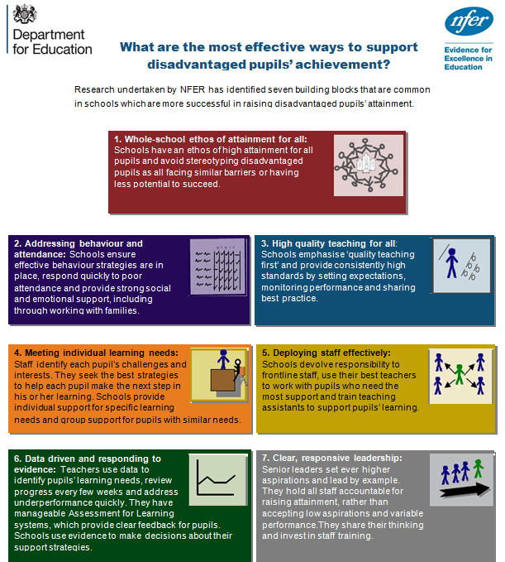

- Summary information
School | The The Federation of Abbey Infant & Junior School
Academic Year | 2019-20 | Total PP budget | £50,160 (I)  £97,980 (J) | Date of most recent PP strategy | Sep 2019
Total number of pupils | 270(78 YN)(I)  361 (J) | Number of pupils eligible for PP | 38 (I)  74 (J) | Date for next PP Strategy Review | Sep 2020
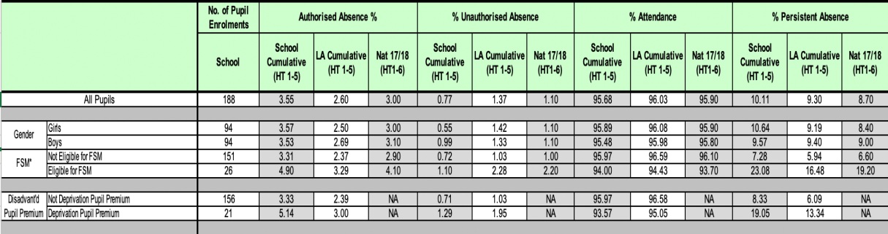
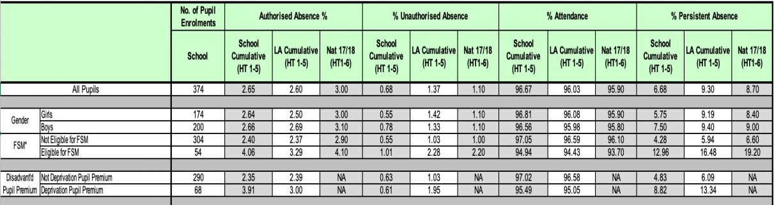
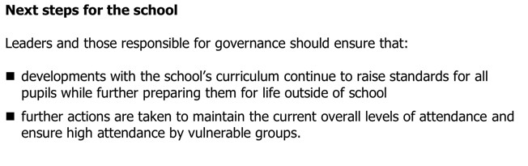

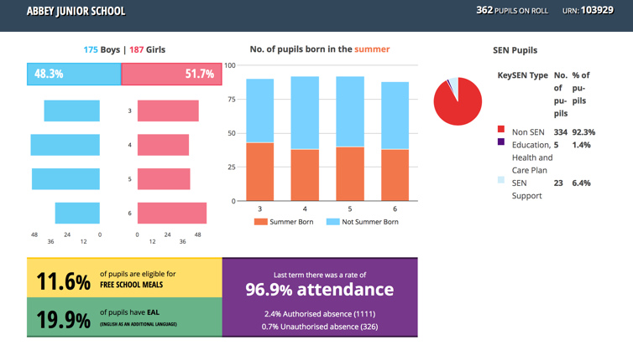
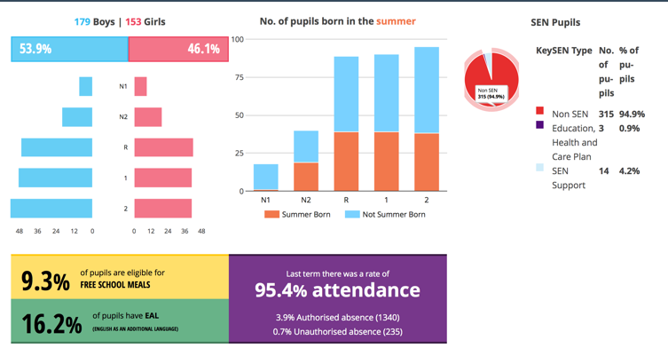
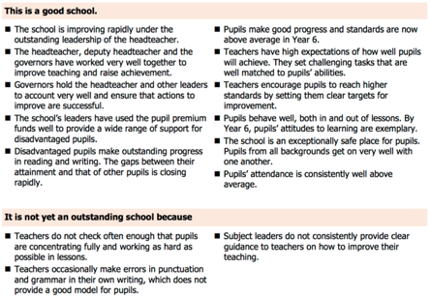
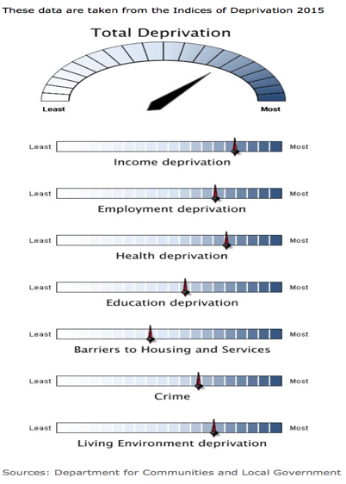

Pupil premium strategy statement

- Current attainment
School summary data for previous academic year (17-18) |  |  |  |  |  |  |  |  |  |  |  |  |  | Pupils eligible for PP (your school) |  |  |  |  |  |  |  | National Pupils not eligible for PP  (national average 2018 unvalidated- figures)
At KS2 % achieving EXS or above in reading, writing & maths  76% |  |  |  |  |  |  |  |  |  |  |  |  |  | 58% (-4 pupil) |  |  |  |  |  |  |  | 70%
At KS2 % achieving EXS or above:  R 83 %; Wr 89 %; Ma 89 % |  |  |  |  |  |  |  |  |  |  |  |  |  | R |  |  | Wr |  | Ma |  |  | R |  |  | Wr |  |  | Ma
 |  |  |  |  |  |  |  |  |  |  |  |  |  | 63% (-3 pupil) |  |  | 83% (-1 Pupil) |  | 83% (-1 Pupil) |  |  | 80% |  |  | 83% |  |  | 81%
At KS2 % achieving higher standard in reading, writing & maths  17% |  |  |  |  |  |  |  |  |  |  |  |  |  | 8 % (-2 pupil) |  |  |  |  |  |  |  | 12%
At KS2 % achieving higher standard:  R 36 %; Wr 31 %; Ma 34 % |  |  |  |  |  |  |  |  |  |  |  |  |  | R |  |  | Wr |  | Ma |  |  | R |  |  | Wr |  |  | Ma
 |  |  |  |  |  |  |  |  |  |  |  |  |  | 18% (-4 pupil) |  |  | 21 % (-2 pupil) |  | 21% (-3 pupil) |  |  | 32% |  |  | 23% |  |  | 28%
At KS1 % achieving EXS or above reading, writing & maths  64 % (9 % GDS) |  |  |  |  |  |  |  |  |  |  |  |  |  | 47% (-3 pupil difference to national)  13% GDS (0 pupil difference to national) |  |  |  |  |  |  |  | 65% (12% GDS)
At KS1 % achieving EXS or above:  78 % (22 % GDS); Wr 67 % (16 % GDS); Ma 73 % (18 % GDS) |  |  |  |  |  |  |  |  |  |  |  |  |  | R |  |  | Wr |  | Ma |  |  | R |  |  | Wr |  |  | Ma
 |  |  |  |  |  |  |  |  |  |  |  |  |  | 60% (-3 pupil) |  |  | 40% (-5 pupil) |  | 50% (-5 pupil) |  |  | 76% |  |  | 70% |  |  | 76%
At Y1 Phonic screen % achieving standard  72 %  94% by the end of Year 2 (Migration in 18-19 affected outcomes) |  |  |  |  |  |  |  |  |  |  |  |  |  | 53 % (-5 pupil difference to national)  94% by the end of Y2 (2018-19) |  |  |  |  |  |  |  | 85%  94 % by the end of Y2
EYFS achieving GLD  70 % |  |  |  |  |  |  |  |  |  |  |  |  |  | 50 % (-2 pupil difference to national) |  |  |  |  |  |  |  | 74%
Other Year groups % on-track for ARE against the school’s curriculum |  |  |  |  |  |  |  |  |  |  |  | Other Year groups % on-track for PP ARE against the school’s curriculum
Y1 |  |  | Y3 |  |  | Y4 |  |  | Y5 |  |  | Y1 |  |  |  | Y3 |  |  |  |  | Y4 |  |  |  |  | Y5
R | Wr | Ma | R | Wr | Ma | R | Wr | Ma | R | Wr | Ma | R | Wr |  | Ma | R |  | Wr |  | Ma | R |  | Wr | Ma |  | R | Wr |  | Ma
75 | 72 | 80 | 83 | 86 | 81 | 83 | 80 | 81 | 79 | 73 | 74 | 50 | 47 |  | 44 | 74 |  | 79 |  | 58 | 85 |  | 62 | 77 |  | 52 | 41 |  | 52

Current PROGRESS
School summary data for previous academic year 2018-19 (un-valudated) |  |  |  |  |  |  |  |  |  |  |  |  |  |  |  |  |  | Pupils eligible for PP (your school) Unvalidated |  |  |  |  |  |  |  |  | Pupils not eligible for PP  (national average unvalidated 2018)
KS2 Overall progress score in Reading, Writing, Maths  R +1.58; Wr +1.77; Ma +1.63 |  |  |  |  |  |  |  |  |  |  |  |  |  |  |  |  |  | R |  |  | Wr |  |  | Ma |  |  | R |  |  | Wr |  |  | Ma
 |  |  |  |  |  |  |  |  |  |  |  |  |  |  |  |  |  | +0.17 |  |  | +1.78 |  |  | +1.42 |  |  | +0.3 |  |  | +0.2 |  |  | +0.3
KS2 Average scaled score in reading, maths and GPS  R 106.5; Ma 107.2; GPS 106.9 |  |  |  |  |  |  |  |  |  |  |  |  |  |  |  |  |  | R |  |  | Ma |  |  | GPS |  |  | R |  |  | Ma |  |  | GPS
 |  |  |  |  |  |  |  |  |  |  |  |  |  |  |  |  |  | 103.9 |  |  | 106 |  |  | 105 |  |  | 106 |  |  | 104 |  |  | 107
Other Year groups % making good or better progress against the school’s curriculum & assessment |  |  |  |  |  |  |  |  |  |  |  |  |  |  |  |  |  | School’s PP children
EYFS |  |  | 1 |  |  | 2 |  |  | 3 |  |  | 4 |  |  | 5 |  |  | EYFS |  |  | 1 |  |  | 2 |  |  | 3 |  |  | 4 |  |  | 5
R | Wr | Ma | R | Wr | Ma | R | Wr | Ma | R | Wr | Ma | R | Wr | Ma | R | Wr | Ma | R | Wr | Ma | R | Wr | Ma | R | Wr | Ma | R | Wr | Ma | R | Wr | Ma | R | Wr | Ma
89 | 76 | 93 | 82 | 87 | 86 | 88 | 86 | 92 | 94 | 91 | 92 | 89 | 94 | 96 | 93 | 96 | 94 | 75 | 91 | 92 | 61 | 78 | 70 | 78 | 78 | 83 | 89 | 89 | 74 | 90 | 92 | 92 | 82 | 89 | 86

Other elements of ROL/ISDR, once published, will complete the unknown national gaps.
- Barriers to future attainment (for pupils eligible for PP)
In-school barriers (issues to be addressed in school, such as poor oral language skills)
In EYFS, CLL aspects are low for some children: T4W and Early Literacy focus through targeted support.
In EYFS: A growing number of children entering school with no pre-school experience and little/no involvement from school nurse/early years external team
(ref: failing in Sandwell for LCSB and new (Oct’16 & Feb’19 completed) Trust arrangement
PSHE and children’s preparedness for learning affects a small but significant group. The use of Boxall profile, specialist Educational Psychologist support along with local cluster based mental-health programmes
To support along with targeted family support through ‘Early help’ and schools Family support worker
C. | Maths at KS1 addressed through the concrete practical apparatus use linked to our maths methods scheme – mastery material  Reading through the use of comprehension, Project X and BRP to ensure the proportion attaining R+WR+MA EXS + rises.
External barriers (issues which also require action outside school, such as low attendance rates)
D. | Attendance of FSM is lower than the main cohort group. This figure is significantly skewed due to some additional health needs of a small minority. Nevertheless, attendance lead continues  To support and challenge families so that attendance rises.

- Outcomes (Desired outcomes and how they will be measured) |  | Success criteria
 | To raise the % of PP attaining the expected standard by 10% in R, Wr & Ma at the end of EYFS (GLD) and KS1 & 2. | Diminishing difference between the national non-PP group  and the Abbey PP children. Increase in % achieving ARE by 10% at all end of key stages.
 | To ensure that 90% of PP children make good and 35% make better progress against the school’s curriculum. | 90% of PP group in each year group make 4+ steps  35% make 5+ steps progress
 | To increase the proportion of PP children who are more-able by 10% in each year group | 10% of the PP group move from being their current  attainment band into the band above e.g. from MA to HA.

- Planned expenditure
- Academic year |  | 2019-20
The three headings below enable schools to demonstrate how they are using the Pupil Premium to improve classroom pedagogy, provide targeted support and support
whole school strategies
- Quality of teaching for all – STRATEGIES IN ADDITION TO HIGH QUALITY 1ST TEACHING.
Desired outcome | Chosen action /  approach |  | What is the evidence and  rationale for this choice? | How will you ensure it is  implemented well? | Staff lead | When will you review implementation?
To raise the % of PP attaining  the expected standard by 10%  in R, WR & MA at the end  of KS1 & 2 | Effective use of provision  mapping to ensure a close  match to learners’ needs  and the targeted support. |  | Provision mapping underpins the intervention across  the school. Ensuring that the programmes are  delivered well with rigorous assessment ensures  effective VFM. | Quality assurance by direct observation.  Provision maps and phase action plans.  SMT feedback | AHT x 5 | Through end of termly pupil  progress reviews
 | CPD for all LSP on effective intervention delivery |  | Evaluation of small-group literacy and maths intervention programmes delivered by well-trained and supported TAs working closely with the class  teacher has demonstrated significant  impact on children’s progress. | Quality assurance by direct observation.  Provision maps and phase action plans.  SMT feedback | AHT x 5 | Through end of termly pupil  progress reviews
Total budgeted cost 1 day release x 5 x 40 weeks = £35,000
- Targeted support
Desired outcome | Chosen action /  approach |  | What is the evidence and rationale  for this choice? | How will you ensure it is  implemented well? | Staff lead | When will you review implementation?
To ensure that 90% of pupil  premium children  make accelerated progress  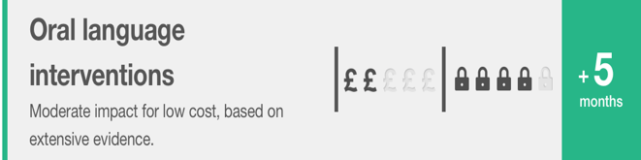 | Communication and  Language  – EEF EYFS Toolkit |  | On average, children who are  involved in communication and language approaches make approximately six months’ additional progress over the course of a year.  All children appear to benefit from such approaches, but some studies show slightly larger effects for children from disadvantaged  backgrounds.  At Abbey this appears through the use of Welcomme Language Screening, ELKLAN and Talk for Writing along with an embedded use of effective talking strategies through the curriculum and SALT programmes. | Quality assurance by direct observation.  Provision maps and phase action plans.  SMT feedback | AHT x 5 | Through end of termly pupil  progress reviews
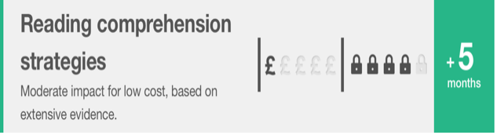 | Early Literacy  -EEF EYFS Toolkit |  | Early literacy approaches aim to improve young children’s skills, knowledge or understanding related to reading or writing. Common  approaches include: storytelling and group reading, activities that aim to develop letter knowledge, knowledge of sounds and early  phonics, or introductions to different kinds of writing.  At Abbey this appears through the use and  application of the ‘Catch up Reading’ and  ‘Better Reading Partners’ (BRP) programmes. | Quality assurance by direct observation.  Provision maps and phase action plans.  SMT feedback | AHT x 5 | Through end of termly pupil  progress reviews
 | Early Numeracy  -EEF EYFS Toolkit |  | Early numeracy approaches aim to develop number skills and improve young children’s knowledge and understanding of early  mathematical concepts. Activities in this area might be structured, for example through programmes designed to develop children’s  ‘number sense’ (their developing understanding of quantity and number), or more informal, such as using mathematical games or computer games (see also Digital technology), or pretend activities involving counting. | Quality assurance by direct observation.  Provision maps and phase action plans.  SMT feedback | AHT x 5 | Through end of termly pupil  progress reviews
 | Feedback  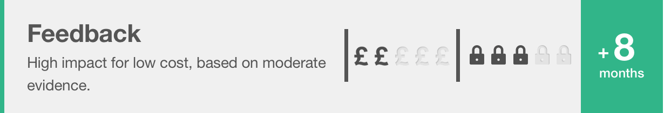  EEF Toolkit |  | In general, research-based approaches that explicitly aim to provide feedback to  learners, such as Bloom’s ‘mastery learning’, also tend to have a positive impact. Feedback has effects on all types of learning across  all age groups. Research in schools has focused particularly on English, mathematics and, to a lesser extent, science.  At Abbey this appears through the application of our developmental marking and feedback policy and predominately appears in English and Mathematics. | Quality assurance by direct observation.  Provision maps and phase action plans.  SMT feedback | AHT x 5 | Through end of termly pupil  progress reviews
 | Meta cognition and  Self-regulation  EEF Toolkit |  | Meta-cognition and self-regulation approaches have consistently high levels of impact, with pupils making an average of eight  months’ additional progress. The evidence indicates that teaching these strategies can be particularly effective for low achieving and  older pupils. At Abbey this takes the format of CTG marking and peer/self-assessment along with the ‘soft-skills’ | Quality assurance by direct observation.  Provision maps and phase action plans.  SMT feedback | AHT x 5 | Through end of termly pupil  progress reviews
Total budgeted cost 8 FTE LSP to deliver targeted interventions across the school = > the allocated PP total £50,160 (I)
£97,980 (J)

- Other approaches
Desired outcome | Chosen action /  approach |  | What is the evidence and rationale  for this choice? | How will you ensure it is  implemented well? | Staff lead | When will you review implementation?
To increase the % of PP  children who are more-able  within each year group by 10% | Whole school  performance management |  | Clearly articulated whole  school aims, supported by CPD, are effective in  raising standards. | The performance management  process | AHT x 5 | Pupil progress and  PM cycle.
To ensure that children  are emotionally ready  to learn. | At Abbey this can be seen  through the consistent  application of the behaviour management strategy,  individualised programmes supported by Inclusion  Support and the pastoral  team in ‘’The Bank’ in KS2  and ‘The rainbow room’  in KS1 Further examples to be  seen include  ‘Fun Fit’, ‘Write Dance’, ‘Chirpy and bounce’, ‘manage my chimp’, ‘emotion coaching’ |  | Three broad categories of interventions can be identified: 1. Universal programmes which seek to improve behaviour and generally take place in the classroom; 2. More specialised programmes which are targeted at students with either behavioural issues or behaviour and academic problems; 3. School level approaches to developing a positive school ethos or improving discipline which also aim to support greater engagement in learning. | 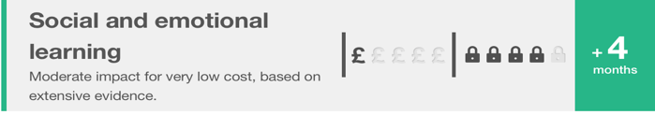  Pastoral records and behaviour logs | JS | Termly
Total budgeted cost

- Review of expenditure
Previous Academic Year 2018-19 |  | This section refers to the 18-19 review.
- Quality of teaching for all
Desired outcome | Estimated impact: Did you meet the success criteria?  Include impact on pupils not eligible for PP, if appropriate. |  | Lessons learned  (and whether you will continue with this approach) | Cost
To raise the % of PP attaining  the expected standard by 10%  in R, WR & MA at the end  of KS1 & 2 | Yes, at KS2, for Ma & Wr where PP are within 1 pupil of the school.  Reading % at ARE dropped with 4 children at a SS of 99.  GDS PP remains strong at R 18%, Wr 21%, Ma 21%  Provision mapping is effective at supporting pupils and ensures VFM for support staff whose  salary is covered, in part, by PP funding.  See intervention analysis for additional detail. |  | Continued Performance  management target support whole school progress to raise attainment.  Continue.  Mindful to avoid one-year data fluctuations detracting from ‘big picture’.  Volatility in AOE of EYFS means that this group’s needs will change  Added to the placement pressure where numbers fluctuate. | £85,000

- Targeted support
Desired outcome | Chosen action /  approach | Estimated impact: Did you meet the success criteria?  include impact on pupils not eligible for PP, if appropriate. | Lessons learned  (and whether you will continue with this approach) | Cost
To ensure that 90% of pupil  premium children  make accelerated progress | High quality  intervention | Yes – there is broad parity across the school with (on average)  85% + making good or better progress.  KS2 progress for R, WR & Ma has now increased to + figures.  The S8 inspection Oct 2017 evaluated PP pupils in KS1 make good progress. | Y1 (new Y2) & Y2 (new Y3) remain needing additional  intervention linked to SEMHS.  BRP to replace all reading interventions due to exemplary impact.  Approach to continue. | £100,000
- Other approaches
Desired outcome | Chosen action  / approach | Estimated impact: Did you meet the success criteria?  Include impact on pupils not eligible for PP, if appropriate. | Lessons learned  (and whether you will continue with this approach) | Cost
To increase the % of PP  children who are more-able  within each year  group by 10% | In-class PM target | Yes – whilst there are is some Variability across year groups,  There has been a year on year increase. . This has been evaluated well also  Through performance management.  e.g. Y6 2018-19 raised GDS PP by 8% from predicted 0 | Partially – PP GDS will remain a focus to maintain at the GDS % and accelerate  a targeted group to move a prior attainment band by the end of the key-stage  longitudinal data success. Continue | £0
To ensure that children  are emotionally ready  to learn. | SEMHS programme | SEMHS still presents a challenge for some PP pupils.  Targeted support, Early help, specialist counselling,  PPE, Boxall  Profile, Emotion Coaching.  In-house safeguarding Team and Inclusion support have all  Been in place, including CAMHS. | Additional LTS SEMHS work to support. SEMHS in unstructured time.  Ready, Steady, Go, Emotion Coaching. | £40,000
Note: Costs exceed the PP funding and represents a further investment.

