Thursday, 13th November 2025

Dear Parents and Carers

Year 4 – Maths Multiplication Workshop

As part of our Maths curriculum in year 4, we have a specific focus on learning times tables and must complete the National Multiplication table Check in June.

We would like to invite you to come in, work with your child and have some fun playing times tables games. This is a great opportunity to see how you can make practising times tables at home more fun and also collect some free resources. Whether you are a multiplication whizz or not, we will have the tools to support you.

Due to numbers and hall space, we ask that only one adult per child attends the workshop. Unfortunately, due to health and safety, we also ask that no siblings or other children attend.

The dates for the workshops are as follows;

4V – Tuesday 3rd February 2026
4S – Wednesday 4th February 2026
4A – Thursday 5th February 2026

Workshops will start at 1.45pm and finish at approximately 3pm.

Please log onto your child’s ParentPay account to let us know that you will be attending by Friday, 12th December 2025 in order for the teachers to be able to accommodate all of those who wish to attend.

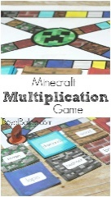
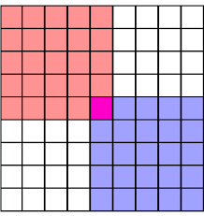



Yours sincerely

Ms S M Collins
School Business Director
Executive Head Teacher’s PA

