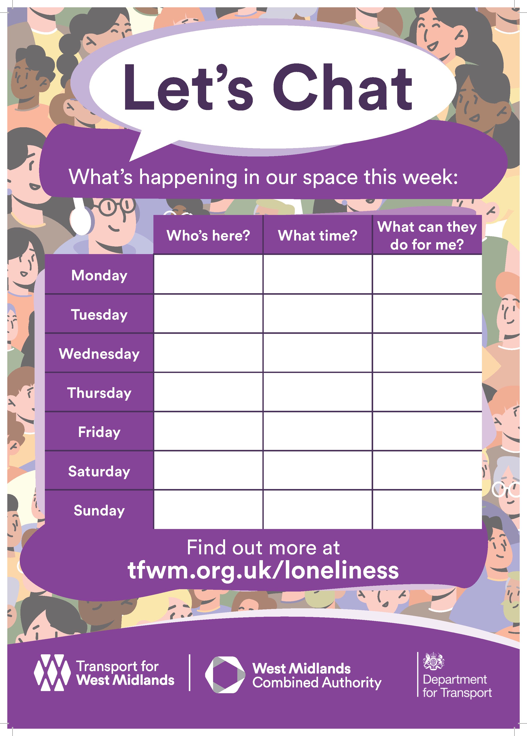
w

Learn a new skill and meet new friends.
Enjoy our free bingo with free tea/coffee
10:am – 12:pm
12:30 – 1:30pm
10:am – 2:30pm
Closed
Knit and Natter
Bingo
Cranstoun – Ladies only session.

Closed
Great way to help with stress and anxiety. Come and find out more from Nick.

10:am – 1:pm
Ear Acupressure – great way to help with stress and anxiety – come in and speak to Nick and give it a try – first session free.
Great way to socialise and meet new people.
Free advice and support

12:30pm – 1:30pm
10:am – 12:pm
Come and join our free Bingo Session.
Benefit and energy advice

Support available to make phone calls and appointments.

Relax and socialise with a free cup of tea/coffee.

10:am – 2:pm

Support available to make phone calls and appointments.

10:am – 2:pm
Relax and socialise with a free cup of tea/coffee.

