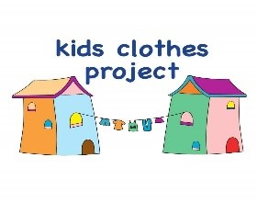Est 2020
Charity registered Sept 26
Charity number 1215064
Our Story
Kids Clothes Project is a registered charity running a free service that provides pre-loved clothing to children in families in need across the Black Country.
Many families struggle to clothe their children. Through public donations and collaborative working the Kids Clothes Project supports the provision of essential quality clothing to 2–12 year-old.
The pre-loved clothing parcels contain 7 of each key items; jumpers, T-shirts, trousers and new underwear. Additional items may include, shoes, coats, pyjamas, dresses, swimwear, books and soft toys.
Clothing parcels are available for collection within 7 days of referral from our project in Brierley Hill
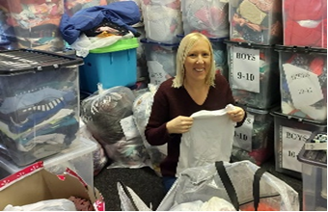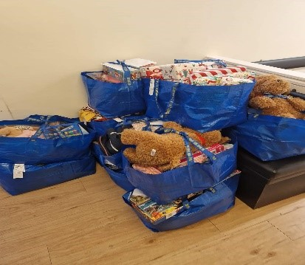
How you can get involved
If you work alongside vulnerable families who would benefit from our service, please do not hesitate to fill in our referral request form, which can be found on our website (below)

Contact Us
If you know of families in need of this free service, please do not hesitate to contact us through our referral portal on our website or contact us for more information
Email: kidsclothesproject@hotmail.com Facebook: @dudleycommunity
Tel: 07984414014 Website kidsclothesproject.co.uk

