
The Federation of Abbey Infant and Junior School.
Pupil Premium Grant Expenditure review.
Plan to Parents and Governors 2015-16.
Overview of the school
Number of pupils and Pupil Premium Grant (PPG) received
Total pupils on roll | 335 (inf) + 359 (Jun)
Total number eligible for PPG | 54 (inf) + 106 (Jun)
Total amount received | £65,840 + £125,240

Nature of support 2015/16
The funding for the Pupil Premium has been allocated in the following ways:

Increase teaching assistant support to develop and run interventions across the school in phonics, reading, mathematics and other wave 2 & 3 interventions.

Support the targeting of a group of KS1 & KS2 pupils.

Curriculum focus of PPG spending 2015-16
Following an analysis of the impact of interventions during the preceding year the school has focussed its additional support on increasing the range of withdrawal interventions used to support children e.g. through the introduction of Catch-up Maths, Better Reading Partners, 5 minute boxes, enable plus and more.

School has increased support for phonics and guided reading from learning support practitioners through providing a greater level of differentiation for these sessions.

School has increased support for targeting groups to accelerate progress from learning support practitioners through providing a greater level of differentiation for these sessions.
Pupil Premium Strategy | Rationale
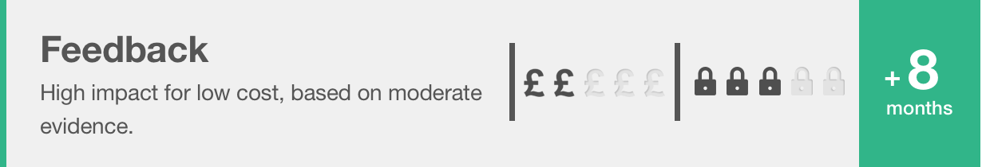 | In general, research-based approaches which explicitly aim to provide feedback to learners, such as Bloom’s ‘mastery learning’, also tend to have a positive impact. Feedback has effects on all types of learning across all age groups. Research in schools has focused particularly on English, mathematics and, to a lesser extent, science.  At Abbey this appears through the application of our developmental marking and feedback policy and predominately appears in English and Mathematics.
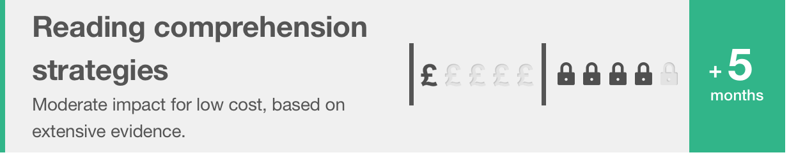 | Comparative findings indicate that, on average, reading comprehension approaches appear to be more effective than phonics or oral language approaches for upper primary and secondary pupils, both in terms of short-term and long-term impact.  At Abbey this appears through the use and application of the ‘Catch up Reading’ and ‘Better Reading Partners’ (BRP) programmes.
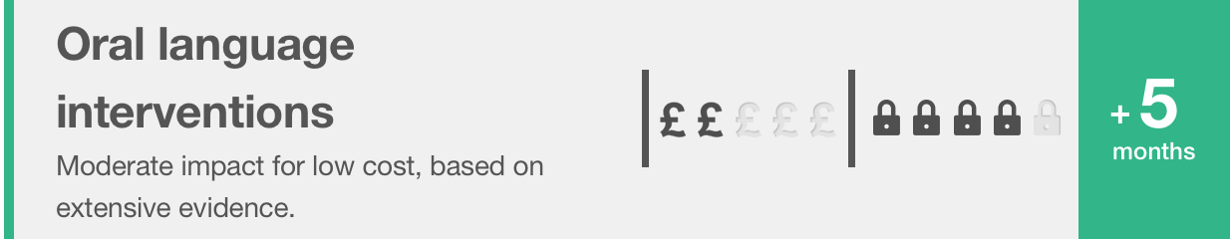 | There is consistent evidence supporting reading to young children and encouraging them to answer questions and to talk about the story with a trained adult. Conversely, ‘whole language’ approaches, which focus on meaning and personal understanding, do not appear to be as successful as those involving more interactive and dialogic activities. A number of studies show the benefits of trained teaching assistants effectively supporting both oral language skills and reading outcomes.  In addition, for all oral language interventions certain factors are associated with higher learning gains, suggesting that careful implementation is important. Approaches which explicitly aim to develop spoken vocabulary work best when they are related to current content being studied in school and when they involve active use of any new vocabulary.  At Abbey this appears through the use of Welcomme Language Screening, ELKLAN and Talk for Writing along with an embedded use of effective talking strategies through the curriculum and SALT programmes.
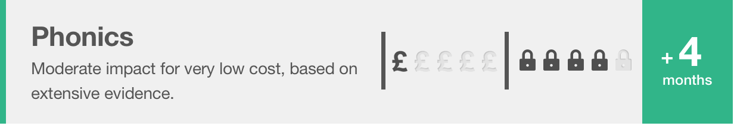 | Phonics approaches have been consistently found to be effective in supporting younger readers to master the basics of reading, with an average impact of an additional four months’ progress. Research suggests that phonics is beneficial for younger learners (4-7 year olds) as they begin to read. Teaching phonics is more effective on average than other approaches to early reading (such as whole language or alphabetic approaches), though it should be emphasised that effective phonics techniques are usually embedded in a rich literacy environment for early readers and are only one part of a successful literacy strategy.  At Abbey this can be seen through the systematic teaching of phonics until mastery.
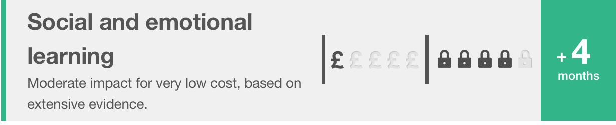 | Three broad categories of interventions can be identified: 1. Universal programmes which seek to improve behaviour and generally take place in the classroom; 2. More specialised programmes which are targeted at students with either behavioural issues or behaviour and academic problems; 3. School level approaches to developing a positive school ethos or improving discipline which also aim to support greater engagement in learning.  At Abbey this can be seen through the consistent application of the behaviour management strategy, individualised programmes supported by Inclusion Support and the pastoral team in ‘The Zone’ and ‘The Rainbow room’. Further examples to be seen include ‘Fun Fit’, ‘Write Dance’, ‘Chirpy and bounce’, ‘Music intervention’.
FSM GLD has reduced in-school gap since ’14 by 14%; in line with national.
Impact of Pupil Premium Spend 14-15
EYFS
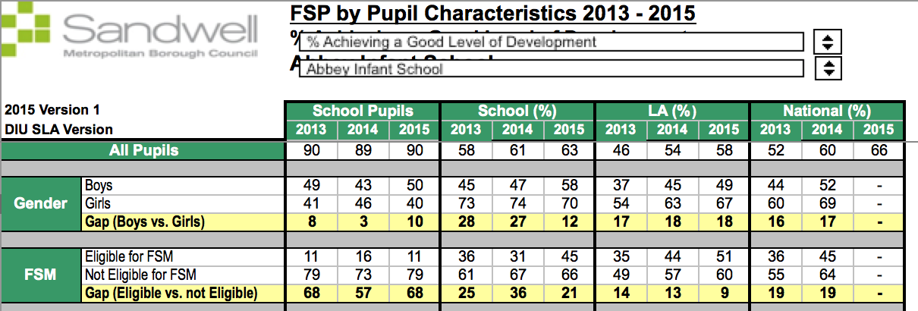
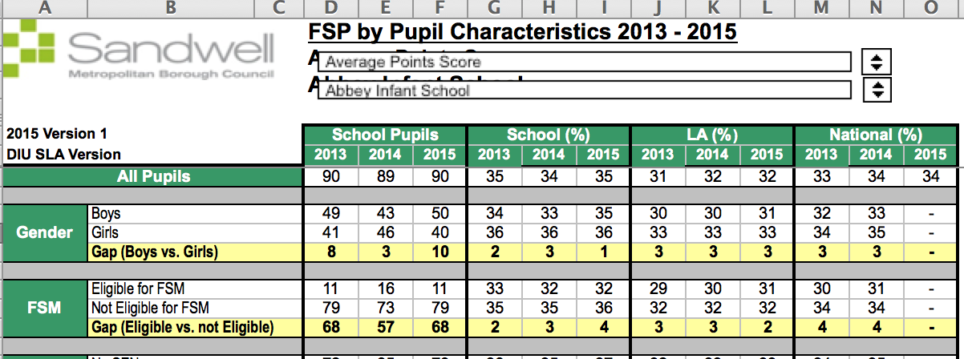
FSM APS has widened lightly from non-fsm in-school pupils but remains in line with national.

Year 1
FSM pass has increased since ’14 by 12% and altgough the gap to non-fsm has widened; the gap to national all pupils has reduced significantly and is above FSM national.
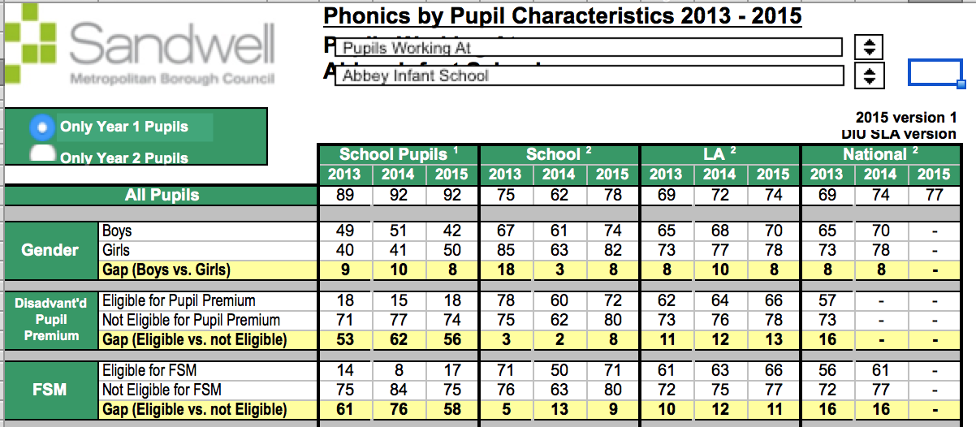

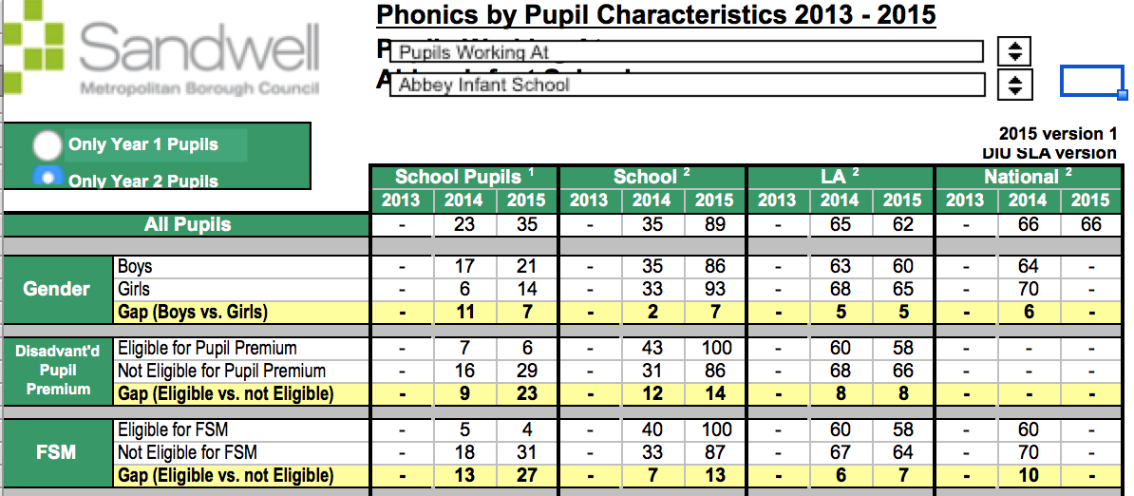
FSM reading 2b+ in-line with school non-fsm and above national.
Y2 phonic re-test has 100% success for FSM; above national and better than non-fsm in-school group.
KS1

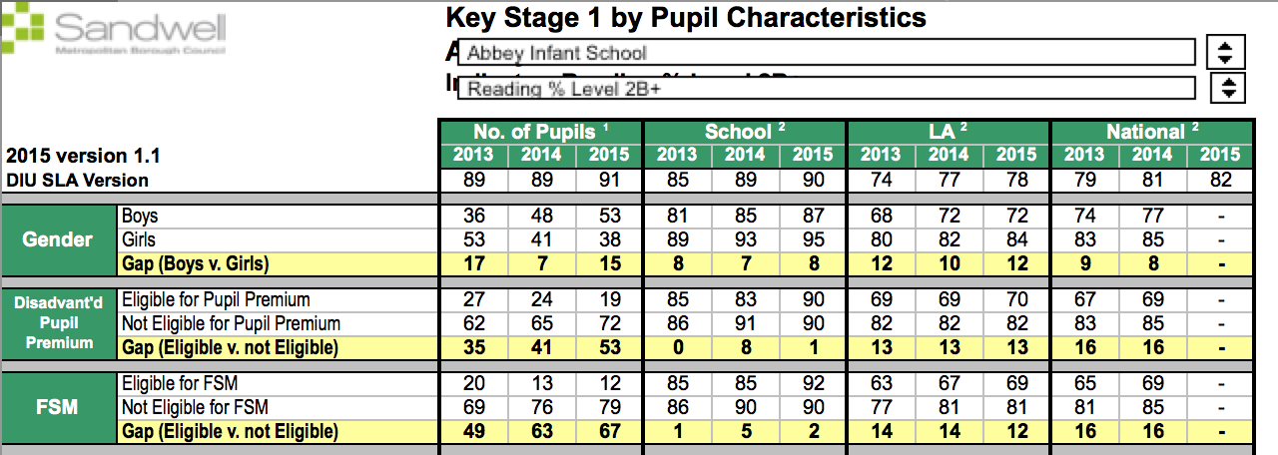
FSM reading L3 has reduced in-school gap since ’14 and is above national FSM group.

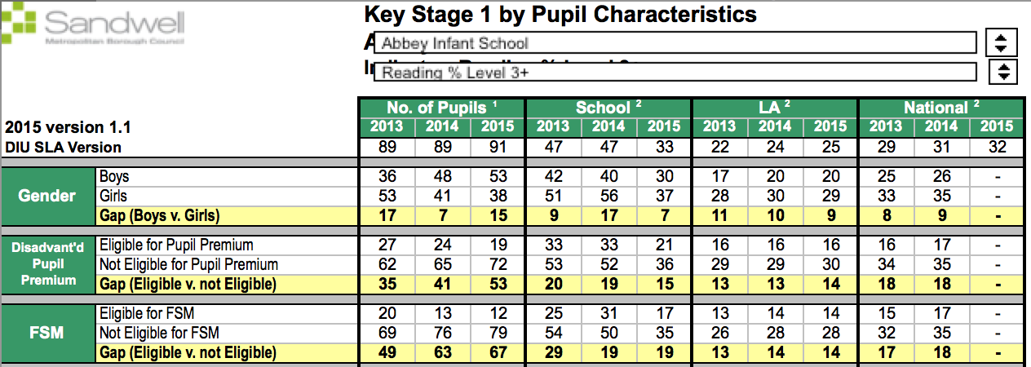

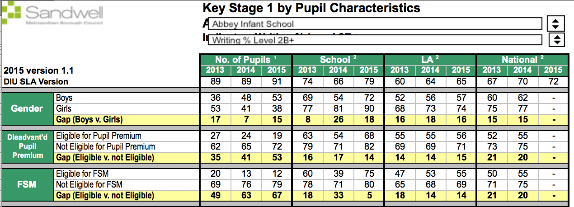
FSM L3 writing gap has widened from in-school gap below the national FSM group.
FSM writing 2b+ has reduced in-school gap since ’14 and is above the national FSM group and broadly in-line with all pupils national.

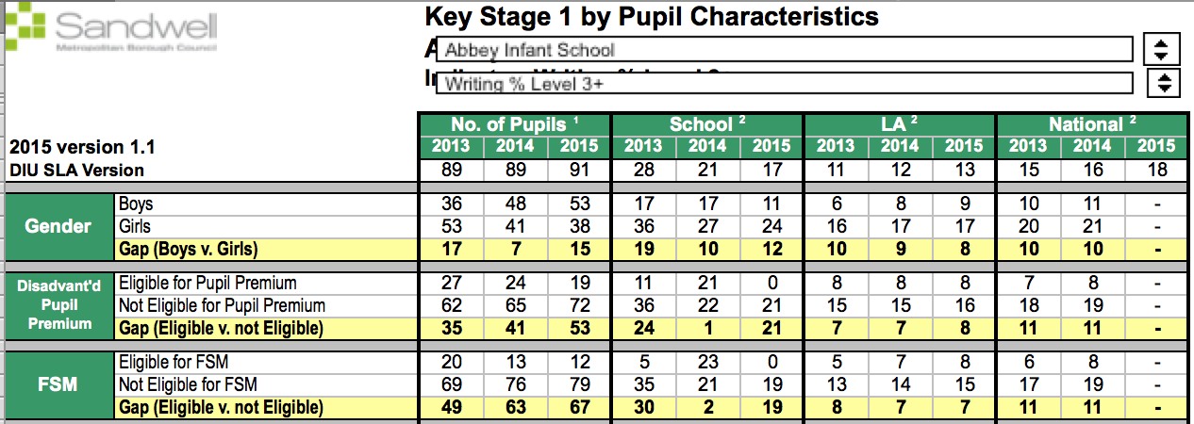
FSM L2 Maths better than non-fsm in-school; above national FSM and all pupils.

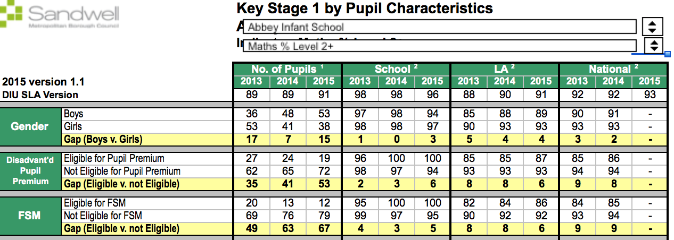
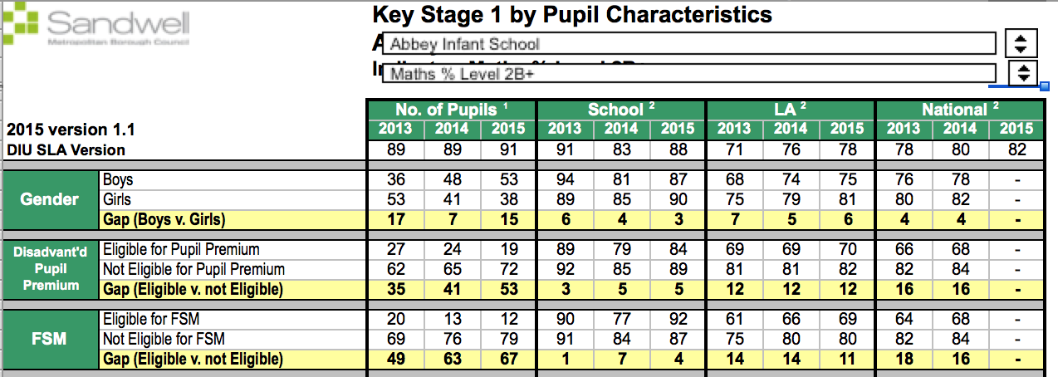
FSM L3 maths gap has widened from in-school gap below the national FSM group.

FSM L2b+ Maths in-school gap remains the same; better than national all pupils and national FSM group.

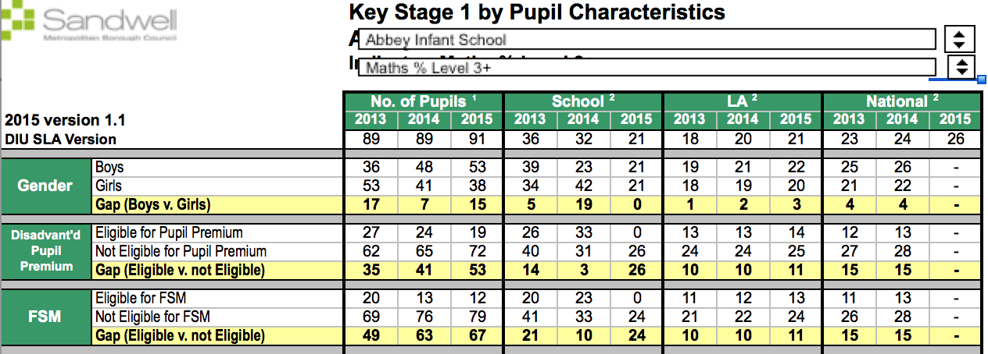
R,Wr, Ma L4+ maths gap has widened from in-school gap below the national FSM group.

KS2

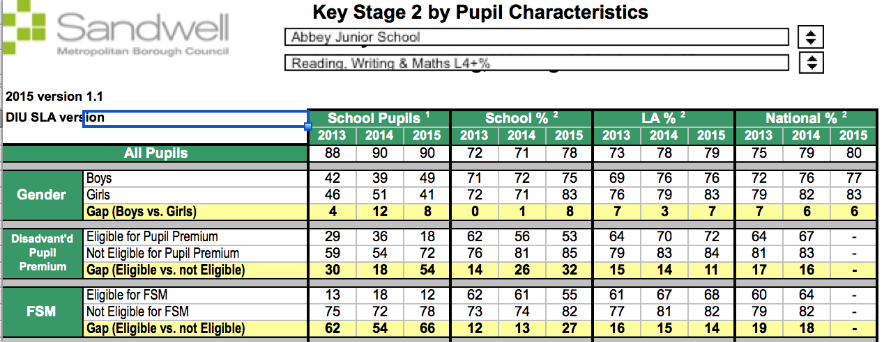
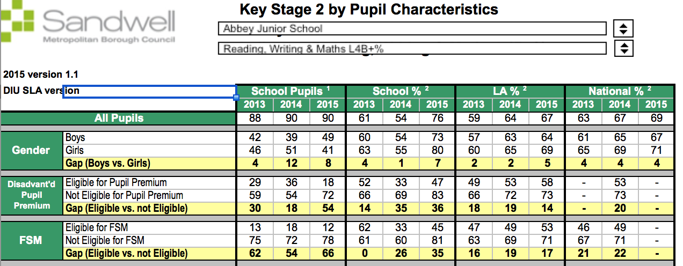
Reading L4 gap has widened from in-school gap; in-line the national FSM group.

FSM L4b+ R, Wr, Ma gap has remained the same from in-school but the attainment level has improved; FSM group broadly in line with national FSM group.

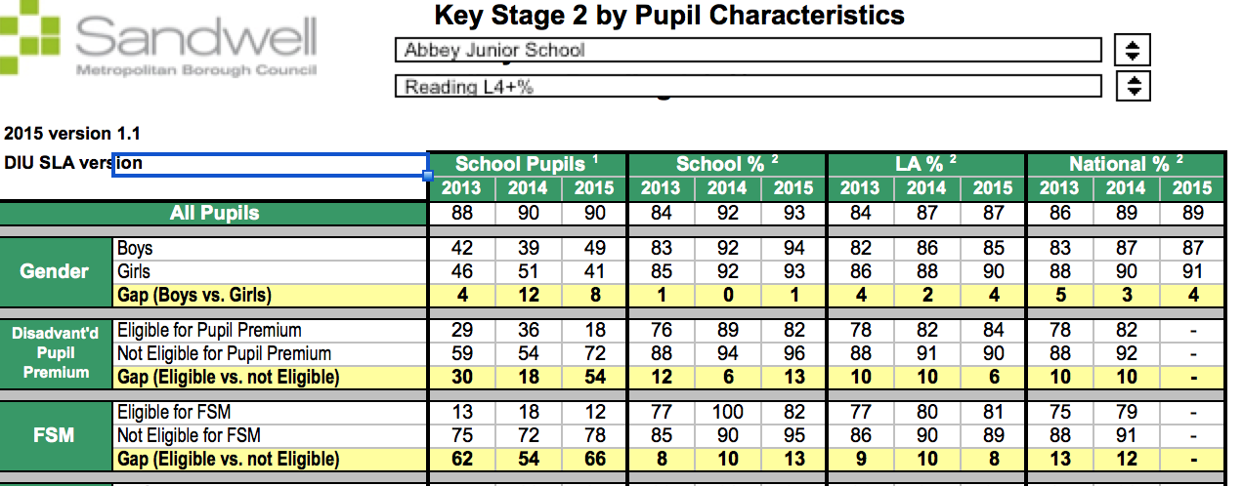
Reading L4b+ gap has widened from in-school gap; broadly in-line with the national FSM group.

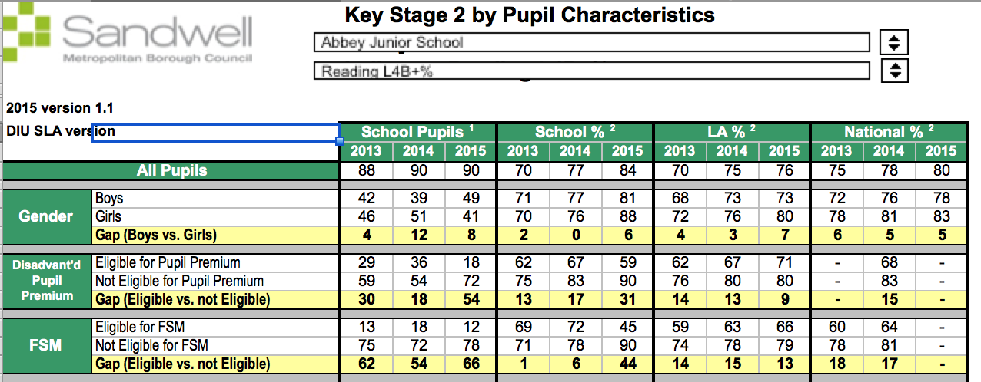
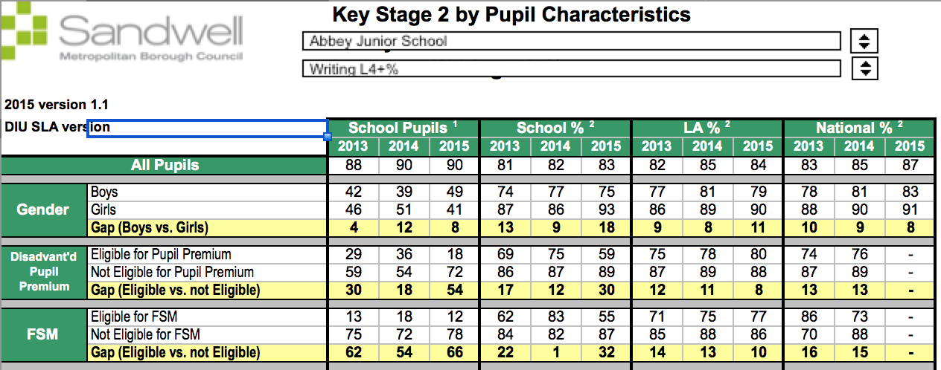
Maths L4+ gap has widened from in-school gap; below the national FSM group.

Reading Lb+ gap has widened from in-school gap; below the national FSM group.

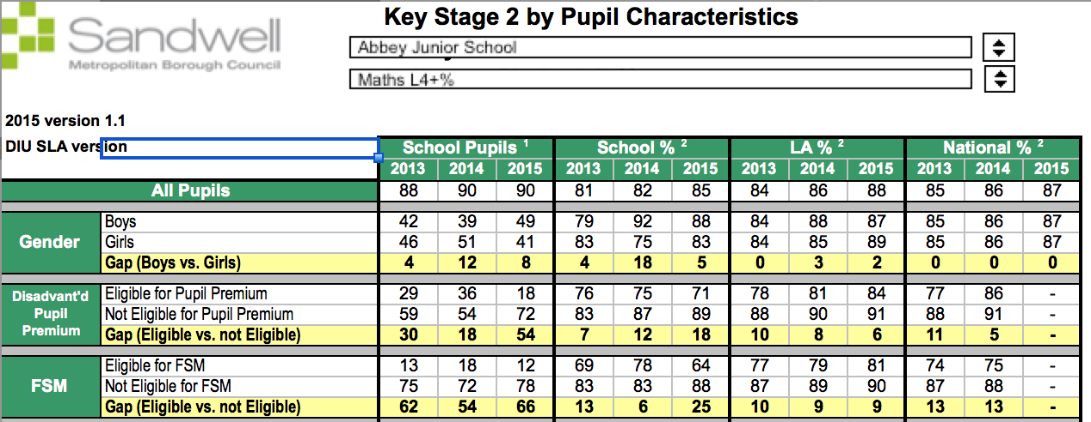
Maths L4b+ gap has widened from in-school gap; broadly in-line with the national FSM group.

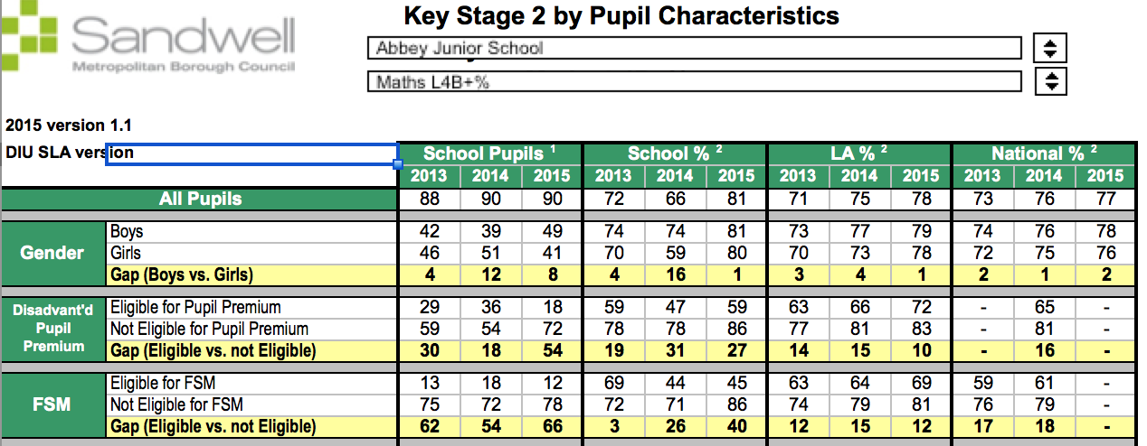
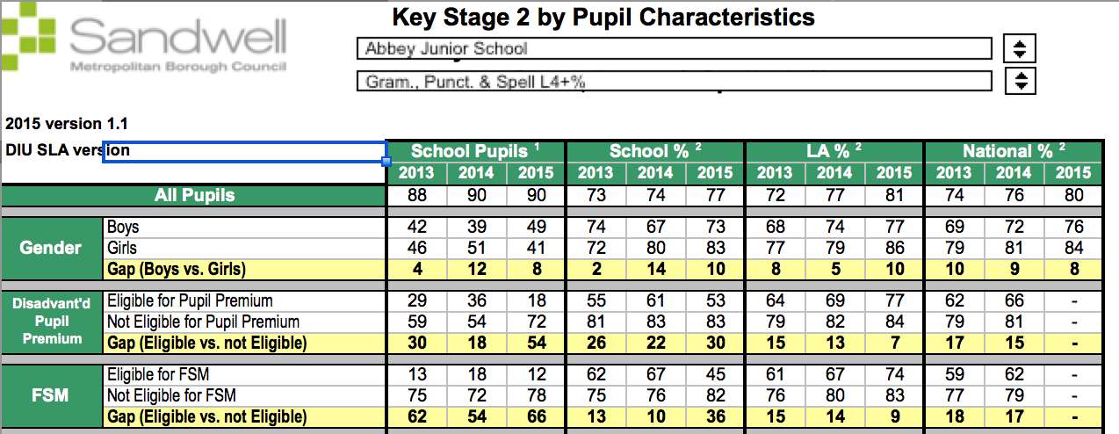
Reading 2-levels progress gap has widened from in-school gap; broadly in-line with the national FSM & all pupil group.

GPS L4+ gap has widened from in-school gap; below the national FSM group.

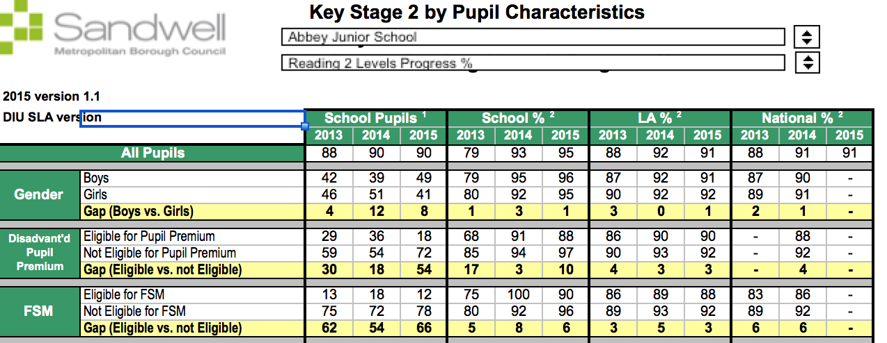
Writing 2-levels progress gap has widened from in-school gap; broadly in-line with the national FSM & all pupil group.

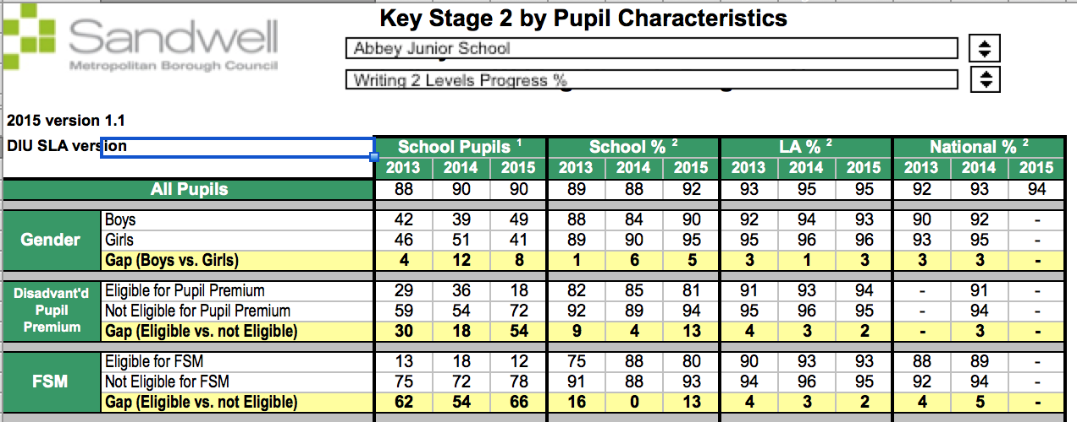
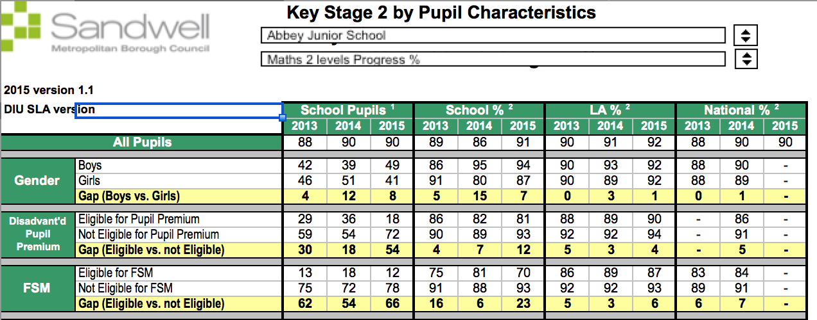
Reading 3-levels progress gap has remained the same from in-school gap; in-line with the national FSM & all pupil group.

Maths 2-levels progress gap has widened from in-school gap; broadly in-line with the national FSM pupil group.

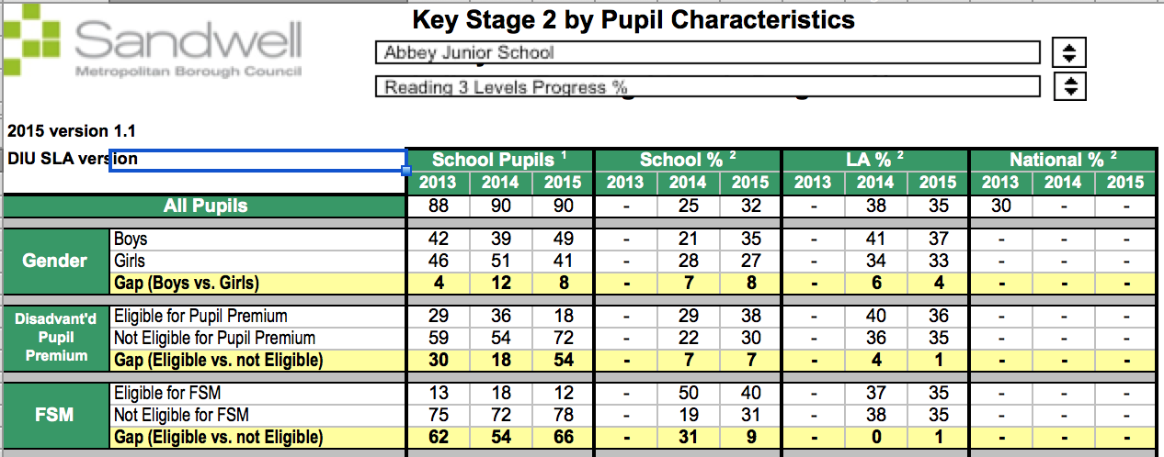
Writing 3-levels progress gap has narrowed from in-school gap; broadly in-line with the national FSM & all pupil group.

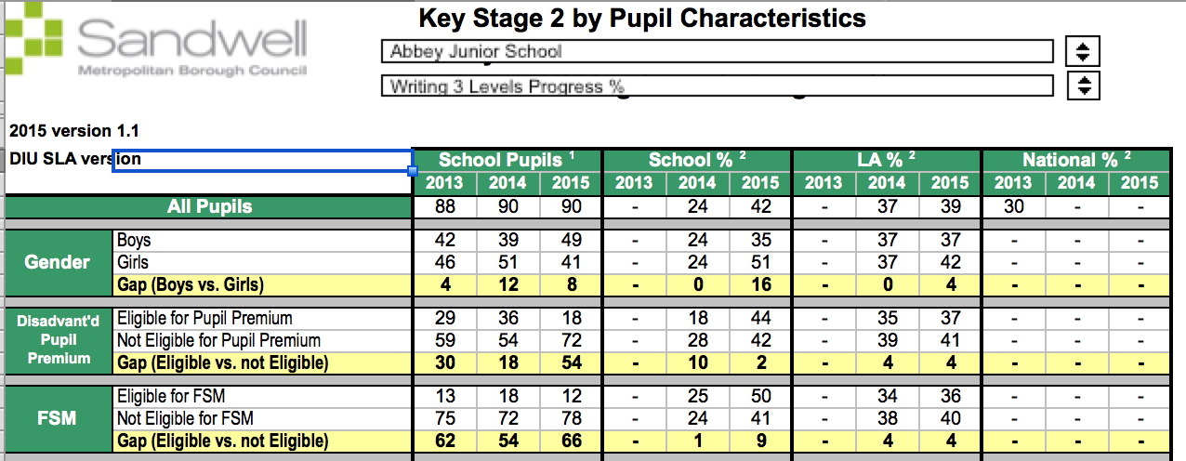
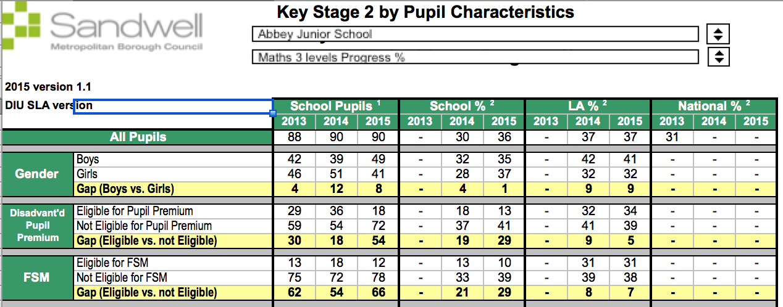
Maths 3-levels progress gap has widened from in-school gap; below the national FSM & all pupil group.

In year progress: -
1 | Static Progress/securing within a level to mastery |  |  | Expected Progress |  |  | Better than expected progress
 | R | Wr | Ma | R | Wr | Ma | R | Wr | Ma
All | 21 | 25 | 21 | 60 | 70 | 79 | 19 | 5 | 0
BOYS | 32 | 26 | 31 | 59 | 74 | 69 | 10 | 0 | 0
GIRLS | 12 | 24 | 13 | 61 | 67 | 88 | 27 | 9 | 0
AIND | 33 | 0 | 29 | 56 | 100 | 71 | 11 | 0 | 0
WBR | 17 | 22 | 21 | 63 | 76 | 79 | 21 | 2 | 0
SEN | 87 | 88 | 83 | 13 | 13 | 17 | 0 | 0 | 0
FSM | 27 | 42 | 40 | 67 | 58 | 60 | 7 | 0 | 0
3 | Static Progress/securing within a level to mastery |  |  | Expected Progress |  |  | Better than expected progress
 | R | Wr | Ma | R | Wr | Ma | R | Wr | Ma
All | 14% | 17% | 6% | 46% | 40% | 79% | 40% | 43% | 15%
BOYS (49) | 23% | 21% | 3% | 47% | 38% | 84% | 30% | 40% | 13%
GIRLS (51) | 3% | 13% | 4% | 45% | 41% | 78% | 53% | 46% | 18%
AIND (8) | 0% | 0% | 17% | 33% | 33% | 67% | 67% | 67% | 17%
WBR (48) | 15% | 17% | 10% | 43% | 35% | 80% | 43% | 48% | 10%
SEN (11) | 18% | 9% | 18% | 36% | 9% | 64% | 45% | 82% | 18%
FSM (10) | 13% | 25% | 20% | 63% | 50% | 70% | 25% | 25% | 10%
4 | Static Progress/securing within a level to mastery |  |  | Expected Progress |  |  | Better than expected progress
 | R | Wr | Ma | R | Wr | Ma | R | Wr | Ma
All | 3% | 3% | 14% | 94% | 68% | 70% | 3% | 19% | 16%
BOYS (40) | 0% | 3% | 15% | 95% | 79% | 58% | 5% | 18% | 27%
GIRLS (50) | 2% | 4% | 12% | 90% | 76% | 84% | 8% | 20% | 4%
AIND (9) | 0% | 22% | 0% | 88% | 45% | 88% | 12% | 33% | 12%
WBR (45) | 7% | 4% | 11% | 90% | 79% | 87% | 3% | 17% | 2%
SEN (8) | 0% | 0% | 0% | 75% | 75% | 100% | 25% | 25% | 0%
FSM (13) | 0% | 0% | 21% | 92% | 69% | 58% | 8% | 31% | 21%
5 | Static Progress/securing within a level to mastery |  |  | Expected Progress |  |  | Better than expected progress
 | R | Wr | Ma | R | Wr | Ma | R | Wr | Ma
All (90) | 31% | 3% | 32% | 59% | 75% | 62% | 10% | 22% | 6%
BOYS (40) | 34% | 5% | 31% | 56% | 72% | 69% | 10% | 27% | 0%
GIRLS (50) | 37% | 2% | 32% | 60% | 82% | 57% | 3% | 41% | 10%
AIND (11) | 20% | 0% | 30% | 80% | 100% | 60% | 0% | 0% | 10%
WBR (44) | 32% | 4% | 36% | 67% | 78% | 57% | 11% | 18% | 7%
SEN (8) | 42% | 0% | 14% | 42% | 75% | 86% | 16% | 25% | 0%
FSM (17) | 36% | 6% | 41% | 57% | 71% | 59% | 7% | 23% | 0%

School Wide interventions – examples.

Intervention | Length of sessions | Number of sessions per week | 1:1 or group | *Cost of running the intervention per session | *Overall cost over a 10 week period
BRP | 20 minutes | 3 | 1:1 | £3.33 per child | £100 per child
HFW | 5 minutes | 5 | 1:1 | £0.85 per child | £42.50 per child
Precision Teaching | 15 minutes | 5 | 1:1 | £2.50 per child | £125 per child
Phonics/reading boosters, 5 minute box, name writing, numeracy | 5 minutes | 5 | 1:1 | £0.85 per child | £42.50 per child
Catch Up maths/literacy | 20 minutes | 3 | group | £3.33 per group | £100 per group
ELS | 20 minutes | 5 x 16 weeks | group | £3.33 per group | £266 per group

The impact of interventions for 2014/15:
Value for money examples.

