Helping Your Child at Home
An activity guide to support reading in KS1


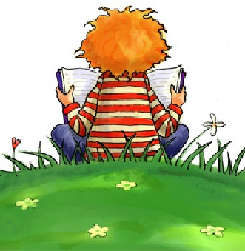

Reading is to the mind what exercise is to the body
Joseph Addison
Getting Started

Why Reading Homework? – Research has consistently shown that parental involvement in a child’s learning is a key factor in that child’s achievement in school. For your KS1 child please look in your child's book bag and see which books that they have been given. Make a note in their reading diaries, each and every time they read with you and please don’t forget to sign it.

Taking an active interest in your child’s learning is one of the best ways you can help your child to do better in school and in life. Learning is not just about what happens in school. Children are learning all the time through what they see, hear and do. Try to create a reading environment in your home and in your life. Have books in your home and make sure that your child sees that books and reading are an important part of your life. Books are cheaply available from charity shops and boot sales, and a library card from Thimblemill Library costs nothing at all.

General tips to support reading

A little reading goes a long way
- Remember: a good 10 minutes every day is much better than a difficult half hour
- Plan a quality, quiet time to read together

Once is never enough! - Encourage your child to read, read and read! Why not re-read favourite books and poems as well as their school reading book. Re-reading helps children read more quickly and accurately.

Why not read subtitles to an age appropriate film, programme or song? Find any opportunity to read.

Dig deeper into the story - Ask your child about the story you have just read – see below for questions and activities.

Take control of the television, iPad or the gaming console - It's difficult for reading to compete with TV, YouTube and computer games. Encourage reading as a distraction free activity.

Pick books that are at the right level - Help your child pick books that are not too difficult. The aim is to give your child lots of successful reading experiences. Pick books that engage and interest your child.

One more time with feeling – Take some time to listen to your child read. Perhaps read a page to them, whilst they sit and listen. Show your child how to read with expression and try to put on some of the voices of the different characters.

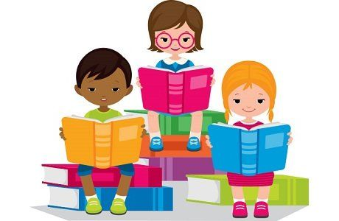

Strategies and Reading Behaviours

In school, children are taught a range of strategies they can use to help them work out unknown words. You may see your child using these at home:
- Using their knowledge of phonics (the sounds that letters make) - If they can sound the word out using the phonics they know then encourage this as the first strategy.
- Using the picture as a clue (this is not cheating!)
- Using picture clues along with the initial letter in the word
- Predicting what the word could be from the context it is in

If you would like to know about sounds that letters make (phonics) why not visit our reading page, ‘Parents’ Guide to Phonics and Early Reading’ on the school website: https://www.abbeyfederation.co.uk/parent-guide-to-phonics-and-early-reading/

As children’s reading skills develop they adopt a range of good reading behaviours. These include:
- Reading from left to right and matching each spoken word to a written one
- Recognising errors
- Re-reading to correct and re-reading to check
- Making meaningful but not always accurate guesses
- Reading with expression

As children progress further they:
- Use punctuation
- Follow print with their eyes
- Search for information in the print
- Read more fluently
- Use letter clusters to attempt to read new words

Reading with your child

- Allow your child to read to the end of a sentence without interrupting
- Share the title, rather than asking them to read it, if the words are unfamiliar
- Remind your child to point to each word individually, rather than continuously run their finger underneath, if they are still learning to match one to one
- Alternate saying “well done” or “that was good” by telling your child what was good
- Remember not to expect your child to work out a word that is not in their vocabulary
- Alternate the strategies you suggest rather than giving the same strategy prompt e.g. sound it out

Book Introduction: Spend time introducing the book. Look at the front cover, the ‘blurb’ on the back and take a guess about what the book may be about.

Strategy Check: Ask your child “What can we do if we get stuck on a word?” Listing the strategies refreshes your child’s memory and gives them the confidence to tackle a new word.

Independent reading: During this time try to remind your child of strategies rather than reading the unknown words for them.

Returning to text for questioning: This is an important part of the reading session as it enables you to see if they have understood what they have read. More confident readers will also be able to return to the text to find out answers to questions. Here is a list of possible questions:

Questions to ask your child when reading
Before reading the book:
- What do you think this story will be about? Look at the title and pictures on the front cover and take a guess.
- Read the title.
- Who is the author?
- Who is the illustrator?
- What do you think might happen in the story?
- What do we call the writing on the back of the book? (Blurb) or What does the blurb tell us? Read it together and find out about the book you are reading.
During the reading of the book:
- Look at the pictures (if there are any) and discuss the illustrations.
- Who is your favourite character? Why?
- Who is the character you like least? Why?
- What has happened so far? Is it what you thought might happen?
- What do you think will happen next?
- How do you think the story might end?
- Find words in the book and talk about their meaning.
At the end of the book:
- Which part of the story is your favourite / least favourite? Why?
- Is there any part of the story that you would change? How?
- Would you change any of the characters? How?
- Which part of the story was the funniest, scariest, saddest, and happiest? Look at the pictures and text when your child tells you their ideas.
- Would you like to read another book by this author? Why?
Other Activities
In addition to the all-important questioning, here are a few activities that you could try out both before, and during reading.
Before Reading
Predicting from just the title or key illustration.
What do they think the text is going to be about? Do they think it’s going to be fiction/non-fiction?
Reader Questions
Give your child the title of the book or look at the picture on the front cover. Can they think of any questions they would like answered before reading the book?
Storytelling
If you are looking at a story book, tell the story simply before reading it using the illustrations from the book.
During Reading
Modelled Reading
Adult reads first! Read aloud a book, or part of a book to your child. This is a great opportunity to model reading with expression and to model how punctuation affects your reading. The more times something is read or heard the more comprehension there will be.
Echo reading:
Read a line and ask your child to read the line back to you in exactly the same way. Then read lines or verses in the same way. Great for modelling fluent, expressive reading.

Choral reading
Read a book together in chorus. Good confidence builder if your child feels a little daunted by a text.

Tell Me
When talking with your child about a text support the talk by using the following approaches:
“Tell me about…” Leave your opinion until later!
Model use of tentative language, e.g. I’m not sure but…. I was wondering whether…. Perhaps... Maybe… Probably…

Spot the error
Read the text together with you leading the reading. Make some deliberate errors. Can they spot them?

We hope that you have found this booklet useful and remember, we all learn more when we enjoy what we are learning! Have fun helping your child learn to read.



