Helping Your Child at Home
An activity guide to support reading in KS2


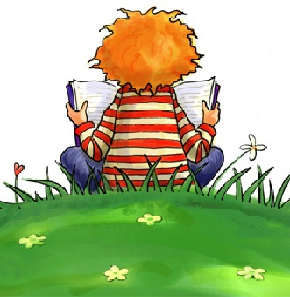

Reading is to the mind what exercise is to the body
Joseph Addison
Getting Started

Parents often wonder how they can help to develop the reading skills of children who are already fluent
readers. The best way is to continue to share books with your child, regularly listening to them read,
sometimes reading to or with them, but also discussing books read in increasing depth.

Try to create a reading environment in your home and in your life. Have books in your home and make sure that your child sees that books and reading are an important part of your life. Books are cheaply available from charity shops and boot sales, and a library card from Thimblemill Library costs nothing at all.

Why Reading Homework? – Research has consistently shown that parental involvement in a child’s learning is a key factor in that child’s achievement in school. For your KS2 child please look in their book bag and see which books that they have been given. Encourage and support your child to read, make a regular time each night to read and try not to leave it to one large block at the weekend. Make a note in their reading diaries and sign it. Please use the advice below to help your child be a happy and confident reader.

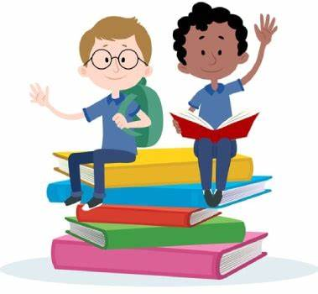

General tips to support reading

Once is never enough! - Encourage your child to read, read and read! Why not re-read favourite books and poems as well as their school reading book. Re-reading helps children read more quickly and accurately.

Why not read subtitles to an age appropriate film or programme. Find any opportunity to read.

Dig deeper into the story - Ask your child about the story you have just read – see below for suitable questions.

Take control of the television, iPad or the gaming console - It's difficult for reading to compete with TV, YouTube and computer games. Encourage reading as a distraction free activity.

Pick books that are at the right level - Help your child pick books that are not too difficult. The aim is to give your child lots of successful reading experiences. Pick books that engage and interest your child.

One more time with feeling – Take some time to listen to your child read. Perhaps read a page to them, whilst they sit and listen. Show your child how to read with expression and try to put on some of the voices of the different characters. Why not film or voice record your child reading using a smart phone? You could use a plain recording feature or use a filter like Snap Chat. It can just make it all a bit more interactive and fun.

KS2 Reading Prompts

To become good readers’ children, need to develop skills in seven key areas and it can be useful to think about these when reading with your child.

Decoding: This is the skill that parents are generally most familiar with, and deals with the varying strategies used by children to make sense of the words on the page. Even fluent readers can be stumped by an unfamiliar word, and it is useful at these times to discuss the range of strategies used to make a sensible guess. If you’d like to find out more then please visit our website and see the Parents’ guide to phonics and early reading, here can find some great advice and guidance about decoding and reading:
https://www.abbeyfederation.co.uk/parent-guide-to-phonics-and-early-reading/

Retrieval and recall: readers need to develop this skill, in order to locate important information and to retell stories and describe events.

Inference: reading between the lines. Encouraging children to make inferences based on clues in the text and their understanding of the context of the book will help them to develop this important skill.

Structure and organisation: as children read a wider range of text types, they need to be able to comment on the features of each and how they are organised. Discussing the presentation of the text, e.g. the use of subtitles to assist reading of a non-fiction text, and the author’s reason for organising the text in this way, will support children’s development in this area. Making links between the purpose of the text and its organisation is a useful place to start.

Language: specifically, thinking about the language choices made by writers, their possible reasons for making those choices and the effect the choices have on the reader. Discussing alternative choices and their effects can be a good way to begin discussion about the author’s language and an opportunity to develop vocabulary generally.

Purpose and viewpoint: Who is the narrator of this story? What does the writer of this biography feel about his/her subject? Children need to understand that writers write for a purpose, and to be able to recognise that this will have an impact on the way a text is written. Newspapers and advertisements are perfect examples of this and can lead to lots of lively discussions.

Making links: as adults, we are constantly making links between ideas and experiences. Good readers connect the book they are reading with real life experiences; with other books read and stories heard; with films; and with the context in which they were written. A child reading ‘Goodnight Mister Tom’, for example, will need to place the story within the context that it was written to fully understand it. They might also link it with other stories read, such as ‘Friend or Foe’ or ‘Carrie’s War’.

Questions: Below there are some questions linked to the above points, which I hope you will find useful. It is not necessary to ask every question each time your child reads, of course, but they may prove to be useful prompts to start a more focused discussion.

- What has happened in the story so far?
- What do you think will happen next?
- Who is your favourite character? Why?
- Who is the character you like least? Why?
- Do you think the author intended you to like / dislike this character? How do you know?
- Does your opinion of this character change during the story? How? Why?
- Find two things the author wrote about this character that made him / her likeable?
- If you met one of the characters from the story, what would you say to him / her?
- Which part of the story is your favourite / least favourite? Why?
- Would you change any part of the story? How?
- Would you change any of the characters? How?
- Which part of the story was the funniest/scariest/ saddest/ happiest? Find some evidence in the
text to support your opinion.
- What is the purpose of this book? How do you know?
- Why is this page laid out in this way? Could you improve it?
- Pick three favourite words or phrases from this chapter. Can you explain why you chose them?
- Did this book make you laugh? Can you explain what was funny and why?
- Have you read anything else by this author? Is anything similar?
- Does this book remind you of anything else? How?
- When do you think this book was written? How do you know? Does it matter? What would it be like
if it was written now?
- Do you think the title of the book is appropriate? What would you have called it?
- What is the genre of the book: sci-fi, mystery, historical, fantasy, adventure, horror, comedy? What
are the features that make you think this?
- Find two sentences which describe the setting.
- Is the plot fast or slow moving? Find some evidence in the text, which supports your view.
- If the author had included another paragraph before the story started what do you think it would
say?
- Would you like to read another book by this author? Why/ why not?

Of course, it doesn’t have to be you asking the questions. Why not turn the tables and let your child ask you about your reading material? The greatest encouragement for your child is to see you, their most influential role model, reading.

We do hope that you have found this booklet useful and if you have any further questions, please do not hesitate to speak to your child’s teacher.



