AFTER SCHOOL CLUBS – September - October 2024
(Autumn Term 1 Clubs)

Monday | Tuesday | Wednesday | Thursday | Friday
  Football  09/09/24-21/10/24 |   Gymnastics  10/09/24 -22/10/24  NO CLUB ON TUESDAY 15TH OCTOBER 2024 DUE TO PARENTS EVENING |   Basketball  11/09/24 – 23/10/24    Lego  11/09/24 – 23/10/24  NO CLUB ON WEDNESDAY, 16TH OCTOBER 2024 DUE TO PARENTS EVENING | 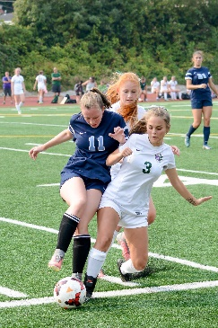  Girls Football  12/09/24 – 24/10/24 |  |   Dance  13/09/24 – 25/10/24

