AFTER SCHOOL CLUBS – Feb - March 2024

(Spring 2 After-School Clubs)

Monday | Tuesday | Wednesday | Thursday | Friday
  FOOTBALL CLUB  19/02/24 – 18/03/24 |   MINI ATHLETICS  20/02/24 – 19/03/24  NO CLUB ON TUESDAY 12th MARCH 2024 DUE TO PARENTS EVENING |   GYMNASTICS  21/02/24 – 20/03/24  NO CLUB ON WEDNESDAY 13th MARCH 2024 DUE TO PARENTS EVENING |   MULTI SPORTS CLUB  &  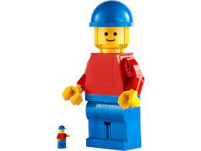  LEGO CLUB  22/02/24 – 21/03/24  &    22/02/24 – 14/03/24  NO CLUB 21/03/24 | NO CLUBS THIS HALF TERM

